Fourth Grade Math Assignment
This assignment is strongly aligned to the standards.
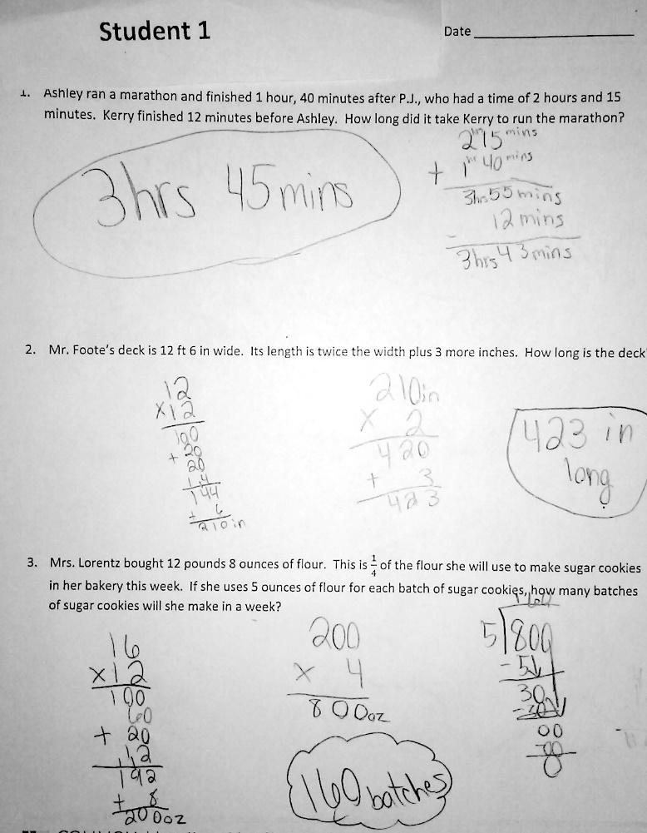

Overview
Fourth-grade students solve multistep word problems involving measurement quantities. This assignment is strong because it requires students to interpret real-world scenarios and represent and solve them mathematically, while giving students continued practice with grade-level operations with whole numbers and fractions.
Related Standards
We looked at how well the assignment aligned to the following standards:
KY.4.MD.2: Use the four operations to solve word problems involving distances, intervals of time, liquid volumes, masses of objects and money.
a. Solve measurement problems involving whole number, simple fractions or decimals.
b. Solve problems that require converting a given measurement from a larger unit to a smaller unit within a common measurement system, such as 2 km = 2,000 m.
c. Visually display measurement quantities using representations such as number lines that feature a measurement scale.

Why is this assignment strongly aligned?
This assignment is well-aligned with fourth-grade standard KY.4.MD.2. The standard requires that students solve word problems involving measurement quantities, and the three problems in this assignment are word problems about time, length, and weight. The standard also requires that students represent measurement quantities using scaled diagrams. The companion lesson for this assignment used tape diagrams to represent problems, and the directions for this assignment (not pictured) prompted students to read, draw, and write to solve each problem.
All three problems in this assignment involve other fourth grade standards as well, including multiplying two-digit by two-digit numbers (standard KY.4.NBT.5), dividing with one-digit divisors and up to four-digit dividends (standard KY.4.NBT.6), solving word problems involving multiplicative comparison (standard KY.4.OA.2) and multiple steps (standard KY.4.OA.3).
This assignment builds students’ application skills which is appropriate for standard KY.4.MD.2. The standard calls for students to solve word problems involving measurement, and all three problems in this assignment are word problems that involve real-world situations. The standard also indirectly targets students’ conceptual understanding of the size of and relationship between different measurement units (such as inches and feet) since it requires students to represent measurement quantities using scaled diagrams, and the directions for this assignment (not pictured) ask students to create a drawing for each problem.
Practice Standards
This assignment allows students to engage with two mathematical practice standards. Interpreting what the word problems are asking them to do gives students the chance to engage with Mathematical Practice Standard #1 ("Make sense of problems and persevere in solving them"). The directions for the assignment (not pictured) also ask students to create drawings to represent each real-world scenario, which gives students the chance to engage with Mathematical Practice Standard #4 ("Model with mathematics").

