4th Grade Reading & Writing Assignment
This assignment is strongly aligned to the standards.

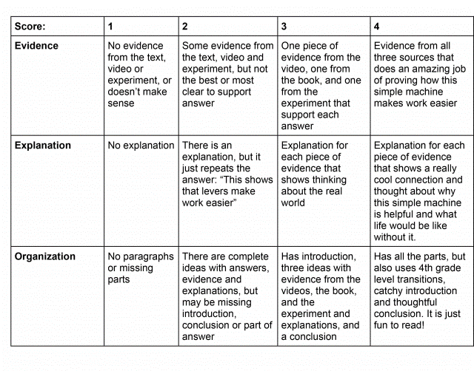

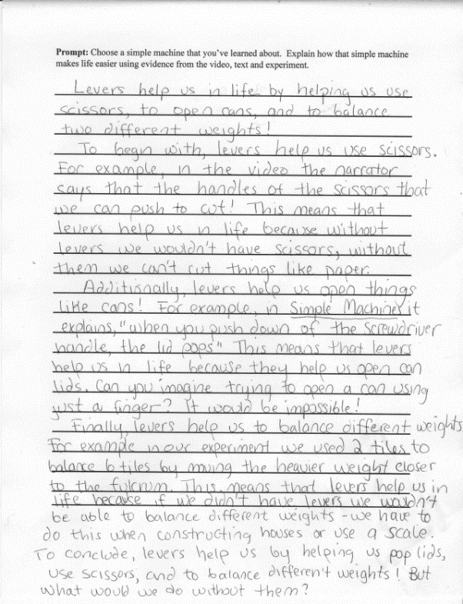
Overview
Fourth-grade students engage with a series of worthwhile sources (text, video, and experiment) about different simple machines, then write in response to the prompt: "Choose a simple machine that you’ve learned about. Explain how that simple machine makes life easier using evidence from the video, text and experiment.” A student-facing writing rubric sets clear expectations for organization, the use of evidence from these sources, and the explanation of evidence. This assignment exposes students to grade-appropriate, content-rich sources that build scientific knowledge and requires students to write an explanatory piece to convey their understanding.

About the Text

Title and Author | "Simple Machines: Forces in Action" by Buffy Silverman
What is the Lexile Level of this text? | 870L
Based on Lexile, which grades is this text intended for? | 4-5
Is the text qualitatively complex enough for the grade? | Yes
Is this text fiction or non-fiction? | Non-Fiction
Is this text authentic or was it written for educational purposes? | Authentic
Does the text provide sufficient detail to build knowledge of a worthwhile topic and/or is it worth reading closely and re-reading? | Yes

Related Standards
RI.4.1: Refer to details and examples in a text when explaining what the text says explicitly and when drawing inferences from the text.
The assignment is strongly aligned to this standard. Students are asked to cite evidence from the video, the text, and the experiment to support their explanation.
RI.4.3: Explain the individuals, events, procedures, ideas or concepts in a historical, scientific or technical text, including what happened and why, based on specific information over the course of a text.
The assignment is strongly aligned to this standard. Students explain how their chosen simple machine makes life easier.
RI.4.10: By the end of the year, flexibly use a variety of comprehension strategies (i.e., questioning, monitoring, visualizing, inferencing, summarizing, synthesizing, using prior knowledge, determining importance) to read, comprehend and analyze grade level appropriate, complex informational texts independently and proficiently.
The assignment is strongly aligned to this standard. Students need to comprehend the information presented in an adequately complex and worthwhile text to complete this task.
C.4.2: Compose informative and/or explanatory texts, using writing and digital resources, to examine a topic and convey ideas and information clearly.
The assignment is strongly aligned to this standard. Students write an explanatory piece to convey their understanding of how simple machines make life easier. The writing prompt and rubric set expectations for students' to produce clear and coherent writing in which the development and organization are appropriate to task, purpose and audience; develop the topic with facts, definitions, concrete details, quotations or other information and examples related to the topic; and provide a conclusion.
C.4.5: Conduct short research projects that build knowledge through investigation of different aspects of a topic.
The assignment is strongly aligned to this standard. Students build knowledge and understanding through exploration of different sources (video, text, experiment) that examine different aspects of the topic.
L.4.2: When writing: a. Demonstrate appropriate use of capitalization rules; c. Use a comma before a coordinating conjunction in a compound sentence.
The assignment is strongly aligned to this standard. Students have the opportunity to demonstrate effective use of capitalization and commas.

Why is this assignment strongly aligned?
The assignment exposes students to multiple sources (text, video, and experiment) that build their scientific knowledge. The central text builds students’ knowledge of simple machines that help us do work (e.g., wedge, screw, lever, pulley, wheel and axle), and prompts exploration of these machines through experiments.
The assignment requires students to identify and examine textual evidence. Students are asked to write an explanatory piece that conveys their understanding of the ideas and information in these sources.
The rubric sets clear expectations for the organization and development of student writing. Students are expected to include an introduction that provides context on the topic, three ideas with supporting evidence from sources, and a concluding statement.
The assignment provides an opportunity for students to practice the conventions of standard English in authentic writing. In this task, however, this opportunity appears to be incidental rather than intentional, as the directions do not include clear expectations for use of grammatical conventions beyond fourth-grade level transitions.

