4th Grade Reading & Writing Assignment
This assignment is partially aligned to the standards.

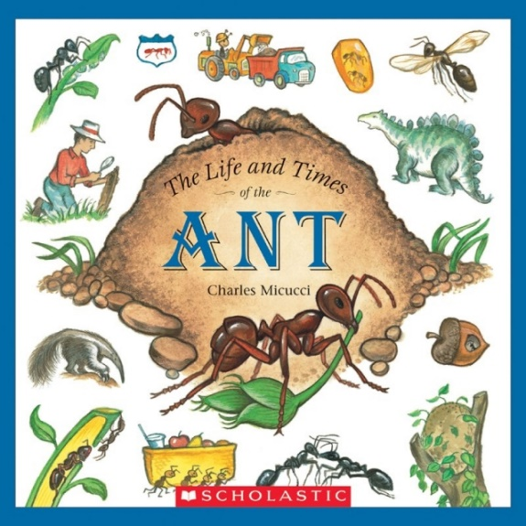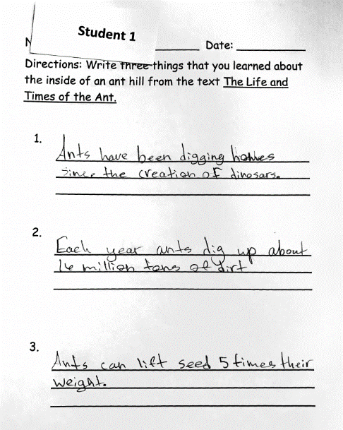
Overview
Fourth-grade students read “The Life and Times of the Ant,” a non-fiction science text by Charles Minucci, then write three things they learned about the inside of an ant hill. The assignment exposes students to a grade-appropriate, worthwhile text, but the assignment only asks students to write things they learned from the text and does not require them to explain the ideas using specific textual evidence.

About the Text

Title and Author | "The Life and Times of the Ant" by Charles Micucci
What is the Lexile Level of this text? | NC950L
Based on Lexile, which grades is this text intended for? | 4-5
Is the text qualitatively complex enough for the grade? | Yes
Is this text fiction or non-fiction? | Non-Fiction
Is this text authentic or was it written for educational purposes? | Authentic
Does the text provide sufficient detail to build knowledge of a worthwhile topic and/or is it worth reading closely and re-reading? | Yes

Related Standards
RI.4.1 Refer to details and examples in a text when explaining what the text says explicitly and when drawing inferences from the text. The assignment is partially aligned to this standard. Students are asked to write three things they learn about the inside of an anthill from the text. Because students are asked to do this writing from the text it is text dependent; however they do not have to identify details and examples from the text to explain anything the text says explicitly or inferentially.

RI.4.3: Explain the individuals, events, procedures, ideas or concepts in a historical, scientific or technical
text, including what happened and why, based on specific information over the course of a text.
The assignment is weakly aligned to this standard. There is no expectation that students explain the ideas in this scientific text based on specific information in the text. Students are merely asked to recall details from the text, which does not reflect the depth of the 4th grade standards.

RI.4.10: By the end of the year, flexibly use a variety of comprehension strategies (i.e., questioning, monitoring, visualizing, inferencing, summarizing, synthesizing, using prior knowledge, determining importance) to read, comprehend and analyze grade level appropriate, complex informational texts independently and proficiently.
The assignment is strongly aligned to this standard. Students do need to comprehend the information presented in an adequately complex and worthwhile text to complete this task.
Why is this assignment Partially aligned?
This assignment is partially aligned because the text is strong, but the questions are not:
Students engage with a worthwhile text that builds scientific knowledge. The text is appropriately challenging, and it builds students’ knowledge of one of the world’s most important insects.
The writing prompt does not require students to analyze the text or write about it substantively. Students are merely asked to recall details from the scientific text, but not to build a deep understanding of the information or analyze it in depth. This task would be stronger if it asked students to demonstrate their understanding of key ideas in the text and explain these ideas in writing, supported by well-chosen textual evidence.

