Fourth Grade Math Assignment
This assignment is partially aligned to the standards.
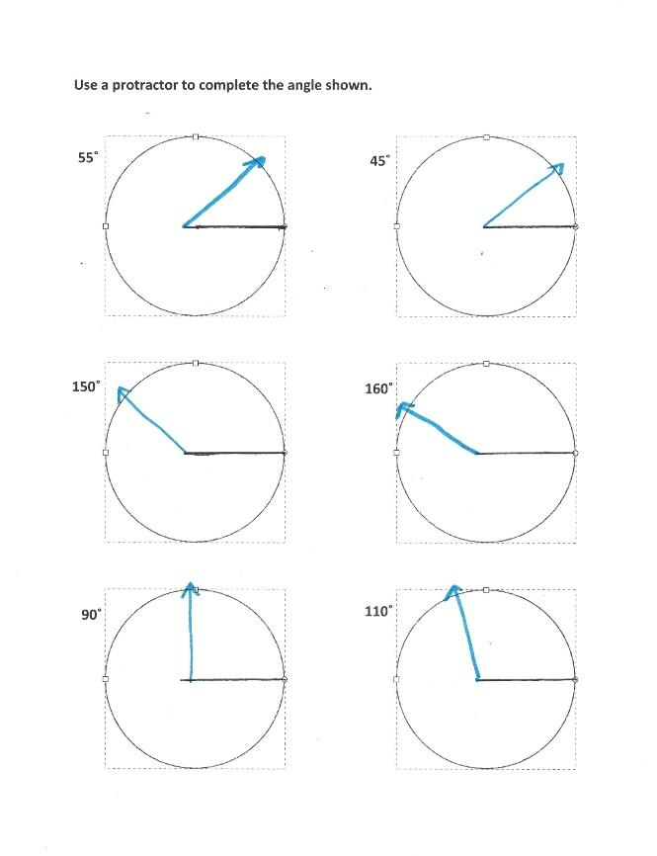

Overview
Fourth-grade students use protractors to draw angles of given measures. This assignment is partially aligned with a fourth-grade standard because students don’t draw the entire angle themselves or draw angles to a single degree.

Related Standards
We looked at how well the assignment aligned to the following standard:
KY.4.MD.6 Measure angles in whole-number degrees using a protractor. Sketch angles of specified measure.

Why is this assignment partially aligned?
This assignment is partially aligned to fourth-grade standard KY.4.MD.6. The standard requires that students draw angles of a given measure and this assignment involves drawing six angles in multiples of five degrees (for example, 45˚ or 110˚). Fourth-graders should also be tasked with drawing angles to a single degree (for example, 47˚ or 113˚).
This standard targets both conceptual understanding and procedural skill. This assignment allows students to build procedural skill through multiple opportunities to practice using a protractor to draw angles of given measures. Students must use the tool correctly (for example, aligning the provided horizontal ray for each angle with the zero mark on the protractor) to accurately draw the angles. However, the assignment does not build students’ conceptual understanding about angles and angle measurement because it only exposes students to one angle orientation and students need to be exposed to varied angle orientations to avoid developing inaccurate understandings. For example, if the angles are always presented with a horizontal ray, students may come to believe that all angles can be read off of a protractor in “standard” position (i.e., with a horizontal base) even when neither arm of an angle is horizontal. To help students build an accurate understanding, they should also measure and draw angles with no horizontal or vertical arms.

Practice Standards
This assignment allows students to superficially engage with Mathematical Practice Standard #5 ("Use appropriate tools strategically"). Students repeatedly practice using a protractor to draw angles of given measures, but they don’t draw the entire angle themselves. The assignment provides one horizontal ray for each angle, so students can’t demonstrate independent proficiency with protractors.

