Fourth Grade Math Assignment
This assignment is weakly aligned to the standards.
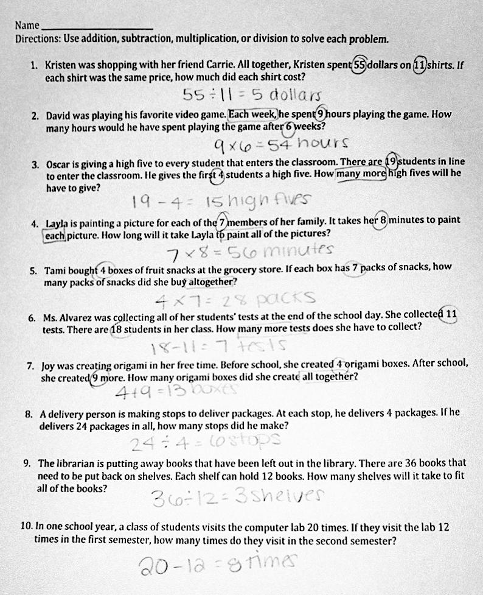

Overview
Fourth-grade students solve ten word problems involving all four operations. This assignment is weak because the problems are most closely aligned with first-grade and third-grade standards.

Related Standards
We looked at how well the assignment aligned to the following standard:
KY.4.OA.3 Solve multistep problems.
a. Perform operations in the conventional order when there are no parentheses to specify a particular order.
b. Solve multistep word problems posed with whole numbers and having whole number answers using the four operations, including problems in which remainders must be interpreted. Represent these problems using equations with a letter standing for the unknown quantity. Assess the reasonableness of answers using mental computations and estimation strategies including rounding.

Why is this assignment weakly aligned?
This assignment is most closely aligned with first-grade standard KY.1.OA.A.1 (solving addition and subtraction word problems within 20) and third-grade standard KY.3.OA.A.3 (solving multiplication and division word problems within 100). In fourth grade, students should be solving multi step word problems involving all four operations (standard KY.4.OA.A.3), but none of the problems in this assignment are multistep.
Though the fourth-grade standard KY.4.OA.A.3 does not specify what types of numbers students should be working with, other fourth grade standards include fluently adding and subtracting multi-digit numbers using an algorithm (standard KY.4.NBT.B.4), multiplying one-digit numbers by up to four-digit numbers and two-digit numbers by two-digit numbers (standard KY.4.NBT.B.5), and dividing with one-digit divisors and up to four-digit dividends, including quotients with remainders (standard KY.4.NBT.B.6). None of the problems in this assignment involved the number types outlined in these fourth-grade standards.
Practice Standards
This assignment allows students to engage with Mathematical Practice Standard #1 ("Make sense of problems and persevere in solving them") by interpreting what operation was needed to solve each word problem. However, the level of interpretation was far below grade level, as standard KY.4.OA.A.3 requires multistep word problems involving all four operations and this assignment only included one-step word problems involving one operation.

