4th Grade Reading & Writing Assignment
This assignment is weakly aligned to the standards.

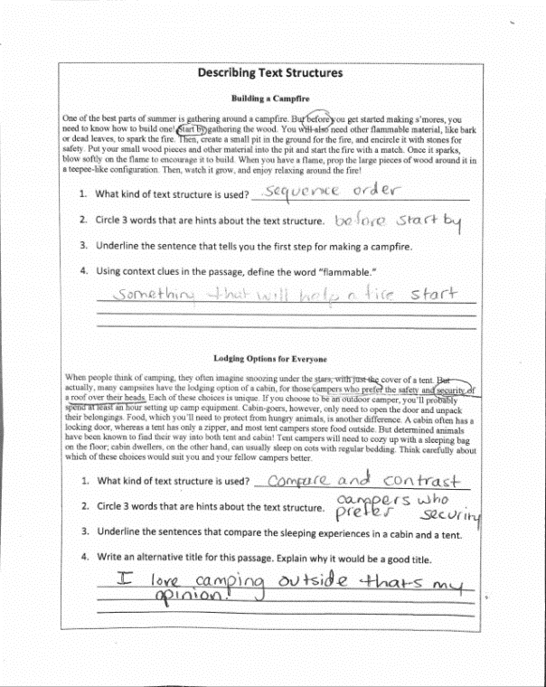
Overview
Fourth-grade students read two short passages, then answer a series of questions about the structure of each text. The texts, which are commissioned for educational purposes, are not grade-appropriate or worthy of student time and attention, and the associated questions do not ask students to explore the craft and structure of the texts, or to build a deep understanding of the texts.
ABOUT THE TEXT

Title and Author | "Building a Campfire" and “Lodging Options for Everyone”
What is the Lexile Level of this text? | 800L
Based on Lexile, which grades is this text intended for? | 2-3
Is the text qualitatively complex enough for the grade? | No
Is this text fiction or non-fiction? | Non-Fiction
Is this text authentic or was it written for educational purposes? | Written for educational purposes
Does the text provide sufficient detail to build knowledge of a worthwhile topic and/or is it worth reading closely and re-reading? | No

Related Standards
RI.4.5: Describe the overall structure, in a text or part of the text, the author uses to organize the events, ideas, concepts or information.
The assignment is weakly aligned to this standard. The texts do not contain implicit and subtle connections between ideas, intricate organization, or text features that warrant an exploration of structure. Additionally, students are asked to identify the kind of text structure instead of describe the overall structure of the text.
RI.4.10: By the end of the year, flexibly use a variety of comprehension strategies (i.e., questioning, monitoring, visualizing, inferencing, summarizing, synthesizing, using prior knowledge, determining importance) to read, comprehend and analyze grade level appropriate, complex informational texts independently and proficiently.
The assignment is weakly aligned to this standard. The texts are not adequately complex for Grade 4 or worthy of student time and attention. Additionally, students are not asked to demonstrate deep understanding of the information and ideas in the texts.

Why is this assignment weakly aligned?
The texts are not adequately complex or worthy of student time and attention. They do not contain useful information for students, nor do they offer the implicit and subtle connections between ideas, intricate organization, or text features that would warrant an exploration of structure.
The task does not require a deep analysis of craft and structure. Students are asked to identify the structure of each text, but not to describe the text’s structure in greater depth.
The task does not require a deep understanding of the information or ideas in the text. The questions do not ask students to use their understanding of the texts or to use evidence from the texts to support their ideas.

