Grade 5 Assignment
This assignment is strongly aligned to the Kentucky Academic Standards (KAS) for Social Studies

Teacher Notes

Introduction
This Teacher Notes document provides instructional support for implementing the strongly aligned assignments to the KAS for Social Studies. To examine why this assignment is strongly aligned to the KAS for Social Studies, engage with the Grade 5 Assignment Review Protocol for this assignment.
It is important to note that the assignment(s), indicated throughout the Teacher Notes, and related resource(s) represent one example. It is not a requirement nor a suggestion for school curriculum. While the Kentucky Department of Education (KDE) is responsible for the development of high-quality academic standards, state law assigns each local district the authority to develop the school’s curriculum and determine appropriate instructional resources based on language found in Kentucky Revised Statute (KRS) 160.345. It is under the discretion of the superintendent to determine the local curriculum, including the evaluation and selection of instructional resources. The KDE does not adopt or select specific curricula for coursework. Per KRS 160.345(g), “the local superintendent shall determine which curriculum, textbooks, instructional materials, and student support services shall be provided in the school after consulting with the local board of education, the school principal, and the school council and after a reasonable review and response period for stakeholders in accordance with local board of education policy.”
Kentucky Academic Standards (KAS) for Social Studies alignment:
- 5.I.Q.1 Ask compelling questions about the founding of the United States.
- 5.I.Q.2 Generate supporting questions to answer compelling questions about the founding of the United States.
- 5.E.MA.1 Describe why the government collects taxes and what goods and services it provides society.
- 5.H.CO.1 Analyze the role conflict and collaboration played in the founding of the United States.
- 5.I.UE.2 Analyze primary and secondary sources on the same event or topic, noting key similarities and differences in the perspective they represent.
- 5.I.UE.3 Integrate evidence that draws information from multiple sources to answer compelling and supporting questions.
- 5.I.CC.3 Explain different approaches people can take to address local, regional and global problems, using examples from U.S. history.

Educators may have to engage with a standard multiple times throughout a year in order to meet the full intent of the standard. As a result, the following assignment example may not encompass the entire scope of the standards identified.

Overview:
Students will analyze the economic and social causes and implications of the Stamp Act. Additionally, students will examine how the Stamp Act created tension that eventually led to the American Revolution. Students will examine a variety of primary and secondary sources from different perspectives related to the Stamp Act.

Setting the Stage: Compelling Question

5.I.Q.1 Ask compelling questions about the founding of the United States.

Compelling Question: “What unites Americans?”

Compelling questions are open-ended, enduring and center on significant unresolved issues. This assignment provides a compelling question to demonstrate alignment because Grade 5 students are not required to ask compelling questions without teacher support. It is not the expectation of the standard that students develop compelling questions on their own. For more information on compelling questions, visit Section B: “What are Compelling Questions and how do students ask them?” from the Inquiry Practices of the KAS for Social Studies module.

Introduce the compelling question, “What unites Americans?” to students. The word “unite” is a term that students may have heard before, but may not fully understand its meaning. To explore the meaning of “unite”, provide students with an opportunity to share their knowledge of this word with their peers. Place students in small groups and pose the following questions for them to discuss:

- Where have you heard the word “unite” used before?
- What do you think “unite” means based on your examples?
- With your group, construct a definition for “unite.”

For guidance on how to conduct a whole class discussion, teachers may reference Leading a Discussion. After groups have had time to discuss their schema about “unite” and develop a definition, ask each group to share. Some examples students may mention during discussion include, but are not limited to, “United States”, “United We Stand, Divided We Fall”, sports teams such as “Manchester United”, etc. Prompt students to determine how “unite” is used in each example they provided. For example, the United States is “united” because the country is made up of individual states that come together to make a nation. As students are sharing, record each group’s definitions of “unite”. By the end of the discussion, students should understand what “unite” means and have a variety of examples to guide their thinking around the compelling question.
Explain to students that they will consider what unites Americans as they are investigating this compelling question. In order to investigate this compelling question, students will engage with the supporting question that follows.

Supporting Question

5.I.Q.2 Generate supporting questions to answer compelling questions about the founding of the United States

Supporting Question: “Why did the colonists demand no taxation without representation?”

Supporting questions are aligned to the compelling question and can be answered though using the concepts and practices of each social studies discipline. In grade 5, students are expected to generate supporting questions. Strategies such as Parts, Perspectives, Me may be used to support students in this work. For more information on generating supporting questions, visit “Section C: What are Supporting Questions, and how do students ask them?”
from the Inquiry Practices of the KAS for Social Studies module.

Investigation: Part 1
5.E.MA.1 Describe why the government collects taxes and what goods and services it provides society.

Prior to diving into Investigation One, present the success criteria to students:

I can describe why the government collects taxes and what goods and services it provides society.

Inform students that in order to demonstrate the success criteria, they are required to describe why the government collects taxes and what goods and services it provides society.

To support students in demonstrating the success criteria, have students describe taxes by answering the question “What are taxes?” To support students in this work, they may view the following resource:
- Easy Peasy Finance. (2021, March 16). What are Taxes? Taxes 101: Easy Peasy Finance for Kids and Beginners. https://www.youtube.com/watch?v=qyCXpr-ZDhE.
After watching the video, conduct a whole group discussion to answer the question below. For guidance on how to conduct a whole class discussion, reference Leading a Discussion.

What are taxes? Use evidence from the video to support your answer.

During this discussion, ensure that students understand the connection between government and taxes. At the conclusion of the whole group discussion, have students reflect on their learning by asking self-regulation feedback questions to ensure that they are prepared to continue with their investigation of why the government collects taxes and what goods and services they provide society.

Ask yourselves the following questions:
- What further questions do I have regarding taxes?
- Can I now teach someone else about taxes?

If students identify any gaps in their understanding after answering the self-regulation feedback questions, encourage them to ask their peers or their teacher for additional help in clarifying any misconceptions.

After students have identified and described taxes, ask students to do the following:

Work with a partner to construct a response to the following question:

“Why does the government collect taxes?”

In your response, cite evidence from the source you investigated.

To support students in sharing the information they have learned with their peers and addressing any misconceptions, have students provide each other with peer to peer feedback. One way to achieve this is to have students apply the success criteria to their constructed response to provide formative feedback to identify areas of improvement. Once the response is constructed, students may assume the roles of “student” and “teacher.” With the lens of each of these roles, the students will separately examine the same response and use the success criteria to identify strengths and areas of need.

Does this response sufficiently answer the question: “Why does the government collect taxes?”

If students identify any gaps in their understanding after answering this peer to peer feedback question, encourage them to ask their peers or their teacher for additional help in clarifying any misconceptions.

When students have completed their responses and their peer to peer feedback, have students share their responses and develop a claim about the purpose of taxes. An example might be: “The government collects taxes from its citizens to pay for services that help citizens and their community.”

Work together as a class to create a mind map to brainstorm government services that serve communities and are funded by tax revenue. Mind mapping is a non-linear, graphic way of organizing information that allows students to focus on the relationships between ideas. For more information on Mind Mapping, watch Mind Mapping or visit Mind Mapping. Some examples students may provide during the discussion include, but are not limited to: building roads, maintaining parks, libraries, police and fire departments. Explain to students that the organizations benefiting from taxation are public institutions, and clear up any misconceptions that arise. Below is an example of how this mind map may look:

Students now will apply their knowledge about taxes and why the government collects them as they explore the Stamp Act in the next investigation. Prior to this investigation, the teacher may find it useful to explain or revisit the relationship between the colonies and Great Britain prior to the Stamp Act to give context to this investigation. It is important to note that prior to the Stamp Act, the colonists had the ability to make most of their own decisions regarding day-to-today matters. The British government tended to not interfere in the matters that affected the everyday lives of the colonists. Colonial governments were able to collect taxes to use for services that would benefit their towns. The colonists were in favor of paying taxes for these purposes because they were the ones who created and decided upon creation and implementation of the taxes. Additionally, the revenue was being used for services that would benefit their communities, including road construction, schools and social programs. However, students will learn in the following investigation that the taxes required in the Stamp Act did not align with the colonists’ beliefs about taxation. 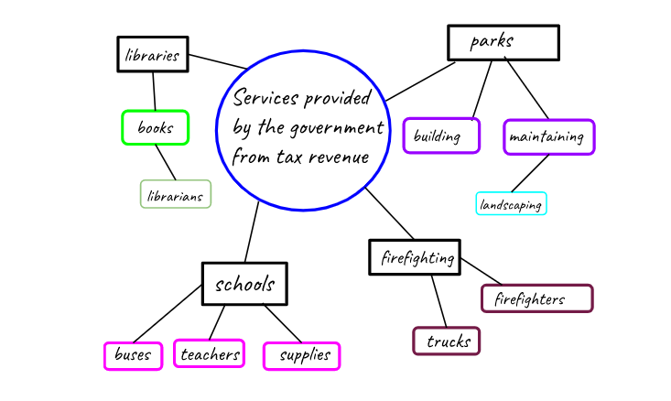
Investigation: Part 2
5.H.CO.1 Analyze the role conflict and collaboration played in the founding of the United States.

This standard will be visited twice during this Teacher Note. The focus during this investigation will be on the role of conflict resulting from the Stamp Act, and Investigation Part 4 will examine the role of collaboration resulting from the Stamp Act. To explore the Stamp Act, the following source may be utilized:

Source A: History.com Editors. (2019). Stamp Act. history.com/topics/american-revolution/stamp-act.

Explain to students that they will now focus on the Stamp Act, examining the role conflict and collaboration played in the event. Additionally, students will examine the Stamp Act’s implications on the founding of the United States. First, students will examine the Stamp Act (Source A), a primary source containing the text of the Stamp Act legislation. Sources throughout these investigations are given a letter, such as Source A, to support students when using sources. This language is written in Old English and is complex, so students will need scaffolding to help them engage with this text. Begin by explaining to students that the introductory paragraph explains the purpose, and read the introductory sentence aloud to students:

Source A (excerpt)
An act for granting and applying certain stamp duties, and other duties, in the British colonies and plantations in America, towards further defraying the expences of defending, protecting, and securing the same; and for amending such parts of the several acts of parliament relating to the trade and revenues of the said colonies and plantations, as direct the manner of determining and recovering the penalties and forfeitures therein mentioned.

After the first read, conduct a second read and model annotating the text. For more information on text annotation, visit Annotating Texts. Work with students to identify challenging words. Have students look up the words if needed, and annotate by listing a synonym for those words to help with comprehension. Additionally, prompt students to determine what “expenses from defending the colonies” is referencing. Then, work with students to develop a summary of this introduction. An example may be: The Stamp Act will help Great Britain recover expenses from defending the American colonies in the French and Indian War.

Once students understand the stated purpose of the act, explain that after the introductory paragraph, each numbered statement in the original source declares a specific type of paper product in the colonies that will be taxed. Look at the first numbered statement together and read it aloud to the class:

Source A (excerpt)
For every skin or piece of vellum or parchment, or sheet or piece of paper, on which shall be ingrossed, written or printed, any declaration, plea, replication, rejoinder, demurrer, or other pleading, or any copy thereof, in any court of law within the British colonies and plantations in America, a stamp duty of three pence.

Work together as a class to annotate this text using the same method as before. After identifying synonyms for challenging words, underline words that identify the specific type of paper that will be taxed. Ensure that students understand that this statement declares any court documents in the colonies will require a stamp of three pence. Together with students, examine statement 43, allowing students to discover that in addition to legal documents, even playing cards were subject to the new tax. After students are familiar with the type of paper products being taxed, pose the following questions to students to check for understanding:

- Why did Great Britain feel that it was the American Colonists’ responsibility to pay for their debt from the French and Indian War?
- What were some of the items listed that will now be taxed?
- Why was this Act named the “Stamp Act”?

Ensure that students understand that Great Britain felt that the Colonists were responsible for helping to recover their debt since they fought alongside the Colonists during the French and Indian War. Additionally, ensure that students are able to identify the types of goods that the Stamp Act placed taxes upon, and that the paper products should receive a stamp indicating that the tax has been paid.

Next, explain to students that they will now be examining the Stamp Act from both the British and Colonists’ perspectives.

Investigation: Part 3
5.I.UE.2 Analyze primary and secondary sources on the same event or topic, noting key similarities and differences in the perspective they represent.

To analyze and compare the British and American Colonists’ perspectives on the Stamp Act, the following sources may be utilized:
- Source B: Stamp Act History. (1999). British View on the Stamp Act. http://www.stamp-act-history.com/stamp-act/british-view-on-the-stamp-act/.
- Source C: Colonial Williamsburg. (2020). A Summary of the 1765 Stamp Act. https://www.history.org/history/teaching/tchcrsta.cfm.

Ask students to work with a partner to examine the Stamp Act from both the British and Colonists’ perspectives. Present them with the following graphic organizer:

Stamp Act Summary
(include who created it, who it impacted, what it did, and what caused it)
British Perspective | Colonists’ Perspective
Do the British have the right to tax the colonists? Cite evidence from the sources.  Do the British believe the colonies have the obligation to help the British? Cite evidence from the sources.  Summarize in detail the OVERALL feelings of the British on the Stamp Act. | Do the British have the right to tax the colonists? Cite evidence from the sources.  Do the colonists believe the British are entitled to the colonists’ help? Cite evidence from the sources.  Summarize in detail the OVERALL feelings of the colonists on the Stamp Act.
Compare the British and colonists perspective on the Stamp Act by analyzing the similarities and differences in their positions.

Ask pairs to complete the first box of the organizer with a summary of the Stamp Act based on the primary source document they examined and discussed. Then, ask students to read British View on the Stamp Act (Source B). Explain that this document explains the perspective of the British. Ask students to work together to read this document and annotate the text to identify language that describes the British perspective. Then, have students respond to the questions in the graphic organizer about the British perspective.

After students have completed the British perspective, ask them to examine A Summary of the 1765 Stamp Act (Source C). This source contains a timeline of the events preceding and during the Stamp Act, including text and images that help explain the events surrounding the Stamp Act, providing the Colonial perspective. Again, have students read and annotate the text, identifying language that describes the colonists’ perspective. Then, ask them to use this information to complete the questions in the graphic organizer from the Colonists’ perspective.

Conduct a Circle of Viewpoints to support students in exploring each perspective. Consider asking students to present an argument for or against the Stamp Act while taking on the role of the colonists or the British. During this exercise, address any misconceptions. Then, ask pairs to complete the last box of the organizer, providing a paragraph that compares the two perspectives. As students work, the teacher may circulate to check for understanding and ask and answer questions as necessary to ensure students understand the Stamp Act and how the perspectives differed between the British and the colonists. Upon completion of this task, discuss students’ responses to the graphic organizer as a class.

A sample of a completed graphic organizer from a Kentucky classroom is below:
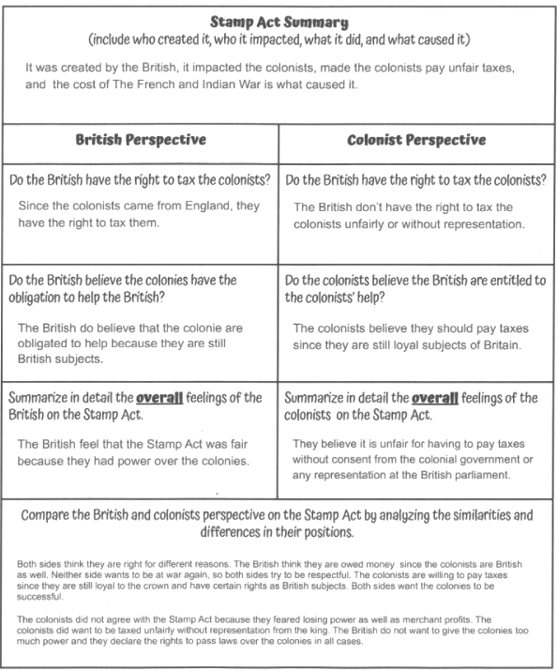

Now that students have analyzed sources to compare the perspectives of the British and the American Colonists on the Stamp Act, they will examine the role conflict and collaboration surrounding the Stamp Act played in the founding of the United States.

Investigation: Part 4

5.H.CO.1 Analyze the role conflict and collaboration played in the founding of the United States.

In order to investigate how the conflict and collaboration surrounding the Stamp Act played a role in the founding of the United States, the following sources may be utilized:
- Digital Public Library of America. (1895). The Stamp Act. https://dp.la/primary-source-sets/road-to-revolution-1763-1776/sources/2.
- History.com Editors. (2019). Parliament Repeals the Stamp Act. https://www.history.com/this-day-in-history/parliament-repeals-the-stamp-act.
- Resolutions of the Stamp Act Congress. (1765, October 19). Teaching American History. https://teachingamericanhistory.org/document/resolutions-of-the-stamp-act-congress-2/.

Explain to students that they begin by investigating the Colonists’ reaction to the Stamp Act. Ask students to access the excerpt from the source Stamp Act (Source D), below:

Colonists React to the Stamp Act
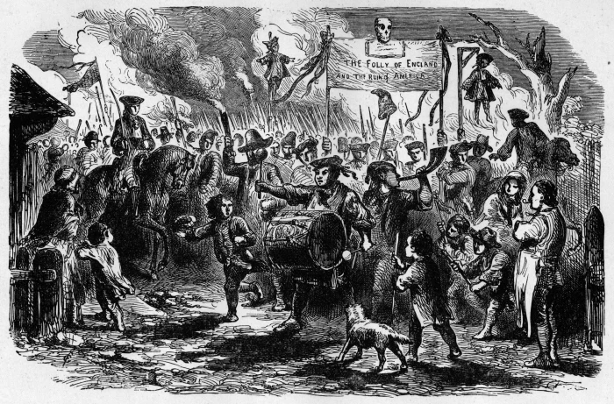
An angry mob protest against the Stamp Act by carrying a banner reading 'The Folly of England, the Ruin of America' through the streets of New York. MPI/Getty Images

Parliament pushed forward with the Stamp Act in spite of the colonists’ objections. Colonial resistance to the act mounted slowly at first, but gained momentum as the planned date of its implementation drew near. In Virginia, Patrick Henry (1736-99), whose fiery orations against British tyranny would soon make him famous, submitted a series of resolutions to his colony’s assembly, the House of Burgesses. These resolutions denied Parliament’s right to tax the colonies and called on the colonists to resist the Stamp Act.

Newspapers throughout the colonies reprinted the resolutions, spreading their radical message to a broad audience. The resolutions provided the tenor for the proclamations of the Stamp Act Congress, an extralegal convention composed of delegates from nine colonies that met in October 1765. The Stamp Act Congress wrote petitions to the king affirming both their loyalty and the conviction that only the colonial assemblies had the constitutional authority to tax the colonists.

While the Congress and the colonial assemblies passed resolutions and issued petitions against the Stamp Act, the colonists took matters into their own hands. The most famous popular resistance took place in Boston, where opponents of the Stamp Act, calling themselves the Sons of Liberty, enlisted the rabble of Boston in opposition to the new law. This mob paraded through the streets with an effigy of Andrew Oliver, Boston’s stamp distributor, which they hanged from the Liberty Tree and beheaded before ransacking Oliver’s home. Oliver agreed to resign his commission as stamp distributor.

Similar events transpired in other colonial towns, as crowds mobbed the stamp distributors and threatened their physical well-being and their property. By the beginning of 1766, most of the stamp distributors had resigned their commissions, many of them under duress. Mobs in seaport towns turned away ships carrying the stamp papers from England without allowing them to discharge their cargoes. Determined colonial resistance made it impossible for the British government to bring the Stamp Act into effect. In 1766, Parliament repealed it.

Before reading the excerpt, ask students to analyze the drawing at the beginning. Some questions to guide their analysis may include:

• Who are the people in this image?
• What are they doing, and why?
• Where are they?
• What are they holding in the air?
• What other objects do you see?
• What emotions are present? Support your answer with descriptions from the image.
• What else do you notice about this image?

Explain to students that this image depicts the colonists rioting in protest of the Stamp Act. The dummy visible to the right of the banner is meant to represent a tax collector and serve as a threat. Read the text together as a class, utilizing the Chunking strategy by pausing after each paragraph to summarize it to support comprehension. Then, ask students to conduct a Think, pair, share to respond to the following question:

How did conflict result from the Stamp Act and the opposing viewpoints of the British and the colonists? Cite evidence from the source.

After pairs have had time to discuss, allow them to share out during a class discussion.

Next, explain to students that collaboration also emerged in light of the Stamp Act. Investigate the primary source language of the Resolutions of the Stamp Act Congress of 1765 (Source E), excerpted below:

Saturday, Oct. 19th, 1765, A.M.—The congress met … and upon mature deliberation, agreed to the following declarations of the rights and grievances of the colonists in America….

The members of this congress, sincerely devoted, with the warmest sentiments of affection and duty, to his majesty’s person and government; inviolably attached to the present happy establishment of the Protestant succession [to the throne], and with minds deeply impressed by a sense of the present and impending misfortunes of the British colonies on this continent; having considered as maturely as time would permit, the circumstances of the said colonies, esteem it our indispensable duty to make the following declarations, of our humble opinion, respecting the most essential rights and liberties of the colonists, and of the grievances under which they labor, by reason of several late acts of Parliament.

1st. That his majesty’s subjects in these colonies, owe the same allegiance to the crown of Great Britain, that is owing from his subjects born within the realm, and all due subordination to that august body, the parliament of Great Britain.

2d. That his majesty’s liege[1] subjects in these colonies are entitled to all the inherent rights and privileges of his natural born subjects within the kingdom of Great Britain.

3d. That it is inseparably essential to the freedom of a people, and the undoubted rights of Englishmen, that no taxes should be imposed on them, but with their own consent, given personally, or by their representatives.

4th. That the people of these colonies are not, and from their local circumstances cannot be, represented in the House of Commons in Great Britain.

5th. That the only representatives of the people of these colonies, are persons chosen therein, by themselves; and that no taxes ever have been, or can be constitutionally imposed on them, but by their respective legislatures.

6th. That all supplies to the crown, being free gifts of the people, it is unreasonable and inconsistent with the principles and spirit of the British constitution, for the people of Great Britain to grant to his majesty the property of the colonists.

7th. That trial by jury is the inherent and invaluable right of every British subject in these colonies.[2]

8th. That the late act of Parliament, entitled, An act for granting and applying certain stamp duties, and other duties in the British colonies and plantations in America, etc.,[3] by imposing taxes on the inhabitants of these colonies, and the said act, and several other acts, by extending the jurisdiction of the courts of admiralty beyond its ancient limits, have a manifest tendency to subvert the rights and liberties of the colonists.

9th. That the duties imposed by several late acts of Parliament, from the peculiar circumstances of these colonies, will be extremely burdensome and grievous, and from the scarcity of specie,[4] the payment of them absolutely impracticable.

10th. That as the profits of the trade of these colonies ultimately center in Great Britain, to pay for the manufactures which they are obliged to take from thence,[5] they eventually contribute very largely to all supplies granted there to the crown.

11th. That the restrictions imposed by several late acts of parliament, on the trade of these colonies, will render them unable to purchase the manufactures of Great Britain.

12th. That the increase, prosperity, and happiness of these colonies, depend on the full and free enjoyment of their rights and liberties, and an intercourse, with Great Britain, mutually affectionate and advantageous.

13th. That it is the right of the British subjects in these colonies to petition the king or either house of Parliament.

Lastly, That it is the indispensable duty of these colonies to the best of sovereigns, to the mother country, and to themselves, to endeavor, by a loyal and dutiful address to his majesty, and humble application to both houses of Parliament, to procure the repeal of the act for granting and applying certain stamp duties, of all clauses of any other acts of Parliament, whereby the jurisdiction of the admiralty is extended as aforesaid, and of the other late acts for the restriction of the American commerce.

The language may be difficult for students to understand, so consider repeating the Chunking strategy here. Read each paragraph together as a class, look up any challenging and unknown vocabulary and annotate the text to provide synonyms. Summarize each paragraph together and add this summary to your annotations to support students with comprehension. Support students in creating a one sentence topic summary for each paragraph, and record this sentence so it is visible to students. As you read and discuss together, ensure that students understand that the colonists are officially denouncing the Stamp Act and explaining why it is unfair. Ask students to identify and underline evidence of this from the text.

After you have finished discussing and summarizing the document with students, emphasize and revisit the third item, asking students do the following:

Reread the third item on the Stamp Act Resolution:

“3rd That it is inseparably essential to the Freedom of a People, and the undoubted Rights of Englishmen, that no taxes should be imposed on them, but with their own Consent, given personally, or by their Representatives.”

Think, pair, share with a partner to discuss this line and its meaning.

After the pairs have had time to discuss, discuss as a class. Emphasize that “taxation without representation” is the main argument given throughout this time period in opposition to British rule and it appears clearly as one of the arguments of the Colonists against the Stamp Act.

Explain to students that collaboration among the colonists led to the repeal of the Stamp Act only a year later. Have students read the Repeal of the Stamp Act (Source F), below. Ask students to annotate the text by identifying evidence of collaboration as they read.

Parliament repeals the Stamp Act

After four months of widespread protest in America, the British Parliament repeals the Stamp Act, a taxation measure enacted to raise revenues for a standing British army in America.

The Stamp Act was passed on March 22, 1765, leading to an uproar in the colonies over an issue that was to be a major cause of the Revolution: taxation without representation. Enacted in November 1765, the controversial act forced colonists to buy a British stamp for every official document they obtained. The stamp itself displayed an image of a Tudor rose framed by the word “America” and the French phrase Honi soit qui mal y pense–“Shame to him who thinks evil of it.”

The colonists, who had convened the Stamp Act Congress in October 1765 to vocalize their opposition to the impending enactment, greeted the arrival of the stamps with outrage and violence. Most Americans called for a boycott of British goods, and some organized attacks on the customhouses and homes of tax collectors. After months of protest, and an appeal by Benjamin Franklin before the British House of Commons, Parliament voted to repeal the Stamp Act in March 1766. However, the same day, Parliament passed the Declaratory Acts, asserting that the British government had free and total legislative power over the colonies.

After reading this text, ask students to consider the role collaboration played in the Stamp Act ultimately being repealed. Ask students to do a Quick Write to individually respond to the following prompt:

Why was collaboration among the colonists effective and essential in order for the Stamp Act to be repealed?

Below is a student sample response from a Kentucky classroom:

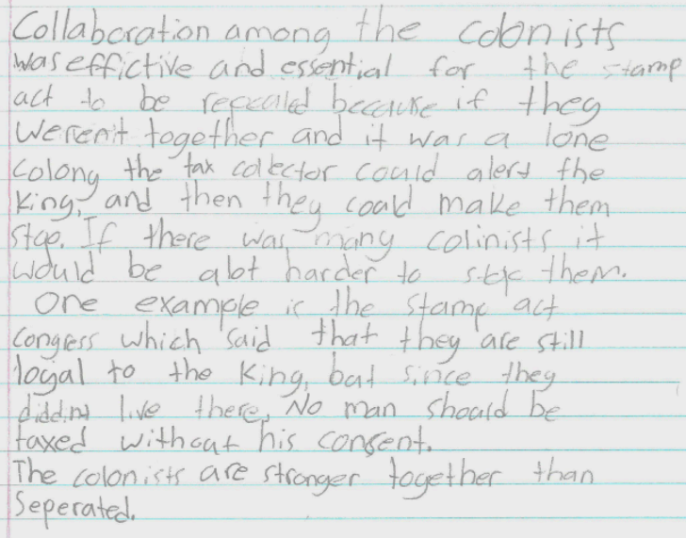

Then, discuss as a class, checking to ensure that students understand the role of collaboration among the Colonists in the Stamp Act’s ultimate repeal.

Finally, it is important for students to understand why the colonists were angry over the Stamp Act, which increased tension between the British and the colonists that eventually led to war. Circle back to the first assignment where students investigated the purpose and intended benefit of taxation. As a class, discuss the following:

Reference the class statement developed in the previous investigation about the purpose of taxation and examples of services from tax revenue that benefit citizens and their community.

Was the British government using (revenue) from the taxes imposed by the Stamp Act to provide goods and services for the colonists? How did this impact the colonists? Cite information from what you have learned to support your response.

After discussing this question with students, explain that the Stamp Act was one of a series of events that caused the American Revolution. Ask students to consider the Stamp Act’s role in causing the American Revolution, using everything they have learned and discussed throughout these assignments, as they answer the supporting question in the assignment below.

Task Aligned to the Supporting Question:
KAS for Social Studies alignment:
- 5.I.Q.2 Generate supporting questions to answer compelling questions about the founding of the United States
- 5.E.MA.1 Describe why the government collects taxes and what goods and services it provides society.
- 5.H.CO.1 Analyze the role conflict and collaboration played in the founding of the United States.
- 5.I.UE.3 Integrate evidence that draws information from multiple sources to answer compelling and supporting questions.

In these assignments, students are required to synthesize information learned through engaging with the disciplinary strand standards to answer a supporting question.

Task Aligned to the Supporting Question:
Construct an argument to answer the following question: “Why did the colonists demand no taxation without representation?”

In your response, be sure to do the following:
- Use your knowledge of why the government collects taxes and what goods and services it provides society.
- Use your knowledge of the role conflict and collaboration played in the founding of the United States.
- Integrate evidence that draws evidence from multiple sources.

To support students in preparing for this task, first read and discuss the prompt as a class, clarifying any challenging vocabulary and checking for understanding. Encourage students to revisit sources from the previous investigations and the work they previously completed, such as the graphic organizer on the British and American Colonists’ perspectives and the Quick Write to help them prepare their responses, support and evidence for this task. Provide students with the opportunity to plan for their response with a graphic organizer such as the one below:

Why did the colonists demand no taxation without representation?
Claim:
Support #1: | Support #2: | Support #3:
Evidence for Support #1: | Evidence for Support #2: | Evidence for Support #3:

Explain to students that they should develop a claim that answers the supporting question. They must also identify support for their claim and evidence from the sources. Ask students to identify the source from which their evidence came when completing this section of the graphic organizer. After students have had the opportunity to complete their pre-writing, ask students to complete the task aligned to the supporting question by developing a written response in paragraph form.

After students have drafted their responses, give students the opportunity to provide feedback for their peers. Provide the following questions for peers to ask one another as they review each other’s work:

- Did you provide information on why the government collects taxes and what goods and services it provides society to develop a claim?
- Did you provide information on the role conflict and collaboration played in the founding of the United States to develop a claim?
- Did you integrate and cite evidence that draws evidence from multiple sources in your response?
- Did you develop a claim with evidence to answer the supporting question, “Why did the colonists demand no taxation without representation?”

For more information on feedback in the social studies classroom, visit KDE’s Evidence-Based Instructional Practices 6: Social Studies.

Student Work Samples:
Below are student work samples from Kentucky classrooms of the Task Aligned to the Supporting Question.

Strongly Aligned Example

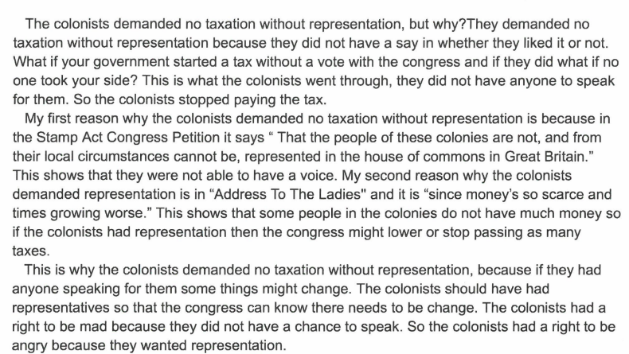

Partially Aligned Example

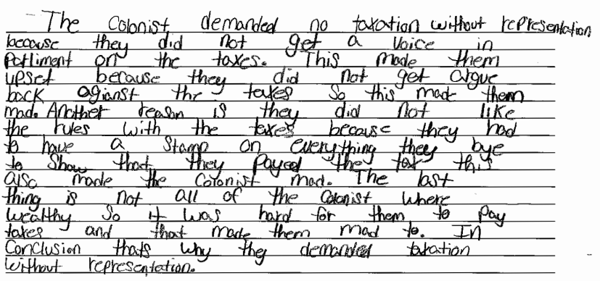

Weakly Aligned Example

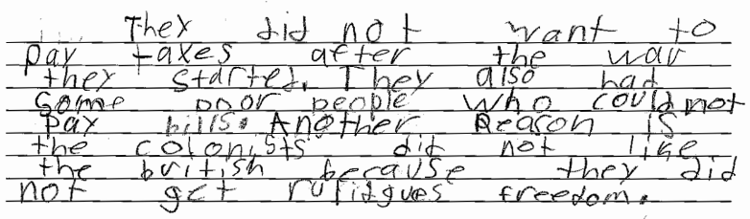

Task Aligned to the Compelling Question:

KAS for Social Studies alignment:
- 5.I.Q.1 Ask compelling questions about the founding of the United States.
- 5.I.UE.3 Integrate evidence that draws information from multiple sources to answer compelling and supporting questions.
- 5.I.CC.3 Explain different approaches people can take to address local, regional and global
- problems, using examples from U.S. history.

Assignments aligned to the compelling question are designed to provide guidance on how to have students synthesize the knowledge learned from engaging with the supporting question(s) to investigate enduring and significant unresolved issues addressed by the compelling question. In this example, one supporting question is provided that is aligned to a compelling question. However, students may need to engage with more than one supporting question in order to fully engage with a compelling question. This assignment culminates with students using their historical thinking skills to address how a specific problem can manifest itself at local, regional and global levels over time.

This assignment culminates with students using their historical thinking skills to explain the different approaches people take to address problems on different scales. When answering the compelling question, students could use their knowledge of all of the events that caused the American Revolution to explain how people addressed problems at each scale. For example: local problems were addressed through Boston’s port being blockaded and other colonies coming to their aid by land; the impact these events had on the region of New England since they were the most directly affected; and how these events impacted global trade based on the monopoly created by Great Britain by only allowing trade with them.

Compelling Question:
“What unites Americans?”

Construct an argument to answer the following question: What unites Americans? Be sure to explain different approaches people can take to address local, regional and global problems, using examples from U.S. history. Integrate evidence that draws from multiple sources in your response.

All valid claims must be based on logical evidence. In order for students to construct coherent arguments and explanations using their understanding of the social studies disciplines, they must understand how to substantiate those claims using evidence. This skill requires students to collect, evaluate and synthesize evidence from primary and secondary sources to develop and support a claim. In order for students to successfully complete this task, they will need to investigate additional supporting questions aligned to the compelling question.

