Grade 5 Social Studies Assignment
This assignment is weakly aligned to the standards.

Sample student assignments are being used to illustrate weak, partial and strong alignment to the Kentucky Academic Standards (KAS) for Social Studies. This assignment with included resource(s) is merely an example. It is not a requirement nor a suggestion for school curriculum. While the Kentucky Department of Education (KDE) is responsible for the development of high-quality academic standards, state law assigns each local district the authority to develop the school’s curriculum and determine appropriate instructional resources based on language found in Kentucky Revised Statute (KRS) 160.345. It is under the discretion of the superintendent to determine the local curriculum, including the evaluation and selection of instructional resources. The KDE does not adopt, select or recommend specific curricula for coursework. Per KRS 160.345(g), “the local superintendent shall determine which curriculum, textbooks, instructional materials, and student support services shall be provided in the school after consulting with the local board of education, the school principal, and the school council and after a reasonable review and response period for stakeholders in accordance with local board of education policy.”

To examine why this assignment is weakly aligned to the KAS for Social Studies, engage with the Grade 5 Assignment Review Protocol for this assignment.

Overview:
Students will read an article about George Washington and answer the questions that follow.

Kentucky Academic Standards (KAS) for Social Studies standards alignment:
- 5.H.CE.1 Analyze the causes of the American Revolution and the effects individuals and groups had on the conflict.
- 5.C.CP.1 Analyze the development and establishment of the U.S. federal government.

Source:
George Washington

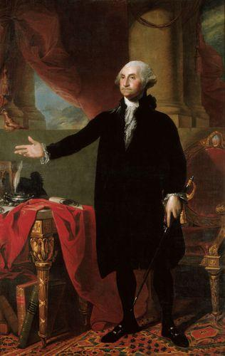
George Washington guided America and helped it evolve into the nation that it is today. This caused him to be known as the “Father of Our Country”. Washington was the leader of the Continental Army before he was President. He led America to victory over the British in the Revolutionary War, which won American independence. The United States Constitution was drafted after the war ended, and Washington played a role in deciding what would be in this document at the Constitutional Convention. His leadership helped give confidence to Americans that they could be a successful country.
In the early years of America, the country was small and weak. At the beginning of Washington’s Presidency, there were 11 states. There were 16 states by the end. The country was also much smaller. It did not go beyond the Mississippi River. Most people did not go to school and instead worked as farmers to try to make a living, but many struggled to get by. Most people were also unable to read or write, or were illiterate. This made communication difficult. Because they did not have cars, transportation was slow. It would take days to reach nearby cities.
George Washington was loved by most Americans. He never gave up when he served as a General in the Continental Army. During brutal winters where many troops were starving and sick, he did not give up. The officers in the Army loved Washington so much that they thought he should be King. He did become the first President, though.
George Washington is still honored today. His face is shown on the quarter and dollar bill. Washington state and Washington, D.C., which is the capital of our country, are named after him. The bridge located where Washington crossed the Hudson River with his troops to defeat the British is named after him. One of his officers said, “He was first in war, first in peace, and first in the hearts of his countrymen.” This sums up the importance of George Washington to United States history.

Assignment:
Students will read an article entitled, “George Washington” and answer the corresponding questions.
Questions: After reading the article entitled, “George Washington,” answer the following questions:
- What is the main idea of this passage?
  - How George Washington is still honored today.
  - How George Washington was the “Father of our Country”
  - How George Washington won the Revolutionary War.
  - How George Washington wanted to be King.
- In what war did George Washington fight?
- Civil War
- Revolutionary War
- French Revolution
- Vietnam War

- America has changed a lot over time. What detail in the passage supports this?
- George Washington is still honored today.
- Because they did not have cars, transportation was slow.
- This caused him to be known as the “Father of our country”.
- During brutal winters where many troops were starving and sick, he did not give up.

- Look at the underlined word, illiterate, in the passage. Using context clues, what does this word mean?

- Choose the word that would best complete this sentence: Cars were not invented yet, ____ transportation was slow.
- After
- Because
- And
- So

- What happened first in the sequence of events?
- George Washington became President.
- George Washington led the Continental Army.
- George Washington helped create the Constitution.

- What is the author’s purpose?
- To inform
- To persuade
- To entertain

