Fifth Grade Math Assignment
This assignment is strongly aligned to the standards.
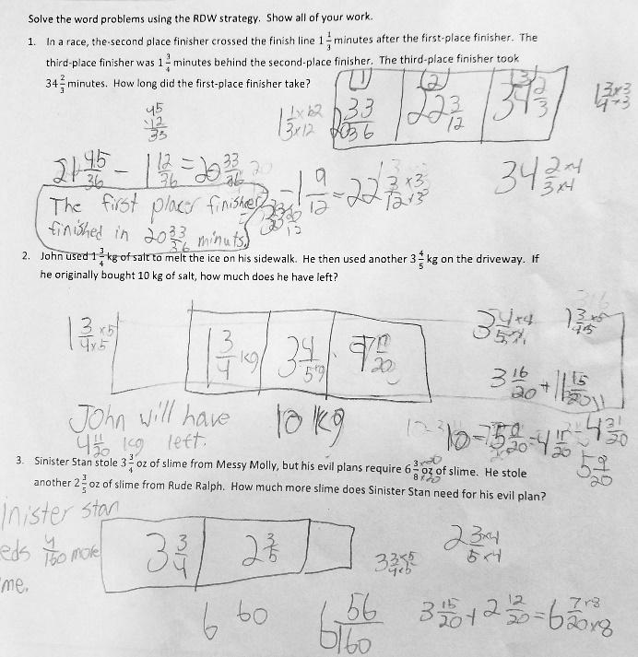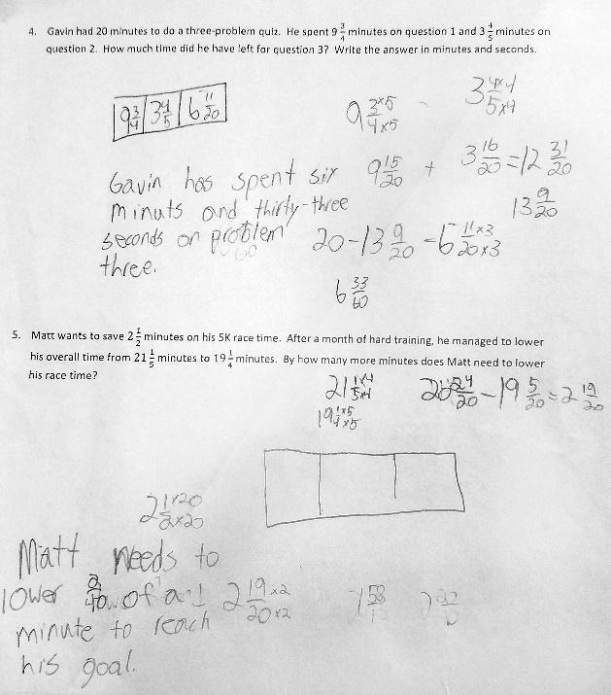

Overview
Fifth-grade students solve word problems involving subtraction of mixed fractions with unlike denominators. This assignment is strong because it requires students to interpret real-world scenarios and represent and solve them mathematically, while giving students practice with grade-level operations with fractions.

Related Standards
We looked at how well the assignment aligned to the following standards:
KY.5.NF.1 Efficiently add and subtract fractions with unlike denominators (including mixed numbers) by
a. using reasoning strategies, such as counting up on a number line or creating visual fraction models
b. finding common denominators
KY.5.NF.2 Solve word problems involving addition and subtraction of fractions.
a. Solve word problems involving addition and subtraction of fractions referring to the same whole, including cases of unlike denominators.
b. Use benchmark fractions and number sense of fractions to estimate mentally and assess the reasonableness of answers.

Why is this assignment strongly aligned?
This assignment is well-aligned with fifth-grade standard KY.5.NF.2. The standard requires students to solve word problems involving addition and subtraction of fractions, including fractions with unlike denominators, and this assignment contains multi-step word problems about subtracting fractions with unlike denominators. Standard KY.5.NF.1 also requires that students represent problems visually or symbolically. The lesson that accompanied this assignment used tape diagrams to represent problems visually and the directions for this assignment prompted students to use the read-draw-write (RDW) strategy to solve each problem.
This assignment builds students’ application skills, outlined in standard KY.5.NF.2. The standard calls for students to solve word problems involving addition and subtraction of fractions, and all five problems in this assignment are word problems that involve real-world situations. Standard KY.5.NF.1 also indirectly targets conceptual understanding because it requires students to represent problems visually and symbolically. The directions for the assignment asked students to represent each word problem with a drawing, which builds students’ conceptual understanding of fractional size as it relates to the same whole.

Practice Standards
This assignment allows students to engage with two mathematical practice standards. Interpreting what the word problems are asking them to do gives students the chance to engage with Mathematical Practice Standard #1 ("Make sense of problems and persevere in solving them"). Although all five problems involved subtraction, students had to determine how many steps were needed to solve each problem and the order in which they should be completed. The directions for the assignment also prompted students to create drawings to represent each real-world scenario, which gives students the chance to engage with Mathematical Practice Standard #4 ("Model with mathematics").

