5th Grade Reading & Writing Assignment
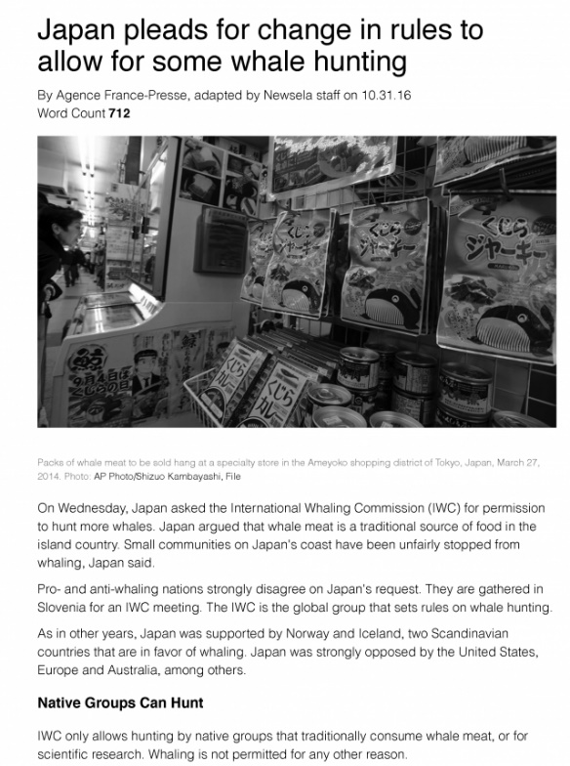
This assignment is strongly aligned to the standards.

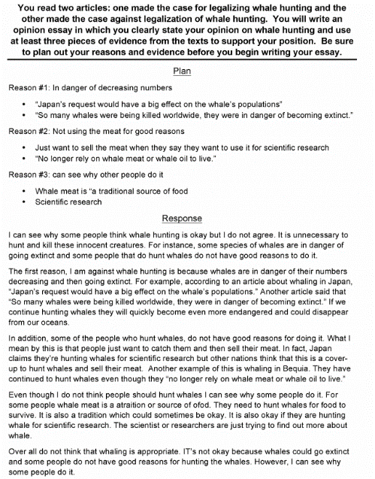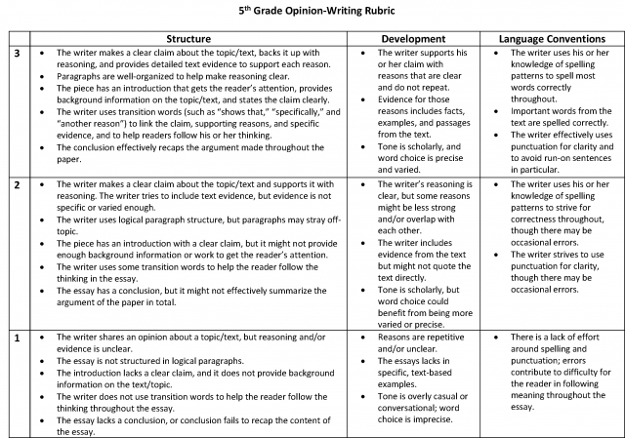

Overview
Fifth-grade students read worthwhile non-fiction texts on whale hunting, then write an argumentative essay. One text argues in favor of legalization, while the other argues against it, and students are required to use evidence from the texts to make a case for one of these positions. This assignment exposes students to content-rich non-fiction and requires students to draw on their learning from the texts to write a substantive, analytical essay. The task rubric outlines thorough expectations that are in line with fifth-grade writing and language standards.

About the Text

Title and Author | “Japan pleads for change in rules to allow for some whale hunting,” by Agence France-Presse
What is the Lexile Level of this text? | 900-1000
Based on Lexile, which grades is this text intended for? | 6-8
Is the text qualitatively complex enough for the grade? | Yes
Is this text fiction or non-fiction? | Non-Fiction
Is this text authentic or was it written for educational purposes? | Authentic
Does the text provide sufficient detail to build knowledge of a worthwhile topic and/or is it worth reading closely and re-reading? | Yes

Related Standards
RI.5.1: Quote accurately from a text when explaining what the text says explicitly and when drawing inferences from the text.
The assignment is strongly aligned to this standard. Students must refer extensively to key details in the text to substantiate their claims about whether or not whale hunting should be legal. The rubric stipulates that evidence must include “facts, examples, and passages from the text.”
RI.5.8: Explain how an author uses reasons and evidence to support particular claims in a text, identifying which reasons and evidence support which claim(s).
The assignment is strongly aligned to this standard. The task requires that students effectively break down the arguments in each piece, identifying author’s point of view and reasoning, in order to compose their own.
C.5.1: Compose opinion pieces, using writing and digital resources, on topics or texts, supporting the writer’s perspective with reasons and information. a. Produce clear and coherent writing in which the development and organization are appropriate to task, purpose and audience. b. Introduce a topic or text clearly, state an opinion and create an organizational structure in which ideas are logically grouped to support the writer’s purpose. c. Provide logically ordered reasons that are supported by facts and details.
The assignment is strongly aligned to this standard. The writing prompt gives students opportunity to articulate a claim about whale hunting and support it with evidence. The rubric outlines clear, fifth-grade-level essay expectations: introduction, logically ordered reasons, effective transitions, and conclusion.
L.5.1: When writing or speaking, demonstrate command of the conventions of standard English grammar and usage.
The assignment is strongly aligned to this standard. Students must demonstrate their command of fifth-grade-level language conventions in the writing piece. The rubric explicitly names the avoidance of run-on sentences as criteria for a strong essay.
L.5.2: When writing: a. Use punctuation to separate items in a series; b. Use a comma to separate an introductory element from the rest of the sentence; c. Use a comma to set off the words yes and no, to set off a tag question from the rest of the sentence and to indicate direct address.
The assignment is strongly aligned to this standard. Students must demonstrate their command of fifth-grade-level language conventions in the writing piece. Students must demonstrate their command of fifth-grade-level language conventions in the writing piece. The rubric explicitly names punctuation as criteria for a strong essay.
Why is this assignment strongly aligned?
The assignment exposes students to grade-appropriate non-fiction texts. The texts are opinion pieces on the harms and benefits of whale hunting, published by reputable news outlets. They give students a nuanced picture of a worthwhile environmental and ethical question.
Students are required to read carefully and focus on the key details. Students must understand each author’s point of view, and they must select relevant passages from the texts to support a claim.
Students are required to share what they learned in writing. Students articulate an independent idea about whether or not they think whale hunting should be legal and must support that idea with specific evidence.
Through their written responses, students gain practice with argumentative writing. Students must make a claim, support it with evidence, and organize their thoughts in a logical introduction-body-conclusion format. The rubric outlines clear expectations for both the substance of the writing and adherence to grade-level language conventions.

