Fifth Grade Math Assignment
This assignment is partially aligned to the standards.
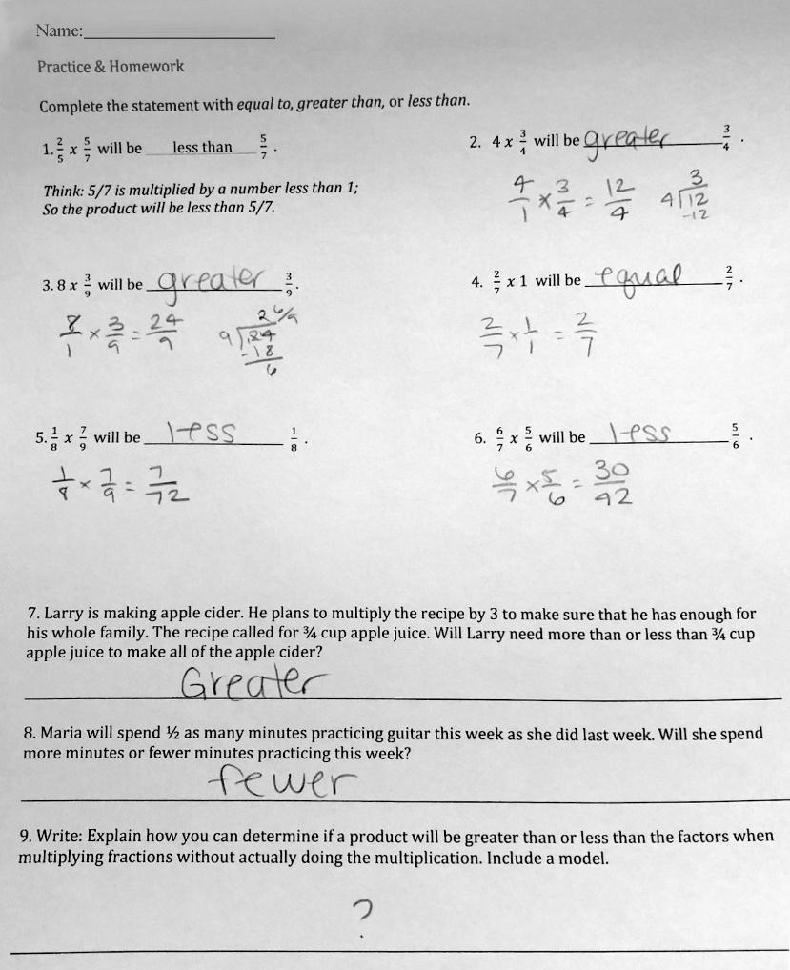

Overview
Fifth-grade students identify whether multiplication problems involving at least one fraction will result in a product greater than, less than, or equal to one of the factors. This assignment is partially aligned with a fifth-grade standard because it involves interpreting the products of whole numbers and fractions, but it only superficially builds students’ conceptual understanding of multiplication as scaling or resizing.

Related Standards
We looked at how well the assignment aligned to the following standard:

KY.5.NF.5 Interpret multiplication as scaling (resizing), by:
- Comparing the size of a product to the size of one factor on the basis of the size of the other factor, without performing the indicated multiplication.
- Explaining why multiplying a given number by a fraction greater than 1 results in a product greater than the given number (recognizing multiplication by whole numbers greater than 1 as a familiar case); explaining why multiplying a given number by a fraction less than 1 results in a product smaller than the given number; and relating the principle of fraction equivalence a/b = (n x a)/(n x b) to the effect of multiplying a/b by 1.

Why is this assignment partially aligned?
The content of this assignment aligns with fifth-grade standard KY.5.NF.5, which requires students to multiply fractions with both whole numbers and with other fractions, and to compare the size of the product to the size of the factors.
The assignment problems provide two factors and ask students to interpret whether the product will be greater than, less than, or equal to one of the factors without actually doing the multiplication (as standard KY.5.NF.5A requires). The assignment includes the appropriate types of numbers, with five problems that involve multiplying a whole number by a fraction and three problems that involve multiplying a fraction by a fraction.
The assignment also asks students to explain how to determine if the product of a multiplication problem involving fractions will be greater or less than the factors (as standard KY.5.NF.5.B requires).
This assignment attempts to build students’ conceptual understanding (required by standard KY.5.NF.5) of multiplication as scaling or resizing, but it does so in a superficial way.
To prepare fifth-grade students to work with ratios and proportional reasoning in sixth grade, they must learn to see multiplication (for example, 3 x ½) in terms of a quantity (3) and a scaling factor (½) and to interpret products in terms of scaling (3 x ½ is half the size of 3).
Students were exposed to the related concept of multiplicative comparison in fourth grade (standard KY.4.OA.1), but fifth-grade students build upon that understanding by using fractions as both quantities and scaling factors. Students should know that multiplying a quantity by a fraction smaller than one produces a smaller quantity (8 x 3/9 < 8), and multiplying a quantity by a fraction equivalent to one leaves a quantity unchanged (8 x 9/9 = 8).
This assignment is structured in such a way that students can complete it procedurally by following a pattern rather than truly demonstrating understanding of the concept of multiplication as scaling: most of the problems follow the same fill-in-the-blank structure as the example in problem #1, so students only have to identify whether one of the factors is a fraction or a whole number and then write “less than” or “greater than” in the corresponding blank.
Practice Standards
This assignment allows students to superficially engage with two mathematical practice standards. Asking students to explain how to determine if the product of a multiplication problem involving fractions will be greater or less than the factors gives students the chance to engage with Mathematical Practice Standard #3 (“Construct viable arguments and critique the reasoning of others”) and Mathematical Practice Standard #6 (“Attend to precision”), but students should be doing this in the context of actual multiplication problems, not in isolation.
There is limited space provided on the worksheet for the model and explanation that students are directed to include in problem #9, which indicates that students are only expected to provide a simple explanation and keeps them from deeply engaging with the mathematical practice standards.

