5th Grade Reading & Writing Assignment
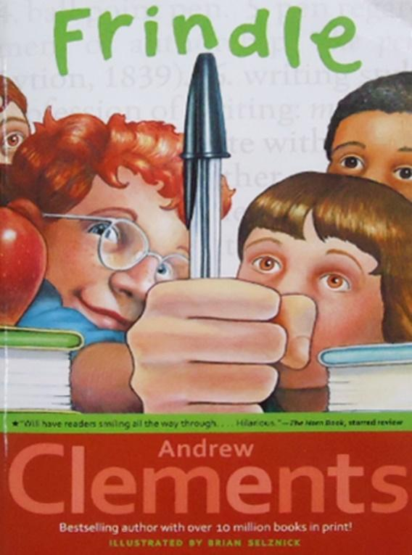
This assignment is weakly aligned to the standards.
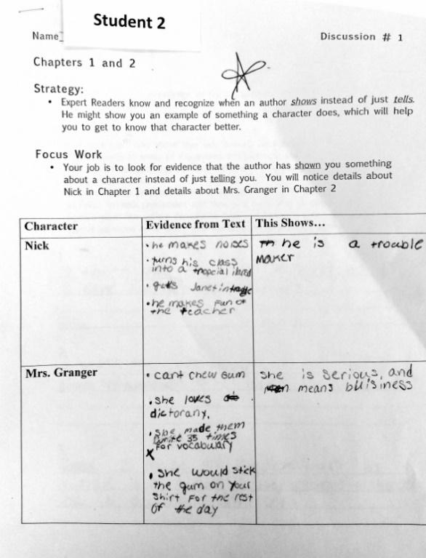
Overview
Fifth-grade students read the first two chapters of "Frindle," a novel by Andrew Clements, then fill out a chart that describes the actions of two main characters, as well as what these actions suggest about the characters. While the text is grade-appropriate, the accompanying task does not give students an opportunity to write substantively about either character, nor to make comparisons between characters. Instead, students are only required to jot brief descriptive phrases about the characters. There is no expectation that they use evidence from the text to support their descriptions.

About the Text

Title and Author | "Frindle" by Andrew Clements
What is the Lexile Level of this text? | 830
Based on Lexile, which grades is this text intended for? | 4-5
Is the text qualitatively complex enough for the grade? | Yes
Is this text fiction or non-fiction? | Fiction
Is this text authentic or was it written for educational purposes? | Authentic
Does the text provide sufficient detail to build knowledge of a worthwhile topic and/or is it worth reading closely and re-reading? | Yes

Related Standards

RL.5.1: Quote accurately from a text when explaining what the text says explicitly and when drawing inferences from the text.
The assignment is weakly aligned to this standard. Students make inferences about the characters’ qualities based on their behaviors in the story. But the task does not capture the more critical part of this standard: drawing on specific language from the text to support inferences.

RL.5.2: Analyze how the theme is reflected in the text, including but not limited to poems, stories and dramas, and cite relevant implicit and explicit evidence to support thinking.
The assignment is weakly aligned to this standard. The assignment concerns the characters, and potentially how they respond to challenge (if students choose to discuss this). But it misses the mark on the substance of this standard, which is making connections between the characters and the story’s larger themes.

RL.5.3: Compare/contrast characters, settings or events in a story or drama, using specific details to analyze their interaction over the course of the text.
The assignment is weakly aligned to this standard. Again, though the task focuses students on the characters, it does not prompt them to compare/contrast characters or other story elements.

Why is this assignment weakly aligned?
This assignment is weakly aligned because although the text is strong, but the questions are not:
The assignment exposes students to a grade-appropriate text. "Frindle" is realistic fiction that is likely to be engaging and accessible to many fifth-grade readers.
Students are not required to carefully analyze the characters in the text, making connections between the characters and the larger themes in the text or comparing and contrasting the characters. Students are only asked to fill out a graphic organizer with events from the text that suggest certain traits in the main characters, then name these traits with a few brief words and phrases.
Students have no opportunity to use evidence from the text. The task does not require students to substantiate their ideas about the characters or use evidence to support those ideas, a critical fifth-grade literacy skill.

