5th Grade Reading and Writing Assignment
This assignment is weakly aligned to the standards.

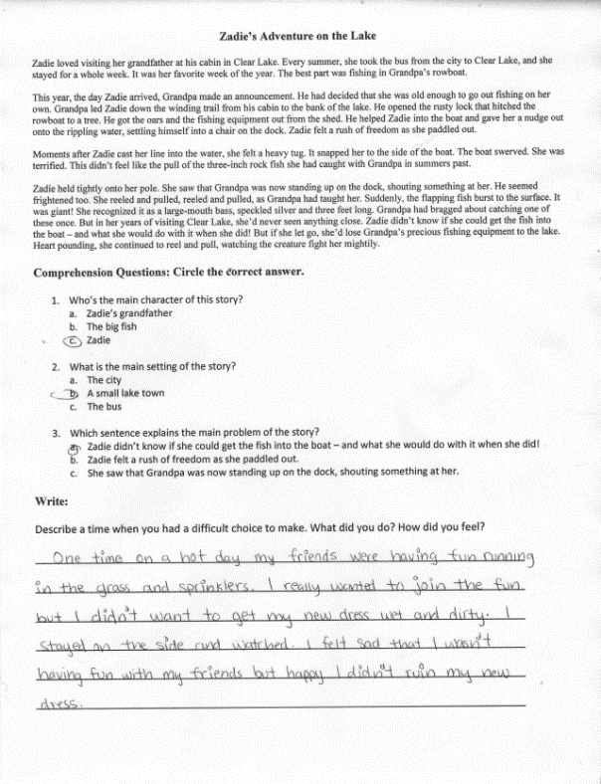
Overview
Fifth-grade students read an excerpt from a story called “Zadie’s Adventure on the Lake,” then answer basic multiple-choice questions. The text is below grade-level, and the excerpt is too brief to give students a strong sense of the complete narrative or to demand significant analysis. The questions ask students to identify the story’s main character, setting, and problem, and the writing prompt asks them to discuss a personal connection to the text (“Describe a time when you had a difficult choice to make”).

ABOUT THE TEXT

Title and Author | "Zadie’s Adventure on the Lake"
What is the Lexile Level of this text? | 700
Based on Lexile, which grades is this text intended for? | 2-3
Is the text qualitatively complex enough for the grade? | No
Is this text fiction or non-fiction? | Fiction
Is this text authentic or was it written for educational purposes? | Authentic
Does the text provide sufficient detail to build knowledge of a worthwhile topic and/or is it worth reading closely and re-reading? | No

Related Standards
RL.5.1: Quote accurately from a text when explaining what the text says explicitly and when drawing inferences from the text.
The assignment is weakly aligned to this standard. The third multiple choice question, which asks students to identify the main problem of the story, requires some degree of inference. But the question does not capture the more critical part of this standard, which is quoting the text to support inferences.
RL.5.2: Analyze how the theme is reflected in the text, including but not limited to poems, stories and dramas, and cite relevant implicit and explicit evidence to support thinking.
The assignment is weakly aligned to this standard. The third multiple choice question also gets at the main idea of the text – but it does not require students to explain larger themes or summarize the text independently.
RL.5.3: Compare/contrast characters, settings or events in a story or drama, using specific details to analyze their interaction over the course of the text.
The assignment is weakly aligned to this standard. The questions focus superficially on characters, setting and events, but not at the level of depth and rigor intended by this standard. There is no expectation of making comparisons among characters, setting or events; nor of drawing on specific details from the text.
L.5.1: When writing or speaking, demonstrate command of the conventions of standard English grammar and usage.
The assignment is weakly aligned to this standard. There is some opportunity to practice with language conventions, as students write a brief paragraph about their own experiences with difficult choices. But given the disconnection of this writing prompt from any meaningful, grade-level reading, the opportunity to demonstrate command of 5th grade-level language conventions is limited.
L.5.2: When writing: a. Use punctuation to separate items in a series; b. Use a comma to separate an introductory element from the rest of the sentence; c. Use a comma to set off the words yes and no, to set off a tag question from the rest of the sentence and to indicate direct address; d. Use underlining, quotation marks or italics to indicate titles of works; e. Use strategies and resources (print and electronic) to identify and correct spelling errors.
The assignment is weakly aligned to this standard. There is some opportunity to practice with language conventions, as students write a brief paragraph about their own experiences with difficult choices. But given the disconnection of this writing prompt from any meaningful, grade-level reading, the opportunity to demonstrate command of 5th grade-level language conventions is limited.
Why is this assignment weakly aligned?
The text is below grade-level and not worthwhile. It does not capture any significant content or cultural knowledge, and the excerpt is too brief for students to get a sense of the complete narrative.
The assignment does not allow students to engage in a literary analysis. Students only identify a few pieces of information from the text. They are asked to practice basic literacy skills, rather than engage in a close examination of a complex, worthwhile text.
Students are not required to draw on specific details from the text. The writing prompt asks students to reflect on a personal experience in loose connection with the content of this story. These generic questions could be applied to any fiction text and students are not required to use evidence from the text to support their ideas.

