Fifth Grade Math Assignment
This assignment is weakly aligned to the standards.
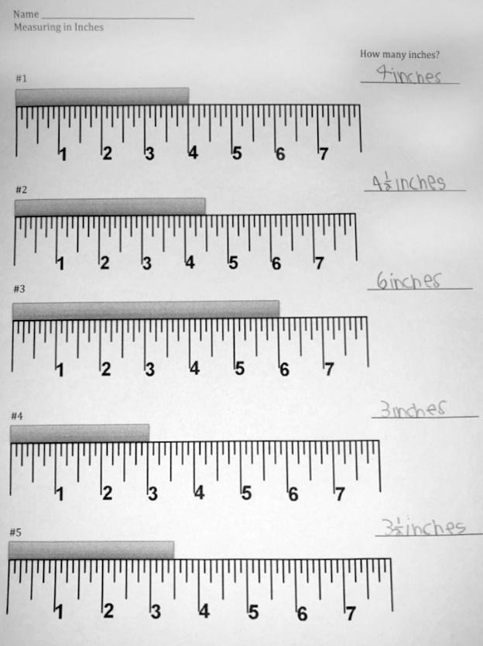

Overview
Fifth-grade students use a ruler to measure the length of several bars in inches. This assignment is weak because it is more closely aligned with second- and third-grade standards. There are no fifth-grade standards about measuring length.

Related Standards
We looked at how well the assignment aligned to the following standards:
KY.5.MD.1 Convert among different size measurement units (mass, weight, liquid volume, length, time) within one system of units (metric system, U.S. standard system and time).
KY.5.MD.5 Relate volume to the operations of multiplication and addition and solve real world and mathematical problems involving volume.
a. Find the volume of a right rectangular prism with whole number side lengths by packing it with unit cubes and show that the volume is the same as would be found by multiplying the edge lengths, equivalently by multiplying the height by the area of the base. Represent threefold whole-number products as volumes.

b. Apply the formulas V= l x w x h and V = B x h for rectangular prisms with whole-number edge lengths in the context of solving real world and mathematical problems.

c. Recognize volume as additive. Find volumes of solid figures composed of two non-overlapping right rectangular prisms by adding the volumes of the non-overlapping parts, applying this technique to solve real world problems.

Why is this assignment weakly aligned?
This assignment is not aligned with any fifth-grade standards. The only fifth-grade standards that relate to length require students to convert between different measurement units (standard KY.5.MD.1) and find the volume of right rectangular prisms using the (length x width x height) formula (standard KY.5.MD.5). This assignment only requires students to measure the length of several bars in inches and most closely aligns with second-grade standard KY.2.MD.1 (measure the length of an object by selecting and using appropriate tools such as rulers) and third-grade standard KY.3.MD.4.b (generate measurement data by measuring lengths using rulers marked with halves and fourths of an inch).

Practice Standards
In this assignment, students use rulers to measure length, which is related to Mathematical Practice Standard #5 ("Use appropriate tools strategically"). However, this is not a meaningful fifth-grade opportunity to use a tool because students are working with below-grade-level content, they don’t have to select which tool would be most appropriate to use given the objects to be measured, and the “objects” (pictures of bars) are all already positioned correctly with one edge aligned at the zero mark.

