Grade 6 Assignment
This assignment is strongly aligned to the standards.

Teacher Notes

Introduction
This Teacher Notes document provides instructional support for implementing the strongly aligned assignments to the KAS for Social Studies. To examine why this assignment is strongly aligned to the KAS for Social Studies, engage with the Grade 6 Assignment Review Protocol for this assignment.

It is important to note that the assignment(s), indicated throughout the Teacher Notes with shaded boxes, and related resource(s) represent one example. It is not a requirement nor a suggestion for school curriculum. While the Kentucky Department of Education (KDE) is responsible for the development of high-quality academic standards, state law assigns each local district the authority to develop the school’s curriculum and determine appropriate instructional resources based on language found in Kentucky Revised Statute (KRS) 160.345. It is under the discretion of the superintendent to determine the local curriculum, including the evaluation and selection of instructional resources. The KDE does not adopt or select specific curricula for coursework. Per KRS 160.345(g), “the local superintendent shall determine which curriculum, textbooks, instructional materials, and student support services shall be provided in the school after consulting with the local board of education, the school principal, and the school council and after a reasonable review and response period for stakeholders in accordance with local board of education policy.”

KAS for Social Studies alignment:
- 6.I.Q.1 Develop compelling questions related to the development of civilizations between 3500 BCE-600 CE.
- 6.I.Q.2 Generate supporting questions related to the development of civilizations between 3500 BCE-600 CE.
- 6.C.CP.1 Explain the origins, functions and structures of governments in River Valley Civilizations and Classical Period Empires between 3500 BCE-600 CE.
- 6.G.HE.1 Analyze how physical environments shaped the development of River Valley Civilizations and Classical Empires between 3500 BCE-600 CE.
- 6.G.GR.1 Use maps and other geographic representations, geospatial technologies, and spatial thinking to determine similarities and differences among River Valley Civilizations and Classical Empires between 3500 BCE-600 CE.
- 6.I.UE.1 Develop claims, citing relevant evidence, in response to compelling and supporting questions.
- 6.I.CC.2 Construct arguments, using claims and evidence from multiple credible sources, while acknowledging the strengths and limitations of the arguments, to address how a specific problem can manifest itself at local, regional and global levels over time.
- 6.I.CC.5 Describe a specific problem from the development of civilizations using each of the social studies disciplines.

Educators may have to engage with a standard multiple times throughout a year in order to meet the full intent of the standard. As a result, the following assignment example may not encompass the entire scope of the standards identified.

Overview:
Students will investigate four River Valley Civilizations to learn about how complex societies develop. To investigate the common characteristics among River Valley Civilizations, students will examine a variety of maps to determine similarities and differences in the geography of the River Valley Civilizations. Students will then take a deep dive into one of the four River Valley Civilizations, analyzing sources to discover how the physical environment shaped its development and its origins, functions and structures. Using the information they gathered, students will create a poster on their civilization and will take part in a gallery walk to learn about the other three River Valley Civilizations. This information will support students in answering the supporting question, “What characteristics do River Valley Civilizations have in common?”

Setting the Stage: Compelling Question

6.I.Q.1 Develop compelling questions related to the development of civilizations between 3500 BCE-600 CE.

Compelling Question: “How do complex societies develop?”

Compelling Questions
Compelling questions are open-ended, enduring and center on significant unresolved issues. It is important to note that while this assignment provides a compelling question to demonstrate alignment, student development of compelling questions is a critical part of the inquiry process. Since 6.I.Q.1 states “develop compelling questions,” teachers should provide opportunities for students to develop their own compelling questions, with teacher support, related to the development of civilizations between 3500 BCE-600 CE. For more information on compelling questions, visit Section B: “What are Compelling Questions and how do students ask them?” from the Inquiry Practices of the KAS for Social Studies module.

For guidance on how to support students in developing their own questions, teachers may implement strategies, such as Question Starts, to support students in developing their own questions. It is important to note that strategies, such as the Question Starts, helps students develop their own questions. However, teachers and students will need to evaluate the created questions to determine if the process elicited compelling questions or if the questions posed need to be revised to make them compelling. For example, a student may pose an open question that, with some additional revision, could become a compelling question about the development of civilizations between 3500 BCE-600 CE.

Prior to engaging with this supporting question, ensure that students are familiar with the characteristics of early civilizations by having them engage with the following article:

- Elshaikh, Eman M. (2017). Social, political, and environmental characteristics of early civilizations. Khan Academy. https://www.khanacademy.org/humanities/world-history/world-history-beginnings/birth-agriculture-neolithic-revolution/a/why-did-human-societies-get-more-complex.

It is important to note that this article may be excerpted, adapted and/or translated to meet the needs of students.

Facilitate a whole class discussion that uses the Overview from the article to engage in pre-reading strategies to increase student comprehension of the article. For guidance on how to conduct a whole class discussion, teachers may reference Leading a Discussion.

Overview
- The growth of agriculture resulted in intensification, which had important consequences for social organization.
- Larger groups gave rise to new challenges and required more sophisticated systems of social administration.
- Complex societies took the form of larger agricultural villages, cities, city-states, and states, which shared many features.
- Specialized labor gave rise to distinct social classes and enabled creative and innovative developments.
- Systems of record-keeping and symbolic expression grew more complex, and many societies had systems of writing.

In the whole class discussion, complete the following using the Overview excerpt:
- Build text specific knowledge by activating background knowledge.
- Relate the content to students’ lives.
- Explicitly teach and model vocabulary and concepts students will encounter.
- Engage in informed prediction about will be explained in the article.

As an example, when supporting students in comprehending the sentence “Complex societies took the forms of larger agricultural villages, cities, city-states, and states, which shared many features,” the teacher may do the following:
- Connect the content to students’ lives by asking “How would you describe the area in which you live? Is it highly populated? Do all people within the society have the same jobs? Is there a government? How do people get their food?” As students are providing their responses, make connections from these questions to their daily lives to support their understanding of complex societies.
- Explicitly teach concepts that are important to understand the development of early civilizations, such as the need for more sophisticated agricultural techniques to support larger societies where not everyone had to grow food.
- Explicitly teach vocabulary, such as but is not limited to, cities, city-states and states. Consider strategies such as semantic mapping to help students understand the vocabulary presented in the article.
- Ask students what they think they will learn about the social, political and environmental characteristics of early civilizations based on the Overview.

Once the whole group discussion using the Overview has concluded, support students in reading the article. Have the students independently read the article in a whole group setting by using Chunking and Annotation. Have students engage in chunking the article by providing time for students to read each section, such as A new social order, Larger social group formation, etc. As they are reading each section, have them follow the directions below to annotate the section they are reading.

Within each additional heading of Social, political, and environmental characteristics of early civilizations (a new social order, larger social group formation, formation of governments and social classes), complete the following with teacher support:
- Change each heading into a question. As an example, “a new social order” would become “How did society change to create a new social order?”
- Circle key concepts and phrases about the characteristics of early civilizations.
- Write brief comments and questions in the margins about the characteristics of early civilizations.
  - In your annotations, use abbreviations and symbols whenever possible. Additionally, limit your use of highlighting and/or underlining.

When students complete their annotation of a section, ask questions in a whole group setting to ensure that students comprehend the information provided in each section using the section titles. For example, after students have read the last section of the article, you may ask, “How did new governments and social classes form?” Correct any misunderstandings as students answer the question. Repeat this process for each section to support students in reading and comprehending this article.

Once students have read each section of the article, have them answer the following question in a whole class discussion:

What social, political and environmental characteristics were essential to the development of early civilizations? Cite evidence from the article to support your answer.

By utilizing a group discussion to answer this question, the teacher is able to facilitate the discussion of the information learned from the article and address any misconceptions on the social, political and environmental characteristics that were essential to the development of early civilizations. This will allow the teacher to ensure that students understand the characteristics that are necessary for a civilization to develop.

Then, ask students to do the following:
In order to demonstrate your knowledge of the characteristics that were essential to create a civilization, create a Pictoword for the term, “civilization.” Each letter of the term must be written in a way that demonstrates the meaning of the word. For example, early civilizations are often described as the River Valley Civilizations because early civilizations formed near rivers. To demonstrate your knowledge of this characteristic of early civilizations, you could draw the word civilization with the “l” drawn as a river.

Below is an example of what this may look like. If students need further support, consider asking students to align each picture to a characteristic of a civilization and identify what the picture indicates to help them prepare for creating their own.
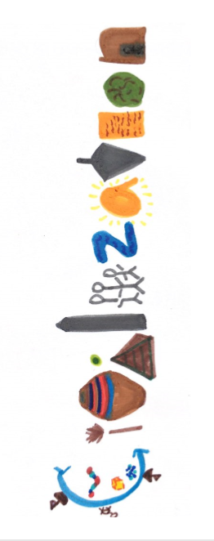
Having students complete a Pictoword enables students to synthesize their understanding of the term “civilization” by requiring them to visually represent the major characteristics of a civilization. This assignment provides another opportunity for the teacher to check for understanding and it enables students to demonstrate their knowledge of the major characteristics of civilizations in a different format. Students may complete this work individually or in small groups. If completing this assignment individually, have students share their Pictoword with a partner or a small group when the Pictoword is complete. If completing this activity in small groups, students may be assigned one letter of the term and complete this assignment on a poster board for display in the classroom.

Inform students that they will now investigate the characteristics of some of the earliest civilizations in the world, the River Valley Civilizations.

Supporting Question

6.I.Q.2 Generate supporting questions related to the development of civilizations between 3500 BCE-600 CE.

Supporting Question: “What characteristics do River Valley Civilizations have in common?”
Supporting Questions:
Supporting questions are aligned to the compelling question and can be answered though using the concepts and practices of each social studies discipline. In grade 6, students are expected to generate supporting questions. Strategies such as Think, Puzzle, Explore may be used to support students in this work. For more information on developing supporting questions, visit “Section C: What are Supporting Questions, and how do students ask them?”
from the Inquiry Practices of the KAS for Social Studies module.

Investigation: Part 1
6.G.GR.1 Use maps and other geographic representations, geospatial technologies, and spatial thinking to determine similarities and differences among River Valley Civilizations and Classical Empires between 3500 BCE-600 CE.

In order to investigate the supporting question for this assignment example, students will use maps to determine similarities and differences among River Valley Civilizations:

Map 1: National Geographic Kids. (2019, April) Fertile crescent map key image. NationalGeographic.org. https://www.nationalgeographic.org/maps/heritage-fertile-crescent/.
Map 2: Encyclopedia Britannica. (n.d.) Principal sites of the Indus Civilization. https://www.britannica.com/topic/Indus-civilization#/media/1/286837/1957
Map 3: Encyclopedia Britannica. (2012) Principal sites of prehistoric and Shang China. https://www.britannica.com/topic/Shang-dynasty#/media/1/538446/1003.
Map 4: Encyclopedia Britannica. (2015) Ancient region of Nubia. https://www.britannica.com/place/Nubia#/media/1/421485/200822

Map 1: Fertile crescent map key image
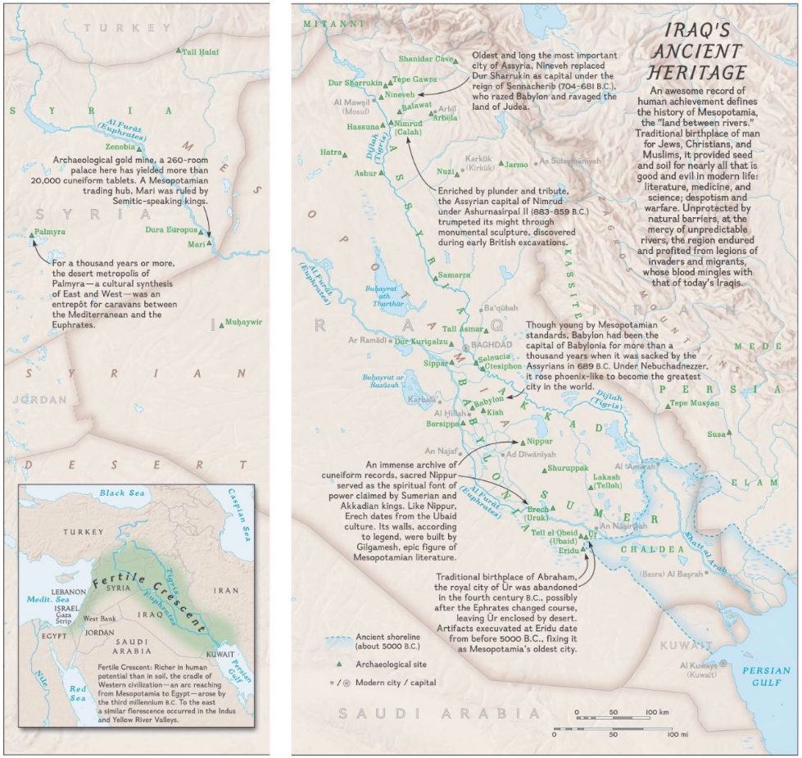

Map 2: Principal sites of the Indus Civilization
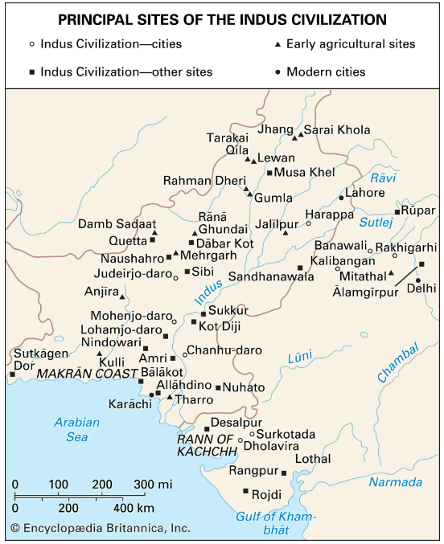

Map 3: Principal sites of prehistoric and Shang China

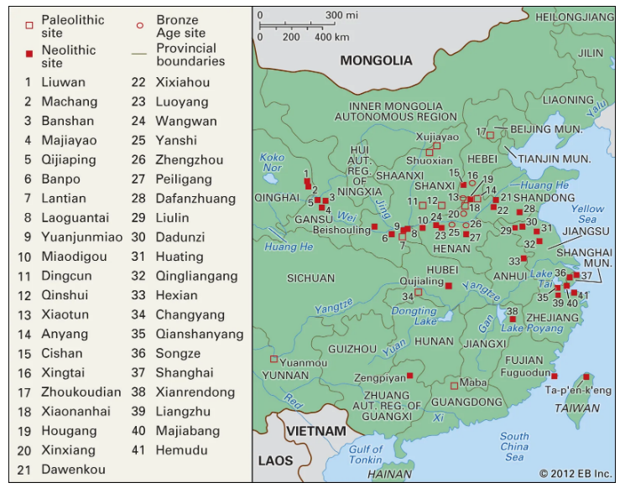

Map 4: Ancient region of Nubia
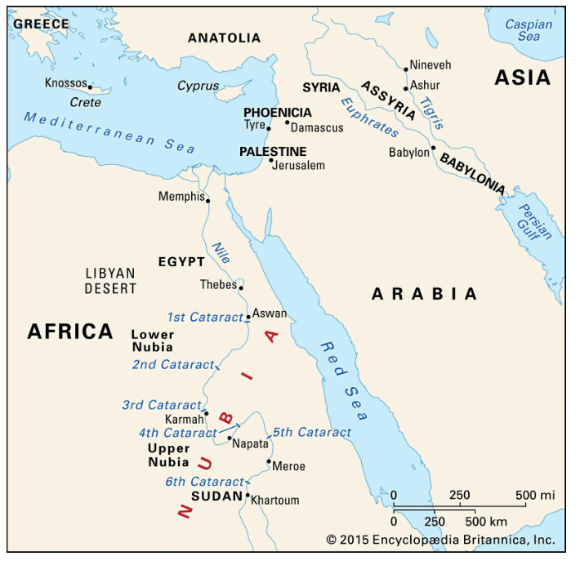

Have students examine these maps in pairs. As students engage with these maps, have students answer the following questions about each map provided:
- What does this map depict?
- Identify the symbols used within the map and describe what they symbolize.
- What physical features do you see in each map?
- Identify two major ancient cities found on each map.
  - Where are they located?
  - Why are these major cities located where they are?

Once students have finished examining the maps provided, conduct a whole class discussion where students share their responses to these questions with their peers. As the discussion progresses, support students in comparing these maps by asking the following questions:

Examine all of the maps provided and answer the following questions:
- What are some similarities among the River Valley Civilizations based on the maps provided?
- What are some differences among the River Valley Civilizations based on the maps provided?

In this discussion, students should be able to share the similarities and differences among River Valley Civilizations based on what they learned from the maps. As students provide their responses, have them reference evidence from the maps to support their answers. Address any misinformation or misconceptions as they discuss these two questions.

At the conclusion of the whole class discussion, have students complete a Quick Write to summarize what they have learned about River Valley Civilizations from the maps they examined.

According to the maps, what were the similarities and differences between the River Valley Civilizations? In your response, cite evidence from the maps you examined.

Next, inform students that they will be assigned into small groups to research one River Valley Civilization. When they have concluded their research on their assigned River Valley Civilization, they will present the information they researched to their peers. Students will use the work of their peers to compare the characteristics of the River Valley Civilizations.

Investigation: Part 2
6.G.HE.1 Analyze how physical environments shaped the development of River Valley Civilizations and Classical Empires between 3500 BCE-600 CE.

In order to determine how physical environments shaped the development of their assigned River Valley Civilizations (Mesopotamia, Indus River Valley Civilizations, Ancient Egypt or Shang Dynasty), divide students into small groups to research one River Valley Civilization. For guidance on how to organize students into small groups, teachers may reference Using Roles in Group Work or Setting up and managing small group work. In order for the successful implementation of small group work, teachers must be mindful of organizing the small groups purposefully, clearly stating the expectations of the assignment being completed and clearly identifying student roles. It is important to note that teachers may need to create more than four groups based on class size. As a result, there might be two groups that study Mesopotamia, two that study the Indus Valley civilizations, etc.

Student groups will engage with the following source for their assigned River Valley Civilization to complete the River Valley Civilizations Evidence Collection Graphic Organizer. Students will only complete the section of the graphic organizer for their assigned River Valley Civilization. It is important to note that these articles may be adapted and/or translated to meet the needs of students and to focus their research on the physical environment of their assigned River Valley Civilization.

- Source One: The Independent. (2009, February 12). Between the rivers: How the people of Mesopotamia established the first human civilisations. The Independent. https://www.independent.co.uk/news/world/world-history/between-the-rivers-how-the-people-of-mesopotamia-established-the-first-human-civilisations-1607594.html.
- Source Two: UShistory.org. (2019). Early Civilization in the Indus Valley. Ancient Civilizations Online Textbook. http://www.ushistory.org/civ/8a.asp.
- Source Three: UShistory.org. (2019). Shang Dynasty - China's First Recorded History. Ancient Civilizations Online Textbook. https://www.ushistory.org/civ/9b.asp.
- Source Four: Khan Academy. (2017). Ancient Egyptian civilization. Khan Academy. https://www.khanacademy.org/humanities/world-history/world-history-beginnings/ancient-egypt-hittites/a/egypt-article.

Excerpt: Source One
Sumeria cuts right through the heart of modern-day Iraq, as far south as the Persian Gulf, where it connects to the Indian Ocean. It was one of the first regions where mankind's new itch to control nature extended into the business of building artificial worlds in the form of cities and states.

Sumeria was a perfect dwelling place for early settled communities of humans. By 10,000 years ago, sea levels had risen by nearly 130m from their low point, and in this part of the world the climate was wetter, and therefore better for growing crops, than it is now. It is only in the last 5,000 years or so that temperatures have increased and rainfall reduced to make the Middle East the sandy, barren land that we know today.

A wetter climate was ideal for growing crops, such as wheat, barley and grapes that need winter rainfall.

The ancient region in which the first Sumerian cities emerged is called Mesopotamia. In Greek it means "between the rivers". The Euphrates and the Tigris proved ideal for supplying water to nearby land through systems of man-made irrigation channels, dykes, reservoirs and dams. These meant people could purposely flood their fields to provide just the right conditions for their artificially chosen crops to thrive. The river valley also provided a large, long, flowing superhighway to carry people and their possessions from one riverside city to the next.

Like all human civilisations, even the ingenious Sumerians could not survive forever. They learnt that living a life in one fixed location, rather than moving from place to place, as hunter-gatherers do, came at a considerable price. After many generations of intensive farming the land became less fertile, owing to increasing levels of salt which spread to the fields through artificial irrigation. To start with, the people responded by switching from growing wheat in favour of barley, which could tolerate higher salt levels. But before long, even that crop just withered away as the soil turned sour.

Excerpt: Source Two
In the vast Indus River plains (located in what is today Pakistan and western India), under layers of land and mounds of dirt, archaeologists discovered the remains of a 4,600 year-old city. A thriving, urban civilization had existed at the same time as Egyptian and Mesopotamian states — in an area twice each of their sizes.

The ruins of two ancient cities, Harappa and Mohenjo-Daro (both in modern-day Pakistan), and the remnants of many other settlements, have revealed great clues to this mystery. Harappa was, in fact, such a rich discovery that the Indus Valley Civilization is also called the Harappan civilization.

Amazing urban architecture was soon uncovered across the valley and into the western plains. The findings clearly show that Harappan societies were well organized and very sanitary.

For protection from seasonal floods and polluted waters, the settlements were built on giant platforms and elevated grounds. Upon these foundations, networks of streets were laid out in neat patterns of straight lines and right angles. The buildings along the roads were all constructed of bricks that were uniform in size.
The brick houses of all city dwellers were equipped with bathing areas supplied with water from neighborhood wells. Sophisticated drainage systems throughout the city carried dirty water and sewage outside of living spaces. Even the smallest houses on the edges of the towns were connected to the systems — cleanliness was obviously of utmost importance.
Eventually, though, around 1900 B.C.E, this prosperity came to an end. The integrated cultural network collapsed, and the civilization became fragmented into smaller regional cultures. Trade, writing, and seals all but disappeared from the area.

Many believe that the decline of the Harappan civilization was a result of Aryan invasions from the north. This theory seems logical because the Aryans came to power in the Ganges Valley shortly after the Indus demise of the Indus Valley Civilization. Because there is little evidence of any type of invasion though, numerous historians claim that it was an environmental disaster that led to the civilization's demise. They argue that changing river patterns disrupted the farming and trading systems and eventually led to irreparable flooding.

Excerpt: Source Three
Recorded history in China begins with the Shang dynasty. Scholars today argue about when the dynasty began, with opinions ranging from the mid-18th to the mid-16th century B.C.E. Regardless of the dates, one event more than any other signaled the advent of the Shang dynasty — the Bronze Age.

The people of the Shang dynasty lived off of the land, and as time passed, settled permanently on farms instead of wandering as nomads.

To guard against flooding by the Yangtze and Yellow Rivers, the ancient Shang developed complex forms of irrigation and flood control. The farming of millet, wheat, rice, and barley crops provided the major sources of food, but hunting was not uncommon.

The last king of the Shang dynasty, Shang Chou, was a cruel man known for his methods of torture. The dynasty had been weakened by repeated battles with nomads and rivaling tribes within China. Shang Chou was ousted by the rebel leader Wu-wang in 1111 B.C.E.

Excerpt: Source Four
Much of the history of Egypt is divided into three “kingdom” periods—Old, Middle, and New—with shorter intermediate periods separating the kingdoms.

Even before the Old Kingdom period, the foundations of Egyptian civilization were being laid for thousands of years, as people living near the Nile increasingly focused on sedentary agriculture, which led to urbanization and specialized, non-agricultural economic activity.

It was only in about 6000 BCE, however, that widespread settlement began in the region. Around this time, the Sahara Desert expanded. Some scientists think this expansion was caused by a slight shift in the tilt of the Earth. Others have explored changing rainfall patterns, but the specific causes are not entirely clear. The most important result of this expansion of the Sahara for human civilization was that it pushed humans closer to the Nile River in search of reliable water sources.

Apart from the delta region, where the river spreads out as it flows into the sea, most settlement in the Nile Valley was confined to within a few miles of the river itself... The Nile River flooded annually; this flooding was so regular that the ancient Egyptians set their three seasons—Inundation, or flooding, Growth, and Harvest—around it.

This annual flooding was vital to agriculture because it deposited a new layer of nutrient-rich soil each year. In years when the Nile did not flood, the nutrient level in the soil was seriously depleted, and the chance of food shortages increased greatly. Food supplies had political effects, as well, and periods of drought probably contributed to the decline of Egyptian political unity at the ends of both the Old and Middle Kingdoms.

Somewhat confusingly, when you look at a map of this area, Lower Egypt is the delta region in the north, and Upper Egypt refers to the southern portion of the country, which is upriver from the delta.

Here is an excerpt of an example of a completed graphic organizer from a Kentucky classroom:

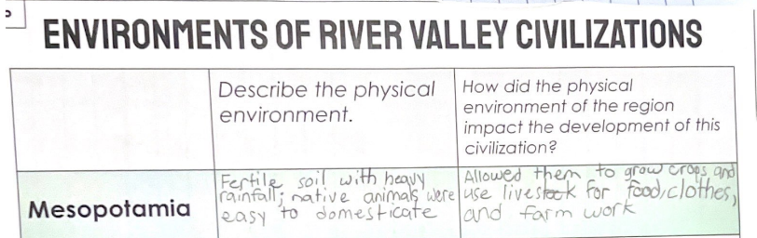

Once students have completed their graphic organizer, conduct a whole group discussion where students complete a Mind Map to answer “How did physical environments shape the development of River Valley Civilizations?” During this whole group discussion, students from each group will share how the physical environment of their assigned River Valley civilization influenced the development of that civilization. Model recording this information on the Mind Map for the students and have the class record this information on their Mind Map. When each group has shared their responses, have the class identify any similarities of the impact of the physical environment on the civilization and highlight this information in a designated color. Similarly, have the class identify the differences of the impact of the physical environment on the civilization and highlight this information in a different color. As students are identifying these similarities and differences in the discussion, highlight the ways in which these characteristics of the physical environment influenced the civilization to develop in similar or different ways.

Once students have discussed the impact of the physical environment on the development of River Valley Civilizations, inform students that they will now investigate the structures of River Valley Civilizations governments originated. Additionally, they will examine the origins and functions of River Valley Civilizations governments.

Investigation: Part 3
6.C.CP.1 Explain the origins, functions and structures of governments in River Valley Civilizations and Classical Period Empires between 3500 BCE-600 CE.

In order to explain the origins, functions and structures of governments their assigned River Valley Civilization (Mesopotamia, Indus River Valley Civilizations, Ancient Egypt or Shang Dynasty), student groups will engage with the following source for their assigned River Valley Civilization to complete the graphic organizer they started in the previous investigation. As a reminder, it is important to note that these articles may be excerpted, adapted and/or translated to meet the needs of students and to focus their research on the origins, functions and structures of governments of their assigned River Valley Civilization.

- Mark, J. J. (2018, March 14). Mesopotamia. Ancient History Encyclopedia. https://www.ancient.eu/Mesopotamia/
- Mark, J. J. (2016, October 13). Ancient Egyptian Government. Ancient History Encyclopedia. https://www.ancient.eu/Egyptian_Government/
- Violatti, C. (2013, October 30). Indus Valley Civilization. Ancient History Encyclopedia. https://www.ancient.eu/Indus_Valley_Civilization/
- Mark, E. (2016, January 28). Shang Dynasty. Ancient History Encyclopedia. https://www.ancient.eu/Shang_Dynasty/

Explain to students that they are going to examine the origin, function and structure of their civilization. It is helpful to review the definitions of these terms in The KAS for Social Studies Glossary of Terms prior to engaging with the articles. Additionally, the Disciplinary Clarifications and Instructional Supports are helpful for providing context as well. The structure of government refers to how the government is organized. For example, pharaohs in Egypt had both political power and were worshiped as gods, while ancient Mesopotamian kings linked their power to divine sources but were not actually considered divine themselves. The origins of government refers to where the point or place of government starts or where the power is derived. When applied to the pharaohs in Egypt and the Mesopotamian Kings, the power for the government came from divine sources which differs from the origin of power in Ancient Greece. Ancient Greece is credited with the creation of the first limited democracy, which arose from a need for more equal representation, while principles of equality before the law and citizens’ rights were developed in the Roman Republic. Elsewhere, Classical China was the first empire to use an effective, merit-based bureaucracy. The function of these governments was based on its origin and structure in terms of how it functioned to meet the needs of its people. Overall, however, the function of the governments was to facilitate the organization and management of civilizations as the population of these civilizations increased.

Here is an excerpt of an example of a completed graphic organizer from a Kentucky classroom:

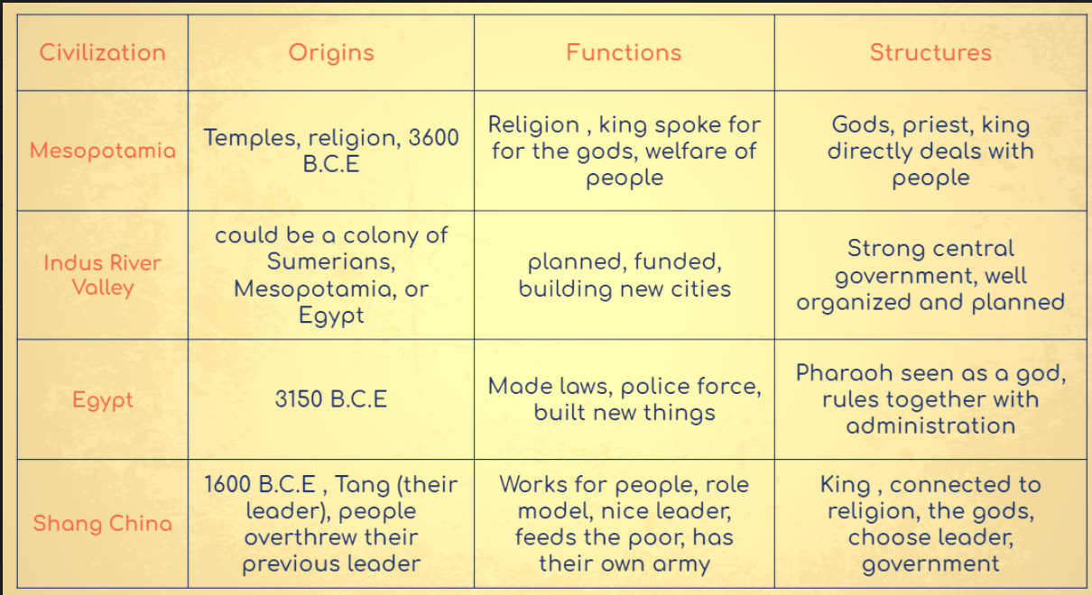

Once students have completed their graphic organizer, conduct a whole group discussion where students use a modified Parts, People, Interactions thinking strategy to discuss what they have learned with the class. This whole group discussion serves many functions. First, it allows for the teacher to check for understanding on how well students can explain the origins, functions and structures of governments in the River Valley Civilization the students explored. As students share their responses to the thinking strategy, the teacher can correct or provide further insight on any information that is shared. Additionally, it provides an opportunity for students to see the connections between the River Valley Civilization they researched and the ones investigated by their peers.

Explain the origins, functions and structures of government of your assigned River Valley Civilization by answering the following questions:

- Identify your River Valley Civilization.
- Explain the origins of the government.
  - How did this government start?
  - Where does power come from?
- Explain the functions of the government.
  - How did the government support organization and management of civilizations as the population of these civilizations increased?
- Explain the structures of the government.
  - What are the parts of the government? How is the government organized?
  - How are people connected to the structures of the government?
- How do the people in the government interact with each other and with the parts of government?
- How does a change in one element of the system affect the various parts and people connected to the government?

Once students have discussed the origins, functions and structures of governments of River Valley Civilizations, they will produce a poster about their assigned River Valley Civilization.

Investigation: Part 4
Students will demonstrate their knowledge of their assigned River Valley Civilization by creating a poster on their assigned River Valley Civilization.

It is important to share with students what makes a high-quality poster prior to students constructing their own. Inform students of the following:

A good poster is a resource for your peers that summarizes information in a clear way through text and images. According to New York University Libraries, a good poster has the following characteristics:

- Important information should be readable from about 10 feet away
- Title is short and draws interest
- Word count of about 300 to 800 words
- Text is clear and to the point
- Use of bullets, numbering, and headlines make it easy to read
- Effective use of graphics, color and fonts
- Consistent and clean layout
- Includes acknowledgments (such as all group member names)

Have students evaluate the poster below based on the characteristics above to inform them of what they need to do to create a high-quality poster.
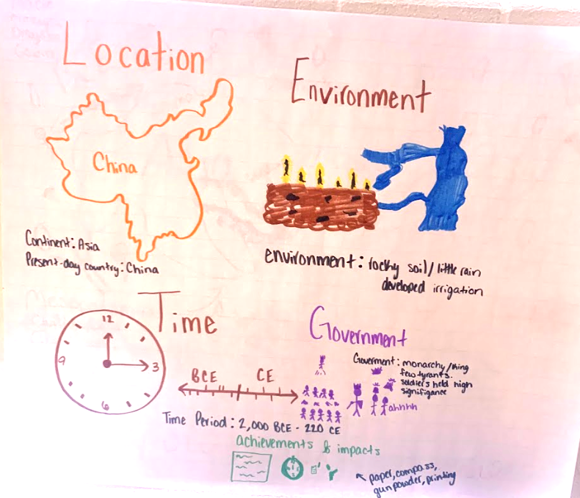

Once students understand the characteristics of a high-quality poster, present the questions that their poster needs to answer:

- What is the name of your assigned River Valley Civilization?
- Where was your assigned River Valley Civilization located?
- What are the dates of your assigned River Valley Civilization?
- Describe the physical environment of your assigned River Valley Civilization.
- How did the physical environment shape the development of your assigned River Valley Civilization?
- What were the origins, functions and structures of governments in your assigned River Valley Civilization?

It is important to note that prior to moving on with these assignments, teachers should have the opportunity to review the posters created by students to ensure accuracy. If a poster contains inaccurate information or not enough information, have students revise their posters to ensure they meet the requirements of the assignment.

Investigation: Part 5
When the small groups have completed their poster on their assigned River Valley Civilization, have the students engage in a Gallery Walk using these student created resources. In this Gallery Walk, have students complete their graphic organizer with information about the other civilizations that they did not investigate. .

During the Gallery Walk, students may pose their questions to their peers on post-it notes and place them on their posters. At the conclusion of the Gallery Walk and as part of the activity debrief, have students answer the questions posed by their peers in a whole group discussion facilitated by the teacher.

Task Aligned to the Supporting Question:
KAS for Social Studies alignment:
- 6.I.Q.2 Generate supporting questions related to the development of civilizations between 3500 BCE-600 CE.
- 6.C.CP.1 Explain the origins, functions and structures of governments in River Valley Civilizations and Classical Period Empires between 3500 BCE-600 CE.
- 6.G.HE.1 Analyze how physical environments shaped the development of River Valley Civilizations and Classical Empires between 3500 BCE-600 CE.
- 6.G.GR.1 Use maps and other geographic representations, geospatial technologies, and spatial thinking to determine similarities and differences among River Valley Civilizations and Classical Empires between 3500 BCE-600 CE.
- 6.I.UE.1 Develop claims, citing relevant evidence, in response to compelling and supporting questions.

In this assignment, students are required to synthesize information learned through engaging with the disciplinary strand standards to answer a supporting question.

Task Aligned to the Supporting Question:
Develop a claim to respond to the supporting question: “What characteristics do River Valley Civilizations have in common?”

In your response, be sure to:
- Use your knowledge of the origins, functions and structures of River Valley Civilization governments.
- Use your knowledge of how physical environments shaped the development of River Valley Civilizations.
- Explain how you used maps and/or spatial thinking to determine similarities and differences among complex societies.
- Cite relevant evidence that supports your claim

To support students in preparing for this task, first read and discuss the prompt as a class, clarifying any challenging vocabulary and checking for understanding. Encourage students to revisit sources from the previous investigations and the work they previously completed, such as the maps from Investigation One, the River Caller Civilizations Graphic Organizer, the physical environments Mind Map and the posters.

To support students in identifying the common characteristics of River Valley civilizations, have students access their River Valley Civilizations Graphic Organizer. Have students work together in small groups to highlight the common characteristics that are present in their graphic organizer. As an example, students may notice that all of the civilizations were by water, so they would identify that as a common characteristic. When students find common characteristics, have them highlight these characteristics by using a highlighter or underlining the information.

Next, have students identify the common characteristics on the graphic organizer below.

Common characteristic: | Common characteristic: | Common characteristic:
Examples from multiple civilizations: | Examples from multiple civilizations: | Examples from multiple civilizations:

Once students have identified the common characteristics in the graphic organizer, prepare them to craft their responses by having them identify their claim, support and evidence for this task. Provide students with the opportunity to plan for their response with a graphic organizer such as the one below:

“What characteristics do River Valley Civilizations have in common?”
Claim:
Support #1: | Support #2: | Support #3:
Evidence for Support #1: | Evidence for Support #2: | Evidence for Support #3:

Explain to students that they should develop a claim that answers the supporting question. They must also identify support for their claim and evidence from the sources. Ask students to identify the source from which their evidence came when completing this section of the graphic organizer. After students have completed their pre-writing, ask them to complete the task aligned to the supporting question by developing a written response in paragraph form.

After students have drafted their responses, give students the opportunity to provide feedback for their peers. Provide the following questions for peers to ask one another as they review each other’s work:

- Did you provide information on the origins, functions and structures of River Valley Civilization governments?
- Did you provide information on how physical environments shaped the development of River Valley Civilizations?
- Did you explain how you used maps and/or spatial thinking to determine similarities and differences among complex societies?
- Did you cite relevant evidence that supports your claim?
- Did you develop a claim with evidence to answer the supporting question, “What characteristics do River Valley Civilizations have in common?”

Below are examples from Kentucky classrooms:

Strongly Aligned
There were 4 ancient RVCs China, Egypt, Mesopotamia and India. They kind of grew up along the same part of the world because of the way the temps were at that time. Things were different back then for those people. What they all really had in common was that they started farming, had to find a way to write things down, and made tools to make things easier to do.

When you farm you grow things from seed where you want them to grow so living next to a river helps alot. You can make water run over the ground and hit the seeds and make them grow or even build something like the Eqyptians did to move water. In document F, it shows how they made a shadoof to move water. This proves that people living next the rivers in these RVCs made things to make things grow.

Writing started when people had to keep track of trading sheep and crops. It got super complicated so they made marks on sticks. When that got to be too much the cuniform was made with a reed in clay to tell about what they did with crops and certain people. Document B shows a picture of the cuniform writing and that proves that it was invented at that time. All of the RVCs had writing that we found or we wouldn’t know about them.

Finally, the tools like the adze (document A) made it easier to dig the ground up to plant stuff to eat. They all had to figure out what to make based on a problem they had where they lived.

In conclusion, it was framing that made all RVCs do things alike back then by making writing and tools. Thank you.

Partially Aligned
My thoughts on what the civilizations have in common are that they all have leaders, jobs and beliefs. They all had some kind of leader that would keep things in order in the town. They would give order and they would get their orders from the gods. While kids are important so is belief.

Next is that people have beliefs and gods that they workshop. They would have these gods and would workship them and make sacrifices to them if needed. The king would make the laws but the gods would tell hom what to do. These gods were very important but jobs were also in every civilization.

Jobs were part of civilization and daily life, every town had them for their own reasons. Jobs were here to keep the town organized and to keep the people busy. Some jobs were blacksmith, Farmer, and clothing maker. Every civilization had different jobs but they all had these. Those are my three things that civilizations had in common.

Weakly Aligned
The Characteristics that River Valley Civilizations all had was water, good soil, and people.

It was good to have lots of water. they used it to drink and fish and water crops. Doc A

The people needed floods for soil. the floods helped them grow crops with the water from the river. Youtube video

No people equals no RVC. They survived an were able to have lots of people because farming helped them stay alive longer than just walking around hunting. My thought.

Task Aligned to the Compelling Question:

KAS for Social Studies alignment:
- 6.I.Q.1 Develop compelling questions related to the development of civilizations between 3500 BCE-600 CE.
- 6.I.UE.1 Develop claims, citing relevant evidence, in response to compelling and supporting questions.
- 6.I.CC.2 Construct arguments, using claims and evidence from multiple credible sources, while acknowledging the strengths and limitations of the arguments, to address how a specific problem can manifest itself at local, regional and global levels over time.
- 6.I.CC.5 Describe a specific problem from the development of civilizations using each of the social studies disciplines.

Assignments aligned to the compelling question are designed to provide guidance on how to have students synthesize the knowledge learned from engaging with the supporting question(s) to investigate enduring and significant unresolved issues addressed by the compelling question. In this example, one supporting question is provided that is aligned to a compelling question. However, students may need to engage with more than one supporting question in order to fully engage with a compelling question. This assignment culminates with students using their historical thinking skills to address how a specific problem can manifest itself at local, regional and global levels over time.

Task Aligned to the Compelling Question:
“How do complex societies develop?”

Part One: Construct an explanation to answer the following question: “How do complex societies develop?” Be sure to cite relevant evidence, while acknowledging the strengths and weaknesses of the explanations concerning the development of civilizations in your response.

Part Two: Using your knowledge of how complex societies develop, describe a specific problem from the development of civilizations using each of the social studies disciplines.

Part Three: Construct an argument, using claims and evidence from multiple credible sources, while acknowledging the strengths and limitations of the arguments, to address how a specific problem can manifest itself at local, regional and global levels over time.

Notes for Part One: All valid claims must be based on logical evidence. In order for students to construct coherent arguments and explanations using their understanding of the social studies disciplines, they must understand how to substantiate those claims using evidence. This skill requires students to collect, evaluate and synthesize evidence from primary and secondary sources to develop and support a claim.

Notes for Part Two: Have students engage in a Chalk Talk to brainstorm ideas on problems from the development of civilizations. In order to conduct this activity, the teacher may pose a question, such as “What problems did civilizations encounter when developing?” in order to encourage student thinking and identification of problems from the development of civilizations.

Notes for Part Three: A student’s ability to effectively communicate their own conclusions and listen carefully to the conclusions of others can be considered a capstone of social studies disciplinary practices. Traditional products such as essays, reports, tables, diagrams, graphs, multimedia presentations and discussions can be used to share conclusions with a variety of audiences. In a world of ever-expanding communication opportunities inside and outside their school walls, students should also be able to utilize newer media forms in order to share their conclusions.

Alavosus, Laura (Ed.). (2010) Bring Learning Alive! Methods to Transform Middle and High School Social Studies Instruction. Teacher’s Curriculum Institute.

