6th Grade Reading and Writing Assignment
This assignment is strongly aligned to the standards.

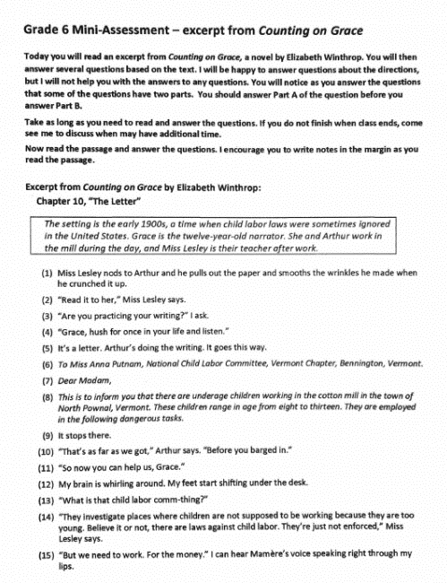

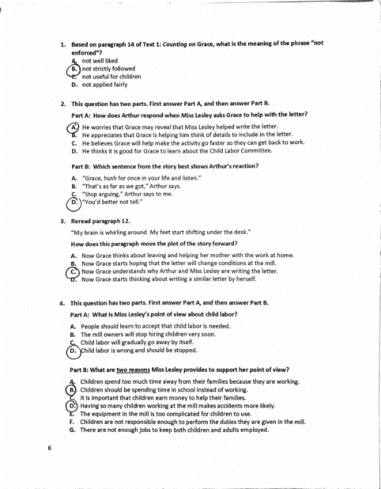

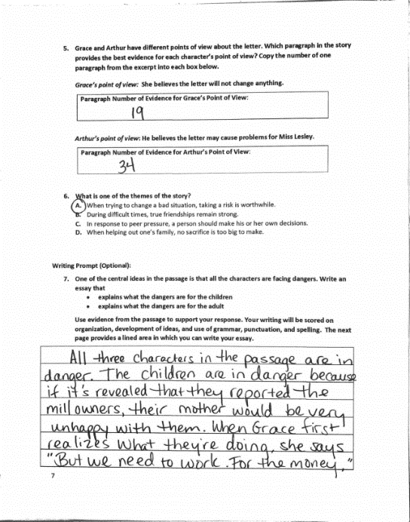

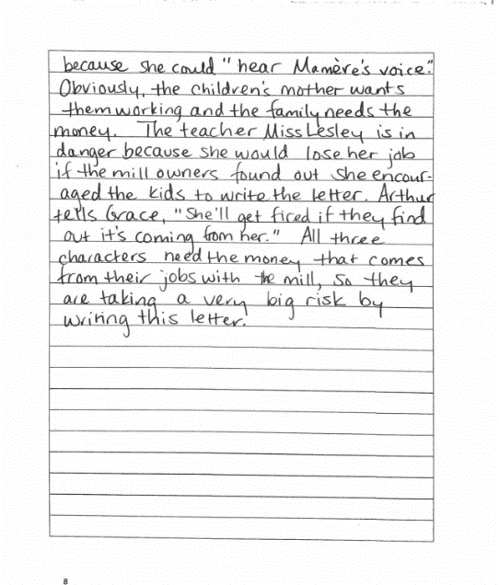

Overview
Sixth-grade students read an excerpt from a grade-level historical fiction text called "Counting on Grace," then answer text-specific written and multiple-choice questions. This assignment is strong because it exposes students to a worthwhile text that builds historical knowledge. It also asks questions that focus students on key details to progressively build their understanding and allows students to articulate that understanding in writing.

About the Text

Title and Author | “Counting on Grace” by Elizabeth Winthrop
What is the Lexile Level of this text? | 760
Based on Lexile, which grades is this text intended for? | 4-5
Is the text qualitatively complex enough for the grade? | Yes
Is this text fiction or non-fiction? | Fiction
Is this text authentic or was it written for educational purposes? | Authentic
Does the text provide sufficient detail to build knowledge of a worthwhile topic and/or is it worth reading closely and re-reading? | Yes

Related Standards
RL.6.1: Cite textual evidence to support analysis of what the text says explicitly as well as inferences drawn from the text.
The assignment is strongly aligned to this standard. Both in the essay and through a number of multiple choice responses students are expected to cite evidence to support their response.
RL.6.2: Analyze how the theme is reflected in the text by citing particular details and/or providing an objective summary.
The assignment is strongly aligned to this standard. Question 6 asks students to identify a theme from the story. Question 7 provides one of the central ideas and requires students to use evidence from the text to explain how the central idea is conveyed.
RL.6.3: Describe how a particular story’s or drama’s plot unfolds in a series of episodes and determine how the characters respond or change as the plot moves toward a resolution.
The assignment is strongly aligned to this standard. Questions 2 and 3 address how the plot unfolds and how characters respond to key events in the story.
RL.6.4: Determine the meaning of words and phrases as they are used in a text, including figurative and connotative meanings; analyze the impact of a specific word choice on meaning and tone.
The assignment is strongly aligned to this standard. Question 1 requires attention to a key phrase that is important to understanding events and characters actions in the story.
RL.6.6: Explain how an author develops the perspective of the narrator or speaker in a text.
The assignment is strongly aligned to this standard. Question 4 requires reasons from the text to support the character’s point of view.
RL.6.10: By the end of the year, flexibly use a variety of comprehension strategies (i.e., questioning, monitoring, visualizing, inferencing, summarizing, synthesizing, using prior knowledge, determining importance) to read, comprehend, and analyze grade-level appropriate, complex literary texts independently and proficiently.
The assignment is strongly aligned to this standard. Students must read and make sense of a high quality, grade-appropriate text.
C.6.1: Compose arguments to support claims with clear reasons and relevant evidence.
The assignment is strongly aligned to this standard. The writing prompt requires that student use evidence to support their response, and notes that writing will be scored on organization, development of ideas, and use of conventions.
L.6.2: When writing: a. Demonstrate appropriate use of punctuation (commas, parentheses, dashes) to set off nonrestrictive/parenthetical elements; b. Demonstrate appropriate use of strategies to identify and correct spelling errors.
The assignment is strongly aligned to this standard. The expectation for use of appropriate spelling and punctuation is outlined in the writing prompt.
Why is this assignment strongly aligned?
It allows students to engage with a worthwhile text. The text is about two children and their teacher writing a letter to a committee that investigates child labor violations. The text builds students’ knowledge of labor movements in the early twentieth century, requires them to navigate period-specific vernacular, and demands significant inferential thinking about the characters’ predicaments because the problem at the heart of the story is not explicitly stated.
It requires students to read carefully and focus on key details. The questions direct students back to the specific passages in the text that matter most to build their understanding. By building on each other and becoming increasingly more complex, the questions posed help students develop a comprehensive understanding of the whole excerpt.
It allows students to share what they learned in writing. Students get the chance to articulate independent ideas about the text, and to support those ideas with specific evidence. They also practice structuring an argumentative piece of writing: making a claim, supporting it with evidence, and organizing their thoughts in a logical introduction-body-conclusion format.

