Sixth Grade Math Assignment
This assignment is partially aligned to the standards.
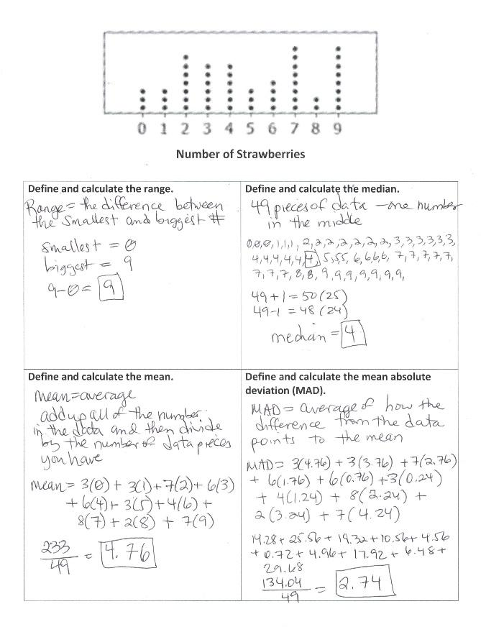

Overview
Sixth-grade students define and calculate range, median, mean, and mean absolute deviation for a provided data set. This assignment is only partially aligned with a sixth-grade standard. Calculating these values is appropriate, but the assignment doesn’t ask students to describe patterns and deviations in the data set, as the sixth-grade standard requires.

Related Standards
We looked at how well the assignment aligned to the following standard:
KY.6.SP.5 Summarize numerical data sets in relation to their context, such as by:
a. Reporting the number of observations.
b. Describing the nature of the attribute under investigation, including how it was measured and its units of measurement.
c. Determining quantitative measures of center (median and/or mean) to describe distributions of numerical data.
d. Describing distributions of numerical data qualitatively relating to shape (using terms such as cluster, mode(s), gap, symmetric, uniform, skewed-left, skewed-right and the presence of outliers) and quantitatively relating to spread/variability (using terms such as range and interquartile range).
e. Relating the choice of measures of center and variability to the shape of the data distribution.

Why is this assignment partially aligned?
This assignment is partially aligned with sixth-grade standard KY.6.SP.5. Students are asked to calculate measures of center and measures of variability, which is called for in the standard. To be fully aligned with the standard, however, the assignment should have asked students to describe patterns or deviations in the data. For example, students could have been asked what the values of the mean and mean absolute deviation tell us about the number of strawberries in the data set.
This assignment only focuses on procedural skill, but standard KY.6.SP.5 targets both procedural skill and conceptual understanding. Students build their procedural skill in this assignment by calculating range, mean, median, and mean absolute deviation. But they don’t get to build their conceptual understanding because they aren’t asked to interpret and describe these measures of center and variability in the context of the specific data set. For example, students could have been asked to describe the distribution as symmetric or non-symmetric, and explain how that relates to the values of the mean and median, to reinforce their conceptual understanding of variability (the closer in value the mean and median, the more even or symmetric the distribution will be).
Practice Standards
Students had a superficial opportunity to engage with Mathematical Practice Standard #6 (“Attend to precision”) through their definitions of range, mean, median, and mean absolute deviation, but they didn’t get a meaningful opportunity to communicate precisely because they were not asked to describe the measures of center and variability within the data set.

