6th Grade Reading and Writing Assignment
This assignment is partially aligned to the standards.
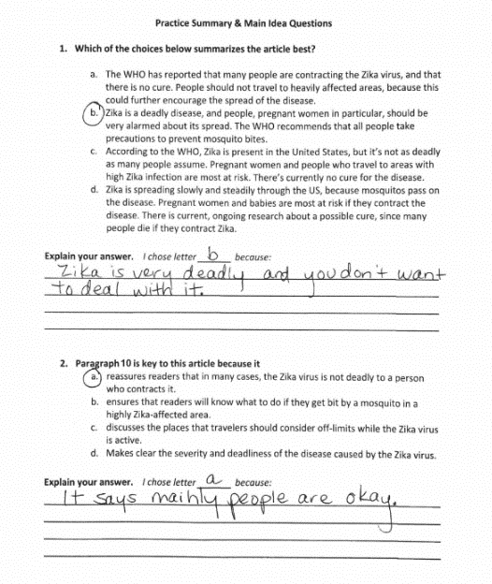
Overview
Sixth-grade students read an article about the Zika virus, then answer two multiple-choice questions about the text and explain why they chose their answers. The assignment is partially aligned to the standards because the text is appropriate for sixth grade, but the accompanying questions are not: students are not required to cite specific details and evidence from the text in their responses.
About the Text

Title and Author | “What Exactly Is Zika Virus – and Should We Be Worried?” by Amy Capetta
What is the Lexile Level of this text? | 1100-1200L
Based on Lexile, which grades is this text intended for? | 6-8
Is the text qualitatively complex enough for the grade? | Yes
Is this text fiction or non-fiction? | Non-Fiction
Is this text authentic or was it written for educational purposes? | Authentic
Does the text provide sufficient detail to build knowledge of a worthwhile topic and/or is it worth reading closely and re-reading? | Yes

Related Standards
RI.6.2: Analyze how the central ideas are reflected in a text by citing particular details and/or providing an objective summary.
The assignment is partially aligned to this standard. In the first question, students are asked to select a summary from among multiple-choice options and then explain why they chose that answer. But there is no expectation of referring back to key details in the text, nor of including evidence beyond a brief personal rationale. In the second question, the assignment moves toward the central idea of one paragraph in the article, but the question could be stronger by explicitly aligning to the language of the standard. In actuality, the second question could also be more closely aligned with RI.6.5: Analyze how a particular sentence, paragraph, chapter or section fits into the overall structure of a text and contributes to the development of the ideas.

RI.6.5: Analyze how a particular sentence, paragraph, chapter or section fits into the overall structure of a text and contributes to the development of the ideas.
The assignment is weakly aligned to this standard. Students are asked to select from among multiple-choice options what the significance of paragraph 10 is and to explain why they chose that answer. Though the question superficially reflects this standard, students do not have the opportunity to engage in the more extensive, text-based analysis suggested here.

RI.6.10: By the end of the year, flexibly use a variety of comprehension strategies (i.e., questioning, monitoring, visualizing, inferencing, summarizing, synthesizing, using prior knowledge, determining importance) to read, comprehend and analyze grade-level appropriate, complex informational texts independently and proficiently.
The text chosen for this assignment is strongly aligned to this standard because it contains the quantitative and qualitative attributes which are grade-level appropriate for sixth graders. The questions, however, do not meet the depth or complexity of this standard.

Why is this assignment Partially aligned?
This assignment is partially aligned because the text is strong, but most of the questions are not:
The text is grade-appropriate. The task is based on a real magazine article about the Zika virus. It is appropriately challenging in terms of structure, vocabulary, and meaning, and builds students’ knowledge of an important public health topic. This text would be particularly strong if it were part of a larger text set connected to a common topic (e.g., viruses or healthcare around the world).
The accompanying questions do not require grade-level analysis. While multiple-choice questions are not necessarily problematic, these particular questions don’t focus students on the level of analysis required by the standards (RI.6.2 and RI.6.5). The questions require students to practice extracting the central idea—an important but simplistic skill for sixth grade—instead of helping students make sense of challenging structures and ideas in order to build understanding of the content.
Students are not required to cite details and evidence from the text—a critical component of the sixth-grade standards. Though students are asked to explain why they chose each answer, there is only space for a brief surface-level explanation. The assignment would be stronger if students were expected to cite specific evidence from the text in their responses.

