Sixth Grade Math Assignment
This assignment is weakly aligned to the standards.
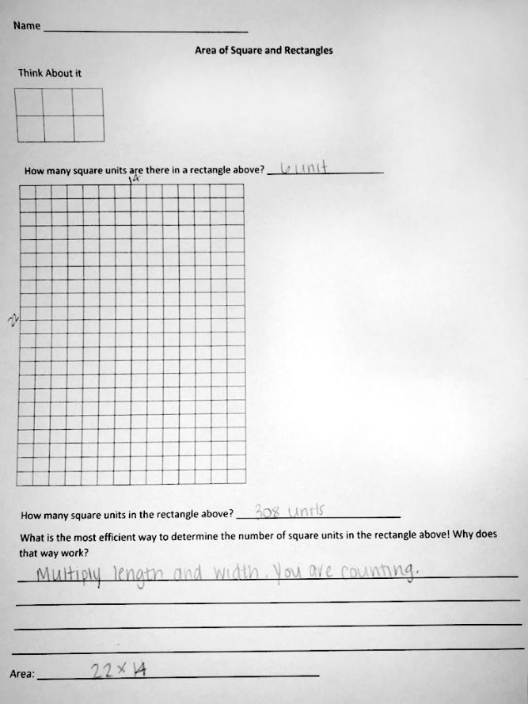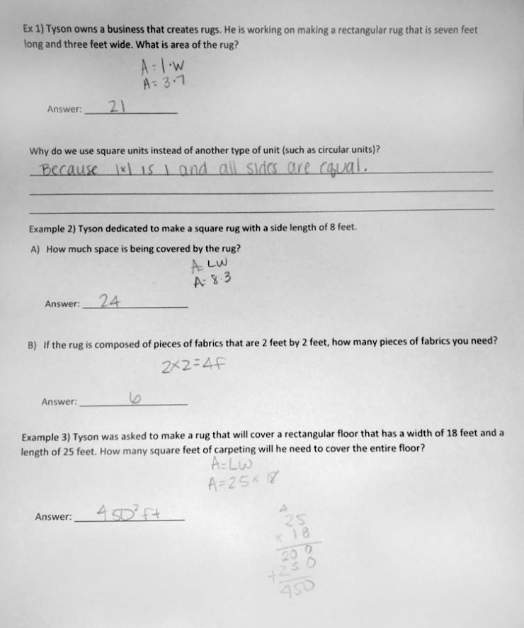

Overview
Sixth-grade students answer several questions about calculating area. This assignment is weak because it is more closely aligned with a fourth-grade standard on calculating the area of rectangles than with the sixth-grade standard on finding the area of more advanced shapes.

Related Standards
We looked at how well the assignment aligned to the following standard:
KY.6.G.1: Find the area of right triangles, other triangles, special quadrilaterals, and polygons by composing into rectangles or decomposing into triangles and other shapes; apply these techniques in the context of solving real-world and mathematical problems.

Why is this assignment weakly aligned?
The sixth-grade standard KY.6.G.1 requires students to find the area of a variety of shapes, such as triangles, “special” quadrilaterals (like parallelograms), and other polygons (like pentagons). The only shapes in this assignment are rectangles, making this assignment more closely aligned with fourth-grade standard KY.4.MD.3.
There was also a missed opportunity to incorporate multiplication appropriate for sixth grade. The multiplication students perform in this assignment (e.g., 3 x 7 and 14 x 22) is below grade level; students should have been asked to work with non-whole numbers.
The assignment doesn’t focus on conceptual understanding, which is an essential aspect of standard KY.6.G.1. The standard calls for students to find the area of a shape “by composing [it] into rectangles or decomposing [it] into triangles and other shapes.” Composing and decomposing shapes builds students’ foundational understanding of the area formula for various shapes. For example, seeing that a parallelogram can be composed of two triangles helps students understand that area is additive and provides an explanation for why the formula for area of a triangle is (½ x base x height). In this assignment, students are only asked to calculate area using the (base x height) formula, which reinforces procedural skill, not conceptual understanding.

