6th Grade Reading and Writing Assignment
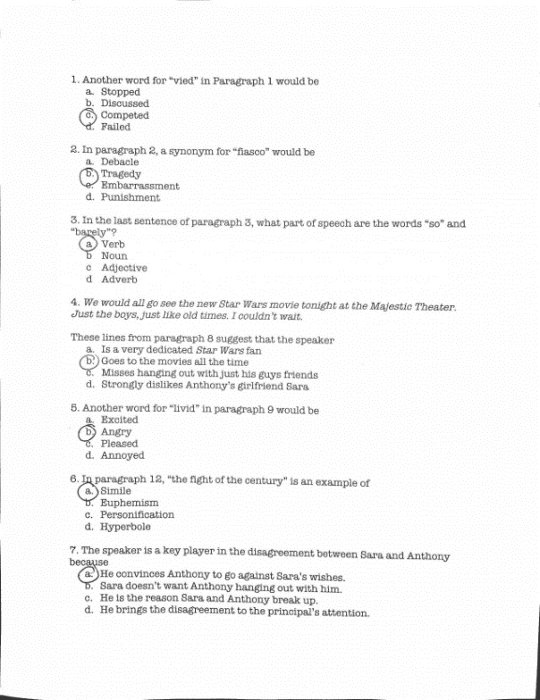
This assignment is weakly aligned to the standards.
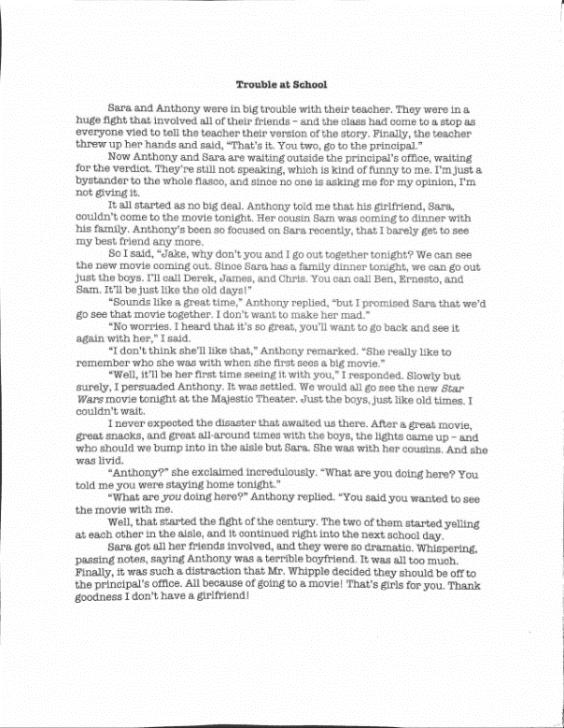
Overview
Sixth-grade students read a short fiction story about a conflict among students and then answer multiple-choice questions about the text. The assignment is weak because the text is significantly below grade level and does not build meaningful content or cultural knowledge for students. In addition, most of the questions do not require close reading or evidence-based responses.

ABOUT THE TEXT

Title and Author | “Trouble at School?”
What is the Lexile Level of this text? | 600-700L
Based on Lexile, which grades is this text intended for? | 2-3
Is the text qualitatively complex enough for the grade? | No
Is this text fiction or non-fiction? | Fiction
Is this text authentic or was it written for educational purposes? | Written for educational purposes
Does the text provide sufficient detail to build knowledge of a worthwhile topic and/or is it worth reading closely and re-reading? | No

Related Standards
RL6.3: Describe how a particular story’s or drama’s plot unfolds in a series of episodes and determine how the characters respond or change as the plot moves toward a resolution.
The assignment is weakly aligned to this standard. Questions 4 and 7 draw some connections between the characters and story’s plot. However, given the low complexity of the text for 6th graders, students do not have opportunity to meet the intent of this standard.
RL.6.4: Determine the meaning of words and phrases as they are used in a text, including figurative and connotative meanings; analyze the impact of a specific word choice on meaning and tone.
The assignment is weakly aligned to this standard. Most questions (1, 2, 5 and 6) focus on the meanings of words within the text, but low text complexity means generally low-level, non-academic words for 6th grade. In addition, questions do not ask about the impact of word choice on text meaning and tone, which is an important part of this standard.
RL.6.6: Explain how an author develops the perspective of the narrator or speaker in a text.
The assignment is weakly aligned to this standard. Questions 4 and 7 are superficially aligned to this standard; while they relate to the narrator’s position/perspective in the story, they are simplistic and the text itself is not complex enough to demand analysis of how the author develops this character’s point of view.
RL.6.10: By the end of the year, flexibly use a variety of comprehension strategies (i.e., questioning, monitoring, visualizing, inferencing, summarizing, synthesizing, using prior knowledge, determining importance) to read, comprehend, and analyze grade-level appropriate, complex literary texts independently and proficiently.
The assignment is weakly aligned to this standard. The assignment does not use a complex text so students are not able to practice a variety of comprehension skills or analyze text independently. Additionally, students are not asked to demonstrate deep understanding of the information and ideas in the texts.
L.6.4.A: Use context (e.g., the overall meaning of a sentence or paragraph; a word's position or function in a sentence) as a clue to the meaning of a word or phrase.
The assignment is weakly aligned to this standard. If students do not know the meaning of the words in questions 1, 2 and 5, then they have an opportunity to use context as a clue to determine an appropriate definition or synonym. However, because the vocabulary is generally low-level for 6th grade, students have minimal opportunity to meet the demands of this standard.
L.6.5.A: Interpret figures of speech (e.g., personification) in context.
The assignment is weakly aligned to this standard. Question 6 asks students to categorize the figure of speech, but the standard requires that students can interpret figures of speech.

Why is this assignment weakly aligned?
It doesn’t use a worthwhile, grade-level text. This text doesn’t build knowledge and does not approach the skillful craft and literary merit we would hope to see in sixth grade. While students might have a personal connection to the characters or events, they are unlikely to gain new knowledge or build new vocabulary from reading the text.
The questions asked do not align to the sixth-grade reading standards. In sixth grade, students are expected to engage in deep analysis of a worthwhile text. In this assignment, they are only asked to define words and perform basic recall-and-restatement of events from the text.
The questions asked do not align to the sixth-grade language standards. While some questions allow students to use context to determine the meaning of vocabulary words (L.6.4A), the words themselves are too low-level and likely don’t require close reading. One question covers figurative language (L.6.5A), but it asks students to label the type of figurative language, rather than asking them to interpret the language in context.

