Seventh Grade Math Assignment
This assignment is strongly aligned to the standards.
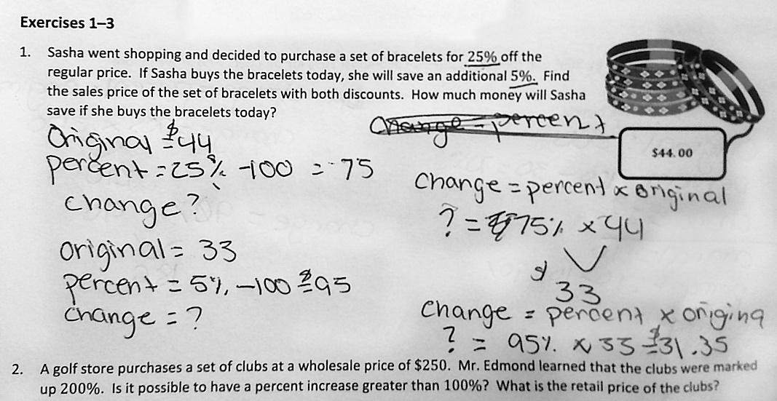

Overview
Seventh-grade students solve word problems about price markups and markdowns. This assignment is strong because it requires students to interpret real-world scenarios and solve them mathematically, while allowing students to practice grade-level operations with percents.

Related Standards
We looked at how well the assignment aligned to the following standards:

KY.7.RP.3 Use percents to solve mathematical and real-world problems.
a. Find a percent of a quantity as a rate per 100; solve problems involving finding the whole, a part and a
percent, given two of these.
b. Use proportional relationships to solve multistep ratio and percent problems.

Why is this assignment strongly aligned?
This assignment is well-aligned with seventh-grade standard KY.7.RP.3, which requires students to solve multi-step problems involving ratios and percents in real-world contexts. This assignment includes two word problems about percents related to price markups and markdowns (a real-world example named explicitly in the standard document). Problem #1 also involves multiple steps (finding the value of a 25% markdown and a 30% markdown, and calculating how much more was saved at the greater discount).
This assignment allows students to engage with the conceptual understanding and application targeted by standard KY.7.RP.3. Solving multistep ratio and percent problems in real-world contexts—like calculating price markups and markdowns—builds students’ application skills. Asking whether it is possible to have a percent increase of more than 100%, as problem #2 does, allows students to draw on their conceptual understanding of proportional relationships.

Practice Standards
This assignment allows students to engage with two mathematical practice standards. Interpreting what the word problems are asking students to do gives students the chance to engage with Mathematical Practice Standard #1 ("Make sense of problems and persevere in solving them"). Explaining whether it is possible to have a percent increase of more than 100% gives students the chance to engage with Mathematical Practice Standard #3 (“Construct viable arguments and critique the reasoning of others”).

