7th Grade Reading and Writing Assignment
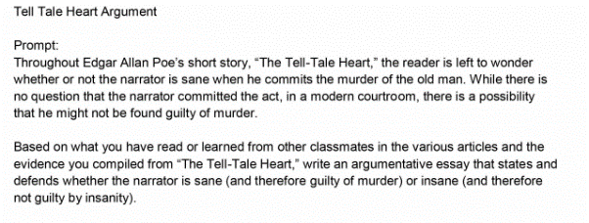
This assignment is strongly aligned to the standards.

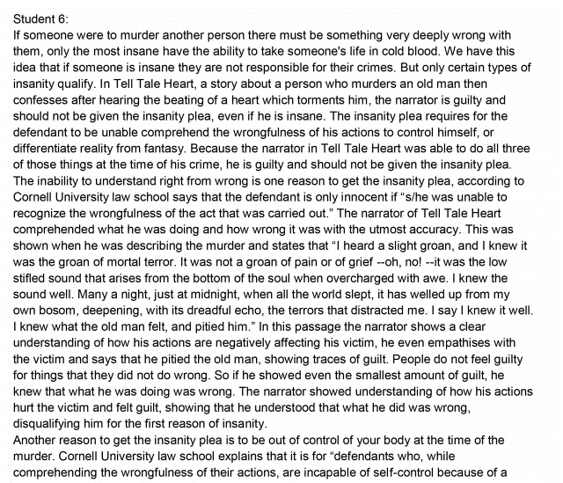

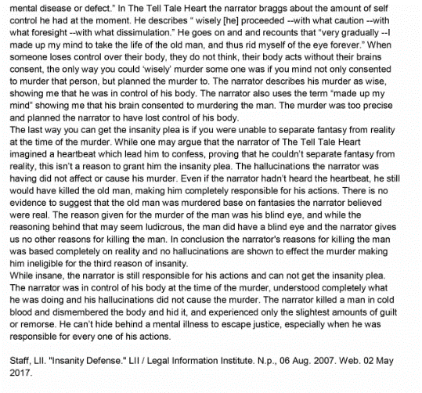
Overview
Seventh-grade students read “The Tell-Tale Heart” by Edgar Allen Poe, a grade-appropriate text, as well as supplemental non-fiction texts about the legal concept of insanity. They then write an argumentative essay about whether the narrator of “The Tell-Tale Heart” is sane (and therefore guilty) or insane (and therefore not guilty) of the story’s crime. This assignment exposes students to a noteworthy literary text and content-rich non-fiction texts, and asks students to write a substantive analytical essay using evidence from both.

About the Text

Title and Author | “The Telltale Heart” by Edgar Allen Poe
What is the Lexile Level of this text? | 820
Based on Lexile, which grades is this text intended for? | 4-5
Is the text qualitatively complex enough for the grade? | Yes
Is this text fiction or non-fiction? | Fiction
Is this text authentic or was it written for educational purposes? | Authentic
Does the text provide sufficient detail to build knowledge of a worthwhile topic and/or is it worth reading closely and re-reading? | Yes
Related Standards
RL.7.1: Cite several pieces of textual evidence to support analysis of what the text says explicitly as well as inferences drawn from the text.
The assignment is strongly aligned to this standard. Students must refer extensively to key details in the text to substantiate their claim about whether or not the narrator is sane.
C.7.1: Compose arguments to support claims with clear reasons and relevant evidence.
The assignment is strongly aligned to this standard. Students have the opportunity to articulate an independent, original claim about the text and support it with evidence. They also must draw on their learning from supplemental non-fiction texts to bolster their reasoning.
L.7.1: In both written and oral expression: a. Create sentences using correctly placed clauses and phrases; b. Demonstrate appropriate use of simple, compound, complex and compound-complex sentences to signal differing relationships among ideas.
The assignment is strongly aligned to this standard. Students have opportunity to demonstrate their command of correctly placed clauses and phrases and/or appropriate use of various sentence structures in the writing piece (though this is implicit rather than explicit in task directions).
L.7.2: When writing: a. Demonstrate appropriate use of a comma to separate coordinate adjectives; b. Demonstrate appropriate use of strategies and resources (print and electronic) to identify and correct spelling errors.
The assignment is strongly aligned to this standard. Students have opportunity to demonstrate their command of using commas to separate coordinate adjectives and to use electronic resources to correct errors in the writing piece (though this is implicit rather than explicit in task directions).
Why is this assignment strongly aligned?
It allows students to engage with a worthwhile text and build their knowledge. The text exhibits exceptional literary craft, offering many students first-time exposure to the concept of narrator reliability. The text demands significant inference and interpretation on students’ part. Students also expand their learning by reading supplemental non-fiction texts on the legal concept of insanity.
It requires students to read carefully and focus on the key details. Students must select relevant passages from the text to advance an argument about the narrator.
It allows students to practice structuring an argumentative piece of writing. Through their written responses, students practice making a claim, supporting it with evidence from multiple texts, and organizing their thoughts in a logical format. Students are also expected to demonstrate command of language conventions.

*The task could have been even stronger, if the author had aligned to RL.7.6, having students explore the development of the narrator’s perspective.

