7th Grade Reading and Writing Assignment
This assignment is partially aligned to the standards.
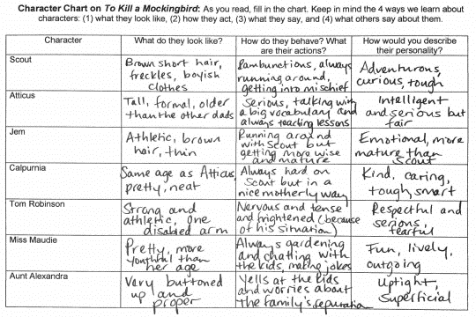
Overview
Seventh-grade students read To Kill a Mockingbird by Harper Lee, then fill out a chart that describes the salient traits of the main characters. The assignment exposes students to a worthwhile text, but the accompanying task does not reflect the depth of the seventh-grade standards. Students do not have opportunity to write substantively. Instead, they jot a series of descriptive words and phrases about multiple characters. There is no expectation that they include specific details from the text to support their descriptions.

About the Text

Title and Author | “To Kill a Mockingbird” by Harper Lee
What is the Lexile Level of this text? | 870
Based on Lexile, which grades is this text intended for? | 4-5
Is the text qualitatively complex enough for the grade? | Yes
Is this text fiction or non-fiction? | Fiction
Is this text authentic or was it written for educational purposes? | Authentic
Does the text provide sufficient detail to build knowledge of a worthwhile topic and/or is it worth reading closely and re-reading? | Yes

Related Standards
RL.7.1: Cite several pieces of textual evidence to support analysis of what the text says explicitly as well as inferences drawn from the text.
The assignment is partially aligned to this standard. Students are asked to make inferences about the characters’ personalities based on their behaviors in the story. The task attempts to capture the more critical part of this standard, which is citing “several pieces of textual evidence” to support analysis, however, where this demand is not explicitly stated, the student responses lack specific textual evidence.

RL.7.3: Analyze how particular elements of a story or drama influence one another.
The assignment is weakly aligned to this standard. The task focuses students on the characters , but it does not address the interaction of characters with other story elements, such as setting and plot, as this standard suggests.

RL.7.10: By the end of the year, flexibly use a variety of comprehension strategies (i.e., questioning, monitoring, visualizing, inferencing, summarizing, synthesizing, using prior knowledge, determining importance) to read, comprehend and analyze grade -level appropriate, complex literary texts independently and proficiently.
The text chosen for this assignment is strongly aligned to this standard because it contains the quantitative and qualitative attributes which are grade-level appropriate for seventh graders.

Why is this assignment partially aligned?
This assignment is partially aligned because the text is strong, but the writing prompt is not:
It allows students to engage with a noteworthy, grade-appropriate text. The text exhibits exceptional literary craft and builds students’ knowledge about the history of the Jim Crow era, racial segregation, and de facto discrimination toward African Americans by the criminal justice system.
The accompanying task does not require grade-level analysis. Students fill out a graphic organizer but have no opportunity to write more substantively about the text. The task does not build to a more rigorous analysis.
Students have no opportunity to use evidence to substantiate their ideas. Students’ descriptions of the characters are surface-level, and do not delve into the language and details of the text itself.

