Seventh Grade Math Assignment
This assignment is weakly aligned to the standards.
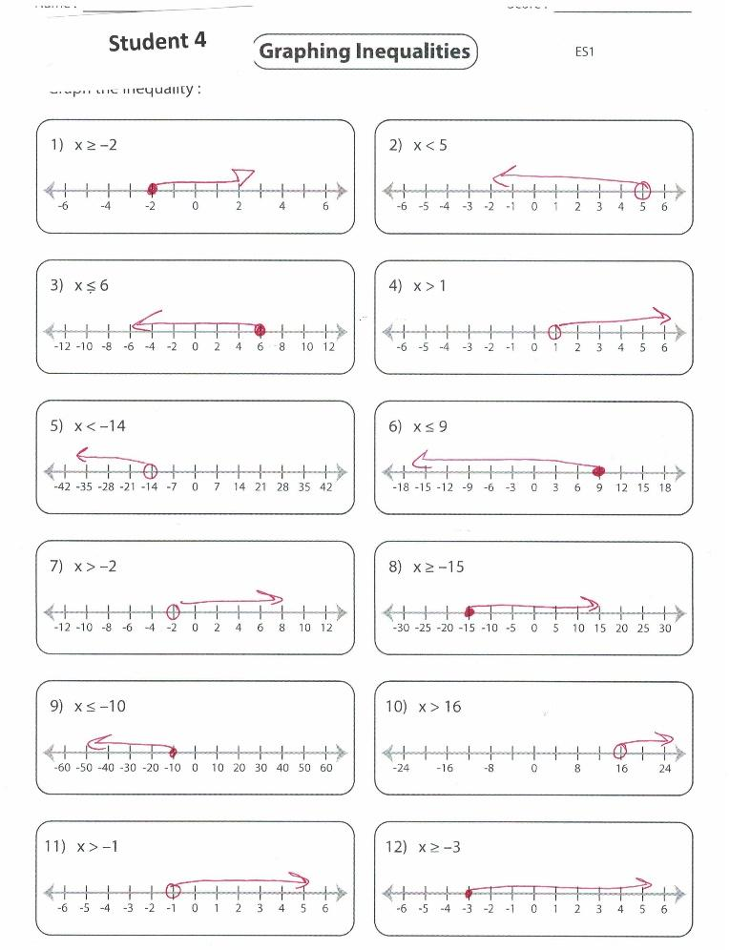

Overview
Seventh-grade students graph inequalities on a number line. This assignment is weak for seventh grade because it is more closely aligned with a sixth-grade standard. Seventh-grade students should be working with more complex inequalities and graphing them instead of representing them on a number line.

Related Standards
We looked at how well the assignment aligned to the following standard:

KY.7.EE.4 Use variables to represent quantities in a real-world or mathematical problem and construct equations and inequalities to solve problems by reasoning about the quantities.
b. Solve word problems leading to inequalities of the form 𝑝𝑥 + 𝑞 > 𝑟, 𝑝𝑥 + 𝑞 < 𝑟, 𝑝𝑥 + 𝑞 ≥ 𝑟, 𝑝𝑥 + 𝑞 ≤ 𝑟; where p, q and r are specific rational numbers. Graph the solution set of the inequality and interpret it in context of the problem.

Why is this assignment weakly aligned?
This assignment is more closely aligned with sixth-grade standard KY.6.EE.8, which requires students to work with inequalities in the form of x > c or x < c and represent solutions of inequalities on number lines. In seventh grade, students should work with more complex inequalities in the form of px + q > r or px + q < r—and that involve non-whole numbers and negative numbers—and graph the solution on the coordinate plane. Seven of the 12 problems in this assignment do involve negative numbers, but none involve non-whole-numbers, more complex inequalities, or graphs.
Standard KY.7.EE.4b targets conceptual understanding, procedural skill/fluency and application. Solving inequality problems in the context of word problems builds students’ application skills, graphing the solution on the coordinate plane builds students’ procedural skill, and interpreting the solution in the context of the problem builds students’ conceptual understanding. This assignment did not include any word problems or ask students to interpret their solutions in any way, and therefore didn’t allow students to build their application skills or conceptual understanding. It did build students’ procedural skill in representing simple inequalities on a number line, but that is a skill that students should be building in sixth grade, not seventh grade.
Practice Standards
This assignment doesn’t allow students to engage with any mathematical practice standards. None of the problems asked students to solve word problems about inequalities and represent the solutions in graphs on the coordinate plane, like standard KY.7.EE.4b requires. As a result, students didn’t have the opportunity to engage with either of the two related practice standards, Mathematical Practice Standard #1 ("Make sense of problems and persevere in solving them") and Mathematical Practice Standard #4 ("Model with mathematics").

