7th Grade Reading and Writing Assignment
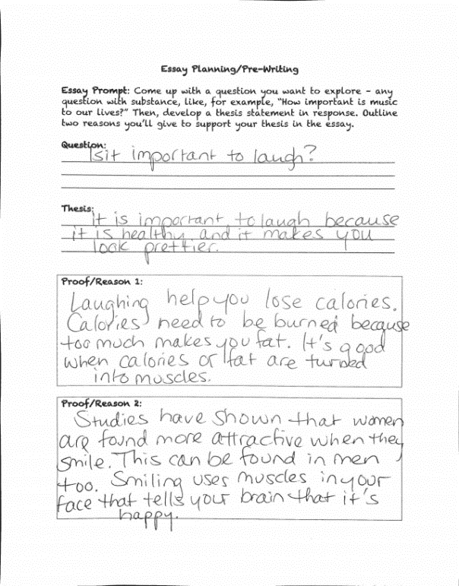
This assignment is weakly aligned to the standards.

Overview
Seventh-grade students plan an essay on a topic of their choice, then pose a question, write a thesis statement, and outline a rationale to support that thesis in an essay. (For example: “Is it important to laugh?” “It is important to laugh because it is healthy and makes you look pretty.”) This task is not connected to any text. Instead, the outline and essay are based solely on personal opinions. There is no opportunity to read, build knowledge, draw on evidence from texts, or share learning.
Related Standards
C.7.1: Compose arguments to support claims with clear reasons and relevant evidence.
The assignment is weakly aligned to this standard. Students are asked to make a claim and they are expected to outline rationale/reasoning for that claim. But the absence of text and meaningful content knowledge from the task render this structure hollow; though they write arguments, students base these arguments on their own experience and opinions rather than on authentic learning.
L.7.1: In both written and oral expression: a. Create sentences using correctly placed clauses and phrases; b. Demonstrate appropriate use of simple, compound, complex and compound-complex sentences to signal differing relationships among ideas.
The assignment is weakly aligned to this standard. Implicit in the task is that students will demonstrate command of language conventions in writing their essays. But given the absence of grade-level reading or writing from the task, they do not have opportunity to meet the demands of these language standards.
L.7.2: When writing: a. Demonstrate appropriate use of a comma to separate coordinate adjectives; b. Demonstrate appropriate use of strategies and resources (print and electronic) to identify and correct spelling errors.
The assignment is weakly aligned to this standard. Implicit in the task is that students will demonstrate command of language conventions in writing their essays. But given the absence of grade-level reading or writing from the task, they do not have opportunity to meet the demands of these language standards.

Why is this assignment weakly aligned?
The task includes no reading. Students write an essay on a topic of their choosing, rather than building an argument based on a text.
Students have no opportunity to do substantive, analytical writing. Students draw only on their personal ideas and experiences.
Students do not build knowledge. There is no opportunity for students to engage with any meaningful content or cultural knowledge.

