Grade 8 Assignment
This assignment is strongly aligned to the standards.

Teacher Notes

Introduction
This Teacher Notes document provides instructional support for implementing the strongly aligned assignments to the KAS for Social Studies. To examine why this assignment is strongly aligned to the KAS for Social Studies, engage with the Grade 8 Assignment Review Protocol for this assignment.

It is important to note that the assignment(s), indicated throughout the Teacher Notes with shaded boxes, and related resource(s) represent one example. It is not a requirement nor a suggestion for school curriculum. While the Kentucky Department of Education (KDE) is responsible for the development of high-quality academic standards, state law assigns each local district the authority to develop the school’s curriculum and determine appropriate instructional resources based on language found in Kentucky Revised Statute (KRS) 160.345. It is under the discretion of the superintendent to determine the local curriculum, including the evaluation and selection of instructional resources. The KDE does not adopt, select or recommend specific curricula for coursework. Per KRS 160.345(g), “the local superintendent shall determine which curriculum, textbooks, instructional materials, and student support services shall be provided in the school after consulting with the local board of education, the school principal, and the school council and after a reasonable review and response period for stakeholders in accordance with local board of education policy.”

KAS for Social Studies alignment:
- 8.I.Q.1 Develop compelling questions related to the development of the United States between 1600-1877.
- 8.I.Q.2 Generate supporting questions, using the disciplines of social studies, to help answer compelling questions in U.S. history between 1600-1877.
- 8.H.CO.2 Describe the conflicts and compromises that shaped the development of the U.S. government between 1783-1877.
- 8.C.KGO.1 Examine the role of Kentucky and Kentuckians within national politics between 1792-1877.
- 8.I.UE.1 Use multiple sources to develop claims in response to compelling and supporting questions.
- 8.I.CC.3 Evaluate how individuals and groups address local, regional and global problems concerning the development of the United States.
- 8.I.CC.4 Apply a range of deliberative and democratic procedures to make decisions about ways to take action on current local, regional and global issues.

Educators may have to engage with a standard multiple times throughout a year in order to meet the full intent of the standard. As a result, the following assignment example may not encompass the entire scope of the standards identified.

Overview:
Students will investigate the Missouri Compromise and how Henry Clay’s influence resulted in a compromise. Students will construct an explanation to evaluate how the U.S. government compromised between 1600-1877.

Setting the Stage: Compelling Question

8.I.Q.1 Develop compelling questions related to the development of the United States between 1600-1877.

Compelling Question: How does a government compromise amidst polarization?

It is important to note that while this assignment provides a compelling question to demonstrate alignment, student development of compelling questions is a critical part of the inquiry process. Since 8.I.Q.1 states “develop compelling questions,” teachers should provide opportunities for students to develop their own compelling questions related to the development of the United States between 1600-1877. For more information on compelling questions, visit Section B: “What are Compelling Questions and how do students ask them?” from the Inquiry Practices of the KAS for Social Studies module

To introduce the Missouri Compromise and to support students in asking questions about this topic, students may engage with The Missouri Compromise, 1820:

Mcconnell Map Co & McConnell, J. (1919) McConnell’s Historical maps of the United States. The Missouri Compromise of 1820. Library of Congress. https://www.loc.gov/resource/g3701sm.gct00482/?sp=25.

Have students ask questions about this map using What Makes You Say That?. This routine supports students in asking questions about what they see and requires them to support their observations using evidence from the map. It is important to note that resources and strategies, such as What Makes You Say That, help students analyze maps to support the development of their own questions; however, this strategy does not necessarily enable students to develop compelling questions. Teachers and students will need to evaluate the created questions posed using the characteristics of a compelling question to determine if the process elicited compelling questions or if the questions posed need to be revised to make them compelling. For example, a student may pose an open question that, with some additional revision, could become a compelling question related to the development of the United States between 1600-1877.

Prior to engaging with this compelling question, ensure that students understand the term “compromise.” Pose the term “Compromise” for students to consider using the 3-2-1 Bridge thinking routine. When students are first considering the term, have them state three thoughts or ideas, two questions, and one metaphor or simile. Next, have students engage with sources about “compromise” such as, but not limited to, quotes from individuals, political cartoons, songs, videos or images from articles. As students engage with the sources, they should corroborate the sources. The Stanford History Education Group (SHEG) states that “Corroboration asks students to consider details across multiple sources to determine points of agreement and disagreement.” According to SHEG, a student who engages in corroboration asks the following questions, among others, of the sources:

- What do other documents say?
- Do the documents agree? If not, why?

After engaging with the sources, have students consider new responses based on what they have learned from engaging with the sources. Students will complete the 3, 2, 1 thinking routine again stating three thoughts or ideas, two questions, and one metaphor or simile using the knowledge they have gained. In pairs, students can share their initial and new thinking while explaining how their responses are related and how engaging with the sources influenced their thinking.

Supporting Question

8.I.Q.2 Generate supporting questions, using the disciplines of social studies, to help answer compelling questions in U.S. history between 1600-1877.

Supporting Question: How did the Missouri Compromise temporarily save the Union?

Supporting questions are aligned to the compelling question and can be answered through using the concepts and practices of each social studies discipline. In grade 8, students are expected to generate supporting questions. Strategies such as Circle of Viewpoints may be used to support students in this work. For more information on developing supporting questions, visit “Section C: What are Supporting Questions, and how do students ask them?”
from the Inquiry Practices of the KAS for Social Studies module.

Investigation: Part 1
In order to investigate the supporting question for this assignment example, students will describe how the Missouri Compromise resulted from conflict surrounding the expansion of slavery and how this compromise shaped the development of the U.S. government during this time.

8.H.CO.2 Describe the conflicts and compromises that shaped the development of the U.S. government between 1783-1877.

It is important to note that the Missouri Compromise is one example of the conflicts and compromises that shaped the development of the U.S. government between 1783-1877. Since students must have the opportunity to master the entire scope of this standard, teachers must be aware that they will engage with this standard multiple times throughout a student’s learning experience in Grade 8. As a result, teachers may determine a variety of ways in which students could engage with 8.H.CO.2 beyond the scope of the Missouri Compromise.

Have students take notes while watching the following video:

History.com Editors. (2019, September 27). Missouri Compromise. History Channel. https://www.history.com/topics/abolitionist-movement/missouri-compromise.

Students may need to watch the video twice to support their understanding of the Missouri Compromise. To guide a student’s focus while watching the video for the first time, have students reflect on the question “What was the Missouri Compromise?” as they engage in their initial viewing of the clip. During the second viewing, have students take notes on what the Missouri Compromise was, why it was created and the impact of the compromise on the United States. For guidance on how to take notes while watching a video, visit Taking Notes During a Video. If students need more support in general note taking strategies, visit Taking Notes: Crash Course Study Skills #1.

At the conclusion of the video, have students engage in small group discussions about the following questions to demonstrate their understanding of the Missouri Compromise. For guidance on how to facilitate a class discussion with these questions, visit The Big List of Class Discussion Strategies and scroll down to “Conver-stations.”

- Describe attitudes toward slavery in America in 1820. How did these conflicting perspectives shape the political climate at this time?
- Explain how the Missouri Compromise appeased those who wanted to expand slavery and those who wanted it abolished.
- Why was this compromise significant?
- Was this compromise successful at resolving the conflict about slavery in America in 1820?

When students have completed the “Conver-stations,” facilitate a whole group discussion for students to share their conclusions and address any misconceptions on the Missouri Compromise from the small group discussions. For guidance on how to conduct a whole class discussion, teachers may reference Leading a Discussion. This will allow the teacher to check for understanding of how the Missouri Compromise shaped the development of the United States in 1820.

Once the whole group discussion has concluded, have students do the following:
Examine the Missouri Compromise of 1820 using the Analyze a Written Document tool. Independently or in small groups, have students answer the questions provided.

Source:
Library of Congress. (n.d.). The Missouri Compromise of 1820. https://memory.loc.gov/cgi-bin/ampage?collId=llsl&fileName=003/llsl003.db&recNum=586%20https://www.history.com/topics/abolitionist-movement/missouri-compromise.

It is important to note that students may need support when engaging with this primary source. Educators may need to adapt, excerpt and or translate this source to support student engagement.

For guidance on how to organize students into small groups, teachers may reference Using Roles in Group Work or Setting up and managing small group work. In order for the successful implementation of small group work, teachers must be mindful of organizing the small groups purposefully, clearly stating the expectations of the assignment being completed and clearly identifying student roles.

When students have completed their Analyze a Written Document tool, have students engage in small group discussions where they share the parts they observed, how they made sense of the document, and the responses they shared for using it as historical evidence by using conversation markers. Conversation markers encourage students to “use statements that promote the cohesion of ideas” (Hattie, Stern, Fisher and Frey, 2020). Sample conversation markers for small group discussion may include, but are not limited to, the following:

- “Can you tell us more about that?”
- “Can you show me where you found that information?”
- “I agree with ____ because ___.” “That is a great point.”
- “I want to add on to what ____ just said.”

As students discuss their responses to the Analyze a Written Document tool, engaging in conversation starters will promote deeper learning of their topic because students are required to engage in deep discussion that build on each other’s points. Additionally, this small group discussion will support students when engaging with Investigation: Part 3.

Here is an example of a completed Analyze a Written Document tool:

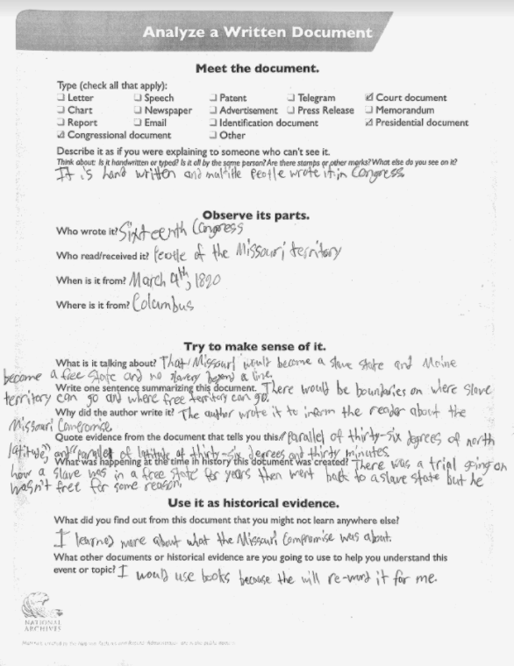

Prior to continuing to the next Investigation, teachers need to check for understanding of the Missouri Compromise. To do so, teachers may use funneling questions when facilitating whole group discussion. Funneling questions “intentionally send students down a cognitive path with a known endpoint.” Funneling questions are appropriate to use here as students are “in the surface acquisition period” of the Missouri Compromise. To check for student understanding, teachers may use some of the questions from the Analyze a Written Document tool such as:
- Who wrote The Missouri Compromise?
- Who read/received The Missouri Compromise?
- When and where is The Missouri Compromise from? Where is it from?
- What is The Missouri Compromise talking about?

As students complete the funneling questions in the whole group discussion, transition to using focusing questions to support a more in-depth discussion of the Missouri Compromise and to prepare students for Investigation: Part 3. Focusing questions “prompt more discussion.” Some questions may be drawn from the Analyze a Written Document tool, and may include, but are not limited to the following:
- Write one sentence summarizing this document.
- Why did the author write it? Quote evidence from the document that tells you this.
- What was happening at the time in history this document was created?
- How does the meaning of “compromise” apply to the Missouri Compromise?

Investigation: Part 3
8.C.KGO.1 Examine the role of Kentucky and Kentuckians within national politics between 1792-1877.

Have students read or listen to Missouri Compromise: A Win-Win for Clay:

National Public Radio. (2007, January 26). Missouri Compromise: A Win-Win for Clay [audio]. https://www.npr.org/templates/story/story.php?storyId=7043103.

As they are reading or listening to the piece, have students answer the following questions:
- In Missouri Compromise: A Win-Win for Clay, Robert Remini states that compromise is achieved when “each side must feel that they have gotten something they wanted. But in order to do that, you must give up something that the other side wants so to that there are no winners and no losers.” How did Henry Clay give something to both sides in the Missouri Compromise?
- Michele Norris asks “could those same tactics (of Henry Clay) be used effectively today? What is Robert Remini’s claim and what evidence does he use to support his claim?
- Why was Henry Clay considered "great" at compromising? Cite evidence from the sources to support your response.

Here is an example of completed questions from a Kentucky classroom:

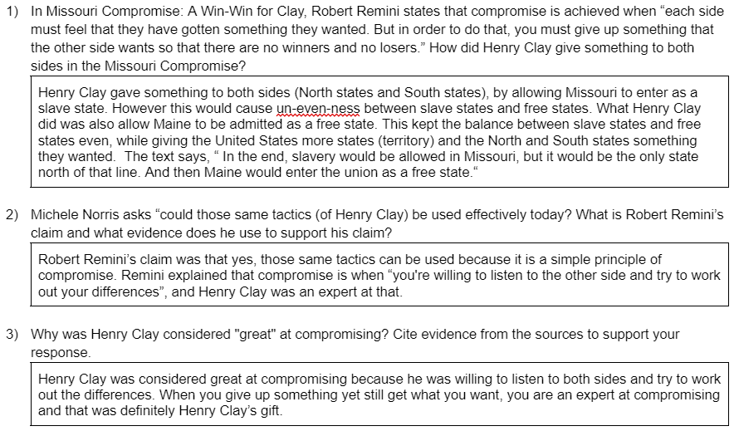

Task Aligned to the Supporting Question:

KAS for Social Studies alignment:
- 8.I.Q.2 Generate supporting questions, using the disciplines of social studies, to help answer compelling questions in U.S. history between 1600-1877.
- 8.H.CO.2 Describe the conflicts and compromises that shaped the development of the U.S. government between 1783-1877.
- 8.C.KGO.1 Examine the role of Kentucky and Kentuckians within national politics between 1792-1877.
- 8.I.UE.1 Use multiple sources to develop claims in response to compelling and supporting questions.
- 8.I.CC.3 Evaluate how individuals and groups address local, regional and global problems concerning the development of the United States.

In these assignments, students are required to synthesize information learned through engaging with the disciplinary strand standards to answer a supporting question.

Task Aligned to the Supporting Question

Construct an explanation to answer the supporting question: “How did the Missouri Compromise temporarily save the Union?”

In your response:
- Demonstrate your knowledge of the conflicts and compromises that shaped the development of the U.S. government.
- Demonstrate your knowledge of the role of Kentucky and Kentuckians within national politics.
- Evaluate how individuals and groups addressed a regional problem.
- Use multiple sources to develop a claim.

Below are examples from Kentucky classrooms.

Strongly Aligned
The Missouri Compromise temporarily saved the Union by saving the north and south from breaking out into war, keeping the balance between the amount of free and slave states there were in the United States, and giving the United States an example of how to settle disputes and debates similar to this in the future.
The first way the Missouri Compromise temporarily saved the Union was it kept the United States from breaking out into war between the North and the South. According to a Win-Win for Clay, “And perhaps his greatest work was the Missouri Compromise of 1820, bridging the gap between the North and the South over slavery. Many say it helped delay the civil war for decades.” As shown, it delayed war between the North and the South, which temporarily saved the Union.
The second way the Missouri Compromise temporarily saved the Union is it kept balance between the amount of free and slave states. According to History Channel, “This time, Speaker of the House Henry Clay proposed that Congress admit Missouri to the Union as a slave state, but at the same time admit Maine (which at the time was part of Massachusetts) as a free state.”, with A Win-Win for Clay stating, “Eleven free states, eleven slave states.” This balance saved the Union because the northerners wanted slavery abolished and the southerners accepted slavery as their culture. They thought so much of their opinions, it could’ve caused the war (earlier spoken of) to break out. As you can see, the Missouri Compromise temporarily saved the Union by keeping balance between slave and free states.
The last way that the Missouri Compromise (Henry Clay specifically) temporarily saved the Union was giving an example for the future on how to Compromise. A Win-Win for Clay explains, “NORRIS: So the tactics that Henry Clay used to bring about the Missouri Compromise, could those same tactics be used effectively today? Mr. REMINI: I think so. Why not? It's a basic principle of compromise.” This is important because the future Compromises can temporarily save the Union in the future. As you can see, the Missouri Compromise (Henry Clay) temporarily saved the Union by setting an example for the future of the Union.
In conclusion, the Missouri Compromise temporarily saved the Union in many ways. The Missouri Compromise delayed war from breaking out. The Missouri Compromise also kept balance between the slave states and the free states. Lastly, the Missouri Compromise (Henry Clay) provided an example for the future of the Union. Clearly, the Missouri Compromise saved the Union, even if it was just temporary.

Partially Aligned

The Missouri Compromise temporarily saved the Union by hearing out both sides of the argument. The Missouri Compromise is an agreement between the North and the South that prohibits any slaves north of the 36°30 line and states that Maine is a free state and Missouri is a slave state. When Missouri wanted to be a state it would mess up the balance between the North and the South. The South wanted Missouri to be a slave state. The North wanted Missouri to be a free state. They were at a disagreement. They solved this disagreement by creating The Missouri Compromise. In a “Win-Win for Clay” it sates, “And so he, Clay, recognized that what you have to do is get the North to back off and yet achieve some kind of victory in bringing an end to the further expansion and growth of slavery, and at the same time protect what the Southerners feel is their institution. And that is what the Missouri Compromise is about. In the Louisiana territory, you draw this line at 36°30' and there is no slavery north of the 36°30'.” This proves that The Missouri Compromise took both sides into consideration and made an agreement. The agreement was all about making everything between the North and South balanced. Although the compromise was temporary it still worked. In the article “History Channel” it says, “When the Missouri Territory first applied for statehood in 1818, it was clear that many in the territory wanted to allow slavery in the new state. Part of the more than 800,000 square miles bought from France in the Louisiana Purchase in 1803, it was known as the Louisiana Territory until 1812, when it was renamed to avoid confusion with the newly admitted state of Louisiana.” This proves that half wanted to make it pro-slavery and half wanted it to make it a free state. They had to find some type of agreement and they did. In the source “History Channel” it also states, “In 1820, amid growing sectional tensions over the issue of slavery, the U.S. Congress passed a law that admitted Missouri to the Union as a slave state and Maine as a free state, while banning slavery from the remaining Louisiana Purchase lands located north of the 36º 30’ parallel.” This proves that in order to prevent any more tensions they needed to create a solution and they did by passing the law. Overall, The Missouri Compromise temporarily saved the Union by hearing out both sides of the agrument.

Weakly Aligned
The Missouri Compromise temporarily saved the Union by not making the slave states not to isolate from the Union. In “Source A: History Channel”, in paragraph 1, it states, "In 1820, amid growing sectional tensions over the issue of slavery, the U.S. Congress passed a law that admitted Missouri to the Union as a slave state and Maine as a free state, while banning slavery from the remaining Louisiana Purchase lands located north of the 36º 30’ parallel.” This proves that It saved the Union from the slave states’ separation because it stopped the slavery debate, which was were the Union wanted slave states and free states. Another piece of evidence is in “Source A: History Channel'' in paragraph 2, it states, “The Missouri Compromise, as it was known, would remain in force for just over 30 years before it was repealed by the Kansas-Nebraska Act of 1854. In 1857, the Supreme Court ruled the compromise unconstitutional in the Dred Scott case, setting the stage for the nation’s final path toward the Civil War.” This proves that the Missouri Compromise stopped the slave states from seperating because the Supreme Court ruled the Kansas-Nebraska Act unconstitutional.

Task Aligned to the Compelling Question:

KAS for Social Studies alignment:
- 8.I.Q.1 Develop compelling questions related to the development of the United States between 1600-1877.
- 8.I.UE.1 Use multiple sources to develop claims in response to compelling and supporting questions.
- 8.I.CC.3 Evaluate how individuals and groups address local, regional and global problems concerning the development of the United States.
- 8.I.CC.4 Apply a range of deliberative and democratic procedures to make decisions about ways to take action on current local, regional and global issues.

Assignments aligned to the compelling question are designed to provide guidance on how to have students synthesize the knowledge learned from engaging with the supporting question(s) to investigate enduring and significant unresolved issues addressed by the compelling question. In this example, one supporting question is provided that is aligned to a compelling question. However, students may need to engage with more than one supporting question in order to fully engage with a compelling question. This assignment culminates with students using their historical thinking skills to confront today’s problems.

Task Aligned to the Compelling Question
How does a government compromise amidst polarization?

Based on your explanation for the supporting question, consider the following video entitled, “This 60-second animation shows how divided Congress has become over the last 60 years.”

Construct an argument to the following question: In light of the modern division within Congress, how does a government compromise amidst polarization? Draw on what you learned about Henry Clay’s civic action and additional compromises in American history to evaluate how individuals or groups might address a local, regional and/or global problem in modern society. Be prepared to share your thinking through deliberative and democratic procedures and support your argument with evidence from multiple sources.

For guidance on how to facilitate student understanding of how individuals or groups might address a local, regional and/or global problem in modern society, engage with the Circles of Action strategy. This strategy supports students to investigate ways that they can take action on an issue.

In the KAS for Social Studies, deliberative and democratic procedures are defined as follows: “a process where deliberation is central to decision making. This process also looks to generate outcomes that promote the common good through reasoning, rather than through a law-making process.” For guidance on how to facilitate deliberative and democratic procedures, visit the Guide to Classroom Deliberation for Students and Teachers for information on how to implement norms and routines for classroom deliberative and democratic processes.

Hattie, J., Stern, J., Fisher, D., & Fry, N. (2020). Visible Learning for Social Studies. Corwin.
Michaels, S., O’Conner, M. C., Hall, M. W., & Resnick, L. B. (2010). Accountable Talk sourcebook: For classroom conversation that works (v. 3. 1). Pittsburgh, PA: University of Pittsburgh Institute for Learning. http://ifl.lrdc.pitt.edu
Hattie, J., Stern, J., Fisher, D., & Fry, N. (2020). Visible Learning for Social Studies. Corwin.
Hattie, J., Stern, J., Fisher, D., & Fry, N. (2020). Visible Learning for Social Studies. Corwin.
Hattie, J., Stern, J., Fisher, D., & Fry, N. (2020). Visible Learning for Social Studies. Corwin.

