Eighth Grade Math Assignment
This assignment is strongly aligned to the standards.
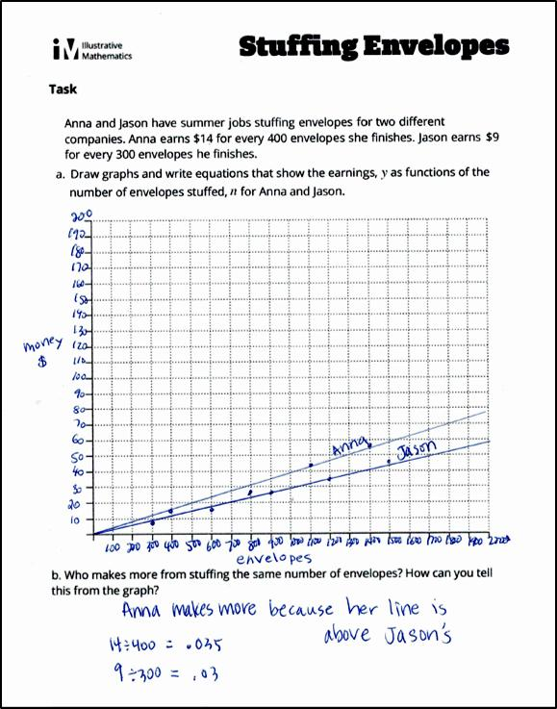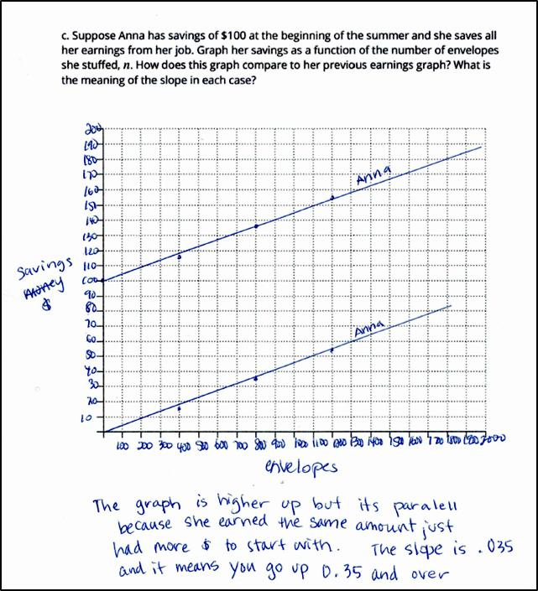

Overview
Eighth-grade students draw graphs and write equations to represent a real-world scenario about earning money by stuffing envelopes, and then interpret the meaning of the rate associated with each graph/equation. The assignment is strongly aligned to eighth-grade standards because it involves graphing proportional relationships and finding and interpreting the unit rate of these graphs.

Related Standards
We looked at how well the assignment aligned to the following standards:
KY.8.EE.5 Graph proportional relationships, interpreting the unit rate as the slope of the graph. Compare two different proportional relationships represented in different ways.’
KY.8.F.4 Construct a function to model a linear relationship between two quantities.
a. Determine the rate of change and initial value of the function from a description of a relationship or from two (x, y) values, including reading these from a table or from a graph.
b. Interpret the rate of change and initial value of a linear function in terms of the situation it models and in terms of its graph or a table of values.
Why is this assignment Strongly aligned?
Students explore proportional relationships through tables, equations, and graphs in seventh grade (standard KY.7.RP.2), and extend the concepts of proportional relationships to linear equations in eighth grade. Because the assignment asks students to interpret the unit rates/rates of change of two graphs in the context of the situation being modeled, it connects and extends their understanding from seventh grade in a manner appropriate to eighth grade.
Standards KY.8.EE.5 and KY.8.F.4 target conceptual understanding, procedural skill, and application, and the assignment addresses each of those. Students build conceptual understanding when they determine which envelope-stuffing rate is greater, use procedural skill by graphing the two relationships, and apply mathematics to a real-world scenario.
Practice Standards
The assignment provides an opportunity for students to engage with Mathematical Practice Standard #2 (“Reason abstractly and quantitatively”). For instance, they decontextualize the math—that is, they think about the numbers and math separate from the real-world context—to construct a graph for each situation, then recontextualize—or consider the meaning of the numbers and the math in terms of the real-world context—as they use the graph and rate to determine who earns more for stuffing envelopes.

