Eighth Grade Math Assignment
This assignment is partially aligned to the standards.
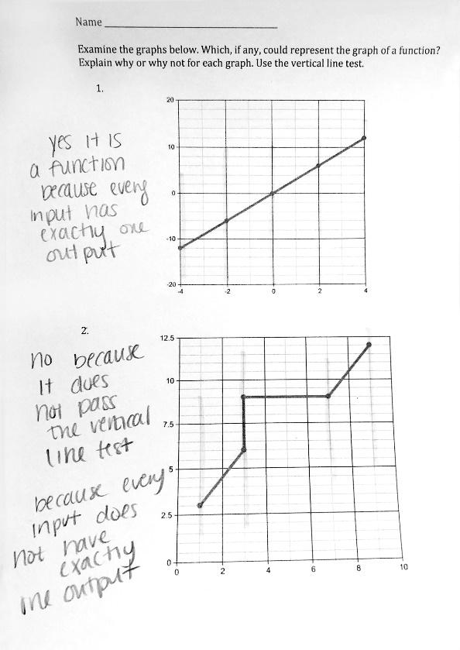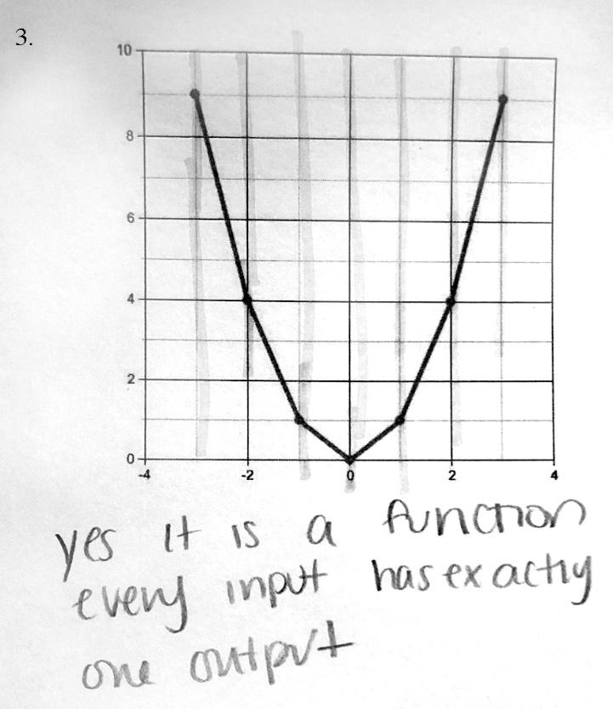

Overview
Eighth-grade students look at relationships to determine whether they represent a function. The assignment is partially aligned to an eighth-grade standard because it addresses the concept of a function, but it doesn’t ask students to reason about whether or not a graph represents a function, nor does it focus on identifying functions in other forms.
Related Standards
We looked at how well the assignment aligned to the following standard:
KY.8.F.1 Understand that a function is a rule that assigns to each input exactly one output. The graph of a function is the set of ordered pairs consisting of an input and the corresponding output.

Why is this assignment partially aligned?
The assignment is aligned to the content of standard KY.8.F.1 because it contains graphical representations and asks students to determine whether they are functions. Two examples represent functions and one example does not, so students can note the difference between the two.
Standard KY.8.F.1 requires students to understand the concept of a function. For example, students might make connections between the visual image and the definition of a function, and reason about how and where the inputs and outputs appear on the graph. However, in this assignment students are instructed to use the vertical line test to determine whether provided graphs represent functions, a shortcut that leads to the right answer without requiring conceptual understanding of what assigning exactly one output to each input actually means. of what assigning exactly one output to each input actually means. In standard KY.8.F.2 students are comparing properties of two functions represented in different ways, including algebraically, graphically, numerically in tables, or by verbal descriptions. Students need to develop a conceptual understanding of what a function is holistically, not only focused on graphing or on the vertical line test.

