8th Grade Reading and Writing Assignment
This assignment is partially aligned to the standards.
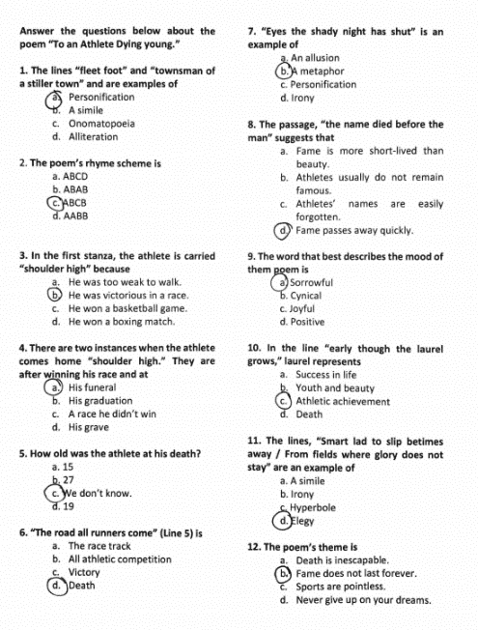

Overview
Eighth-grade students read “To an Athlete Dying Young” by A.E. Housman, then respond to a series of multiple-choice questions. While the text is grade-appropriate and worthwhile, the questions only ask students to recall straightforward content from the text (e.g., “How old was the athlete when he died?”) or to identify discrete examples of literary devices (e.g., “’Eyes the shady night has shut’ is an example of _______”). The questions do not build deep understanding of the text, and there is no expectation that students draw on specific details and language to support their responses.

About the Text

Title and Author | “To an Athlete Dying Young” by A.E. Housman
What is the Lexile Level of this text? | As a “non-prose” (NP) text, the poem does not have a Lexile level.
Based on Lexile, which grades is this text intended for? | N/A (poetry)
Is the text qualitatively complex enough for the grade? | Yes
Is this text fiction or non-fiction? | N/A (poetry)
Is this text authentic or was it written for educational purposes? | Authentic
Does the text provide sufficient detail to build knowledge of a worthwhile topic and/or is it worth reading closely and re-reading? | Yes

Related Standards
RL.8.1: Cite relevant textual evidence to support analysis of what the text says explicitly as well as inferences drawn from the text.
The assignment is weakly aligned to this standard. Some questions require students to make inferences about the character and the basic narrative of the poem, but the task does not capture the more critical part of this standard, which is citing textual evidence to support these inferences.

RL.8.2: Determine themes of a text, and analyze how they are developed through relationships of characters, setting and plot, citing textual evidence, paraphrasing or summarizing.
The assignment is weakly aligned to this standard. The final question asks students to choose a theme statement from among several provided choices. Students do not have opportunity to analyze the development of this theme over the course of the text, or to articulate its relationship to the characters, setting, plot, etc.

RL.8.4: Determine the meaning of words and phrases as they are used in a text, including figurative and connotative meanings; analyze the impact of specific word choices on meaning and tone, including but not limited to analogies or allusions to other texts.
The assignment is partially aligned to this standard. Several questions call attention to specific words and phrases within the text. The first question, for example, asks students to identify the literary device exemplified by the lines “fleet foot” and “townsman of a stiller town” (alliteration). These questions mostly represent isolated practice with identifying a literary device or deciphering a specific phrase, so they do not work to build students’ understanding of meaning and tone in the poem. Question 9 attempts to capture the mood of the poem, but the standard requires meaning and tone to be addressed. Questions 3, 6, 8, and 10 attempt to address the part of the standard “determining the meaning of words and phrases as they are used in a text”. Although these questions could be stronger, there is partial alignment with this standard.

RL.8.10: By the end of the year, flexibly use a variety of comprehension strategies (i.e., questioning, monitoring, visualizing, inferencing, summarizing, synthesizing, using prior knowledge, determining importance) to read, comprehend, and analyze grade-level appropriate, complex literary texts independently and proficiently.
The assignment is partially aligned to this standard because the poem does require a variety of comprehension strategies for analysis. Although some of the questions do not meet the rigor of the standard (e.g., questions 2 and 5) , there is an attempt to align others to this standard (e.g., questions 3, 4, 8). The poem contains the qualitative attributes which are grade-level appropriate for eighth grade because students have to analyze various elements of poetry (e.g., structure, vocabulary, figurative language, imagery).

Why is this assignment partially aligned?
This assignment is partially aligned because the text is strong, but the some of the questions are not:
The assignment allows students to engage with a worthwhile, complex poem. The text exhibits exceptional literary craft, using imagery, metaphor, and irony to develop a theme about the fleeting nature of fame and glory.
The accompanying task does not require students to analyze the poem deeply. Students respond to multiple-choice questions that ask them to recall the basic narrative of the poem or identify literary devices. Students do not have to assess how the poem uses imagery and metaphor to develop a complex theme.
Students have no opportunity to use evidence to substantiate their ideas. Students are not asked to write about the poem or demonstrate understanding of its tone or meaning.

