Eighth Grade Math Assignment
This assignment is weakly aligned to the standards.
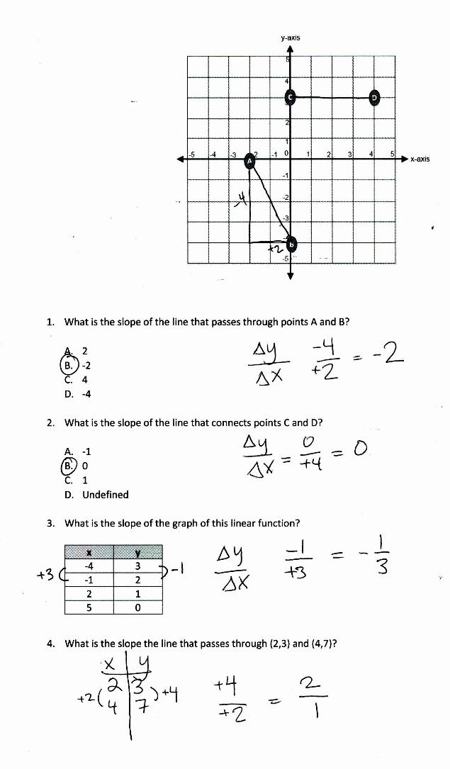

Overview
Eighth-grade students find the slope of the line through two given points in a variety of formats. The assignment is weakly aligned to the eighth-grade standard because it does not require students to make connections between their understandings of similar triangles and slope of linear equations.

Related Standards
We looked at how well the assignment aligned to the following standard:
KY.8.EE.6 Use similar triangles to explain why the slope, m, is the same between any two distinct points on a non-vertical line in the coordinate plane; know the equation y = mx for a line through the origin and the equation y = mx + b for a line intercepting the vertical axis at b.

Why is this assignment weakly aligned?
The assignment misses the opportunity for students to make connections between their conceptual understanding of similar triangles and the slope of a linear equation, as required by standard KY.8.EE.6. When this connection is made explicit, it gives students a deeper understanding of what the slope of a line means and provides an authentic application of the concept of triangle similarity.
Standard KY.8.EE.6 calls for students to explain why the slope m is the same between any two distinct points on a non-vertical line, which requires students to have a conceptual understanding of what slope is. The assignment only tests for procedural skill by asking students to simply calculate the value of the slope.
Practice Standards
The assignment does not support students’ use of any mathematical practice standards, even though standard KY.8.EE.6 presents an opportunity for students to engage with Mathematical Practice Standard #8 (“Look for and express regularity in repeated reasoning”). By constructing a right triangle that connects two distinct points on a non-vertical line in the coordinate plane, students can visualize the slope of the line as represented by the hypotenuse of a right triangle. Then, by selecting any other two points on the same non-vertical line and constructing the corresponding right triangle, students can recognize that the two triangles are similar and therefore have a basis for understanding slope as a constant rate of change.

