8th Grade Reading and Writing Assignment
This assignment is weakly aligned to the standards.

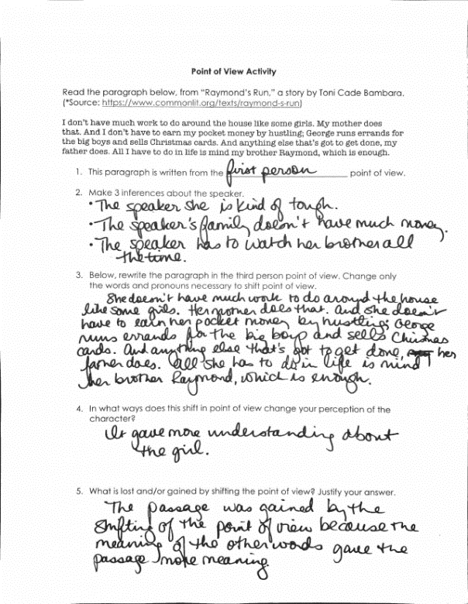
Overview
Eighth-grade students read a short excerpt from “Raymond’s Run,” a short story by Toni Cade Bambara, then answer a few basic questions. The text is below grade level, and the excerpt does not give students a strong sense of the narrative or demand significant analysis. The questions are not text-dependent, and only require students to differentiate between first and third person point of view. The task is skills-based and does not allow students to demonstrate a deep understanding of the text or to read or write substantively.
ABOUT THE TEXT

Title and Author | “Raymond’s Run” by Toni Cade Bambara
What is the Lexile Level of this text? | 600-700 (This is the Lexile Level for the brief passage that students read, not the full story)
Based on Lexile, which grades is this text intended for? | 2-3
Is the text qualitatively complex enough for the grade? | No
Is this text fiction or non-fiction? | Fiction
Is this text authentic or was it written for educational purposes? | Authentic
Does the text provide sufficient detail to build knowledge of a worthwhile topic and/or is it worth reading closely and re-reading? | No

Related Standards
RL.8.1: Cite relevant textual evidence to support analysis of what the text says explicitly as well as inferences drawn from the text.
The assignment is weakly aligned to this standard. Question 2 asks students to make 3 inferences about the speaker in the passage. But the task does not capture the more critical part of this standard, which is citing textual evidence to support such inferences.
RL.8.6: Analyze characters’ and readers’ perspectives and how the differences create effects, including but not limited to suspense, humor and empathy.
The assignment is weakly aligned to this standard. The questions are focused superficially on the text’s point of view, but not at the level of depth and rigor intended by this standard. Questions ask students to name the point of view in the passage, rewrite the passage from a different point of view, and reflect briefly on that difference. But there is no expectation of contrasting the points of view of different characters or analyzing the literary effects created by point of view.
RL.8.10: By the end of the year, flexibly use a variety of comprehension strategies (i.e., questioning, monitoring, visualizing, inferencing, summarizing, synthesizing, using prior knowledge, determining importance) to read, comprehend, and analyze grade-level appropriate, complex literary texts independently and proficiently.
The assignment is weakly aligned to this standard.
L.8.1: In both written and oral expression: a. Identify verbals correctly based on their intended function; b. Demonstrate appropriate use of verbs in the active and passive voice; c. Demonstrate appropriate use of verbs in the indicative, imperative, interrogative, conditional and subjunctive mood, while recognizing and correcting inappropriate shifts.
The assignment is weakly aligned to this standard. There are limited opportunities to practice with appropriate use of verbs in the active and passive voice as students rewrite the paragraph from a different point of view. But they are essentially copying a paragraph and changing pronouns; there’s no opportunity to independently demonstrate command of language.
L.8.2: When writing: a. Demonstrate appropriate use of punctuation to indicate a pause or break; b. Demonstrate appropriate use of an ellipsis to indicate an omission; c. Demonstrate appropriate use of strategies and resources (print and electronic) to identify and correct spelling errors.
The assignment is weakly aligned to this standard. There are limited opportunities to practice with appropriate use of punctuation to indicate a pause or break as students rewrite the paragraph from a different point of view. But they are essentially copying a paragraph and changing pronouns; there’s no opportunity to independently demonstrate command of language.

Why is this assignment weakly aligned?
The text is below grade-level and the excerpt does not allow students to get a sense of the storyline. Students are required to read only a few sentences from the introductory paragraph of the story, which do not capture any significant content or cultural knowledge. It does not constitute a substantial, meaningful reading experience for students.
Students have no opportunity to engage in literary analysis. The task only asks students to identify first- and third-person point of view based on the text’s voice and use of pronouns. This is a basic literacy skill that aligns better to a first-grade standard (RL.1.6).
The assignment offers only skills practice for students. The questions are not text-dependent and could be answered based on any piece of writing. The substance and details of this particular text do not require careful attention to answer these questions.

