9th – 10th Grade Reading and Writing Assignment
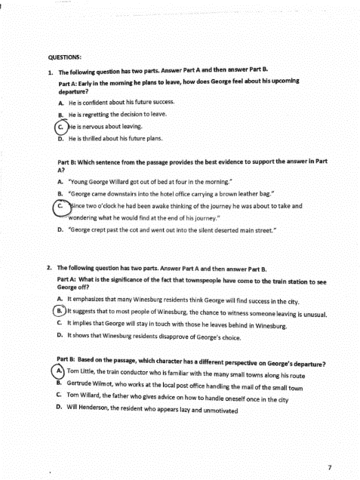
This assignment is strongly aligned to the standards.
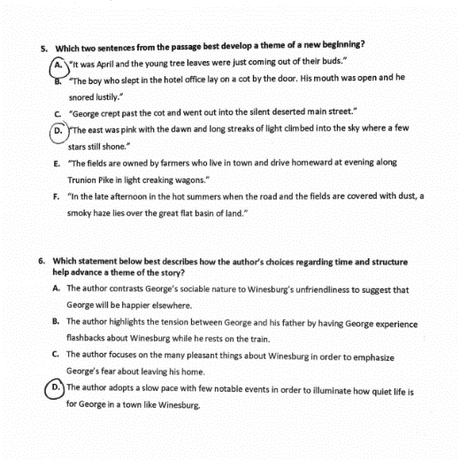

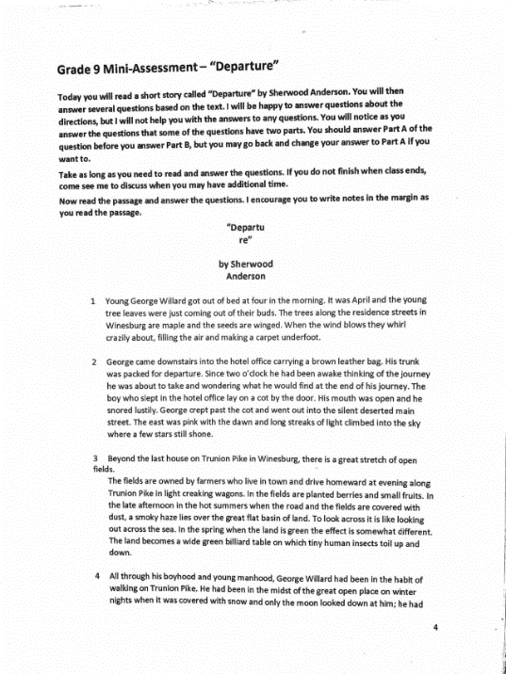
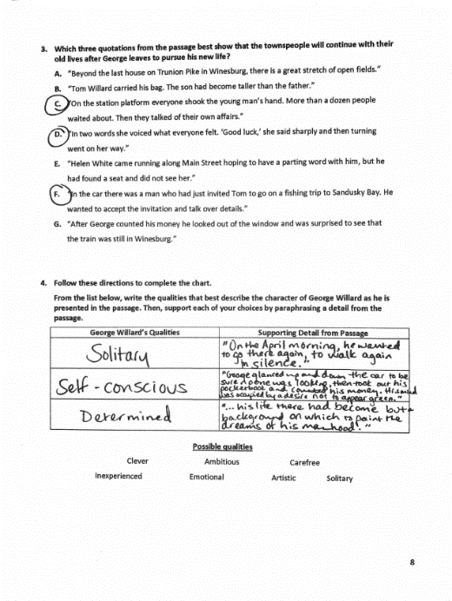

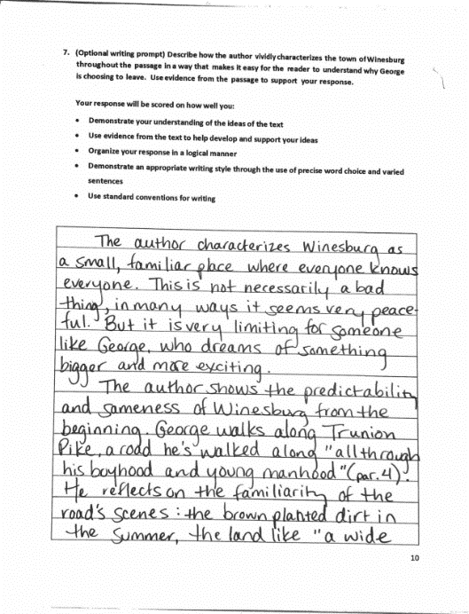
Overview
Overview
Ninth-grade students read “Departure,” an excerpt from Sherwood Anderson’s "Winesburg, Ohio," then answer multiple-choice and writing-based questions about the text. This assignment exposes students to a noteworthy literary text and the questions build students’ understanding of it. Students also analyze the text in a written response.

About the Text

Title and Author | “Departure” by Sherwood Anderson
What is the Lexile Level of this text? | 1050
Based on Lexile, which grades is this text intended for? | 6-8
Is the text qualitatively complex enough for the grade? | Yes
Is this text fiction or non-fiction? | Fiction
Is this text authentic or was it written for educational purposes? | Authentic
Does the text provide sufficient detail to build knowledge of a worthwhile topic and/or is it worth reading closely and re-reading? | Yes

Related Standards
RL.9-10.1: Cite relevant and thorough textual evidence to support analysis of what the text says explicitly as well as inferences drawn from the text.
The assignment is strongly aligned to this standard. Question 1, for example, asks both how the main character, George, is feeling, and which specific sentence from the text suggests this.
RL.9-10.2: Determine a theme or central idea of a text, and analyze in detail its development over the course of the text, including how it emerges and is shaped and refined by specific details.
The assignment is strongly aligned to this standard. Question 5 asks students to pinpoint the specific language from the text that develops the theme of a “new beginning.”
RL.9-10.3: Analyze how complex characters develop over the course of a text, interact with other characters and advance the plot or develop themes.
The assignment is strongly aligned to this standard. Question 4 asks students to choose several descriptors for George, and to support those descriptors with specific passages from the text.
RL.9-10.4: Determine the meaning of words and phrases as they are used in the text, including figurative and connotative meanings; analyze the cumulative impact of specific word choices on meaning and tone.
The assignment is strongly aligned to this standard. The culminating writing prompt asks students to describe how the author’s vivid descriptions of Winesburg evoke an understanding of George’s desire to leave.
RL.9-10.5: Analyze how an author’s choices concerning how to structure a text, order events within it and manipulate time create such effects as mystery, tension or surprise.
The assignment is strongly aligned to this standard. Question 6 asks students how the author’s structuring and pacing impacts the story.
RL.9-10.10: By the end of the year, flexibly use a variety of comprehension strategies (i.e., questioning, monitoring, visualizing, inferencing, summarizing, synthesizing, using prior knowledge, determining importance) to read, comprehend and analyze grade-level appropriate, complex literary texts independently and proficiently.
The assignment is strongly aligned to this standard.
C.9-10.1: Compose arguments to support claims in an analysis of substantive topics or texts, using valid reasoning and relevant and sufficient evidence.
The assignment is strongly aligned to this standard. The writing prompt gives students opportunity to articulate a claim about the text and support it with evidence.
L.9-10.2: When writing: a. Demonstrate appropriate use of a semicolon with and without a conjunctive adverb to link two or more closely related independent clauses. b. Demonstrate appropriate use of a colon to introduce a list or quotation. c. Demonstrate appropriate use of strategies and resources (print and electronic) to identify and correct spelling errors.
The assignment is strongly aligned to this standard. Students have opportunity to demonstrate their command of 9th grade-level spelling in the writing piece; the directions specifically name language conventions as a criterion for strong work.
Why is this assignment strongly aligned?
Students read a worthwhile text. There’s extensive imagery and symbolism within the text, which requires inference and interpretation on students’ part.
Students must read the text carefully to answer the questions. The questions direct students back to specific passages in the text that build their understanding. Questions become increasingly more complex and help students understand the whole excerpt.
The questions ask students to articulate independent ideas about the text and support those ideas with evidence; Students have an opportunity to share what they learned from the text.
Students practice structuring an argumentative piece of writing. They must make a claim, support it with evidence, and organize their thoughts in a written response.

