9th & 10th Grade Reading and Writing Assignment
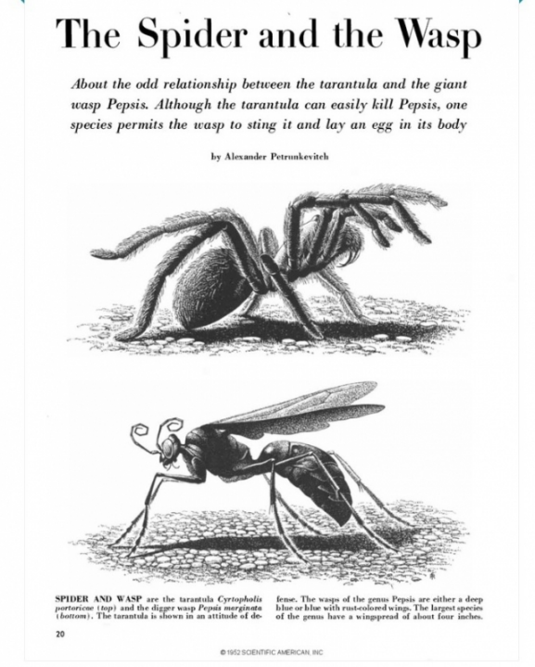
This assignment is partially aligned to the standards.

- What are some supporting details that defend the author’s thesis?
- What is the main idea of the article? Support your answer with evidence from the text.
- How does the paragraph about the spider’s tactile responses fit into the overall structure of the text?
- The author discusses the spider’s tactile responses and how they serve it well, until it encounters the wasp. Evaluate the claims and evidence that Petrunkevich uses in supporting this argument.

Overview
Ninth-tenth grade students read a renowned scientific article called “The Spider and the Wasp,” by Alexander Petrunkevitch and respond to questions about it. This is a strong text, but not all of the questions reach the depth of the standards.

About the Text

Title and Author | “The Spider and the Wasp” by Alexander Petrunkevitch
What is the Lexile Level of this text? | 1100-1200L
Based on Lexile, which grades is this text intended for? | 9-10
Is the text qualitatively complex enough for the grade? | Yes
Is this text fiction or non-fiction? | Non-fiction
Is this text authentic or was it written for educational purposes? | Authentic
Does the text provide sufficient detail to build knowledge of a worthwhile topic and/or is it worth reading closely and re-reading? | Yes

Related Standards
RI.9-10.1: Cite relevant and thorough textual evidence to support analysis of what the text says explicitly as well as inferences drawn from the text.
The assignment is partially aligned to this standard. Assignment directions refer to using “textual evidence,” but the questions are both simplistic and lack the deeper analysis of inferencing. Therefore, the questions do not meet the full intent of the standard. In Question 1, students are asked to give supporting details, but this isn’t coupled with an analysis of what the text says explicitly or how a student might draw inferences from the text. Questions 2 and 4 also ask students to state evidence from the text in support of their response which only partially aligns to the standard.

RI.9-10.2: Determine central ideas of a text, and analyze in detail their development over the course of the text, including how they emerge and are shaped and refined by specific details.
The assignment is weakly aligned to this standard. Question 2 should ask students to determine the central idea, however, this question actually asks for identification of the main idea of a text. This language does not match the language of the standard. To reach the depth of this 9-10 grade-level standard, students must also analyze the development of central ideas–-more than one--and how they emerge over the course of a text. Simple identification of the central idea is more reflected in the standards of second and third grade, therefore, this question does not meet the rigor of RI.9-10.2.

RI.9-10.5: Analyze in detail how an author’s ideas or claims are developed and refined by particular sentences, paragraphs or larger portions of a text.
The assignment is partially aligned to this standard. Question 3 makes an attempt to reach the depth of this standard by asking for students to consider an important paragraph in the text (a paragraph about spider’s tactile responses). The question does not ask students to analyze how the paragraph develops or refines the author’s claims. It is hitting the intent of the Guiding Principle of RI.5, but the question is not aligned to the specificity of the language of the grade-level standard.

RI.9-10.8: Evaluate the argument, specific claims and evidence in a text, assessing the validity, reasoning, relevancy and sufficiency of the evidence; identify false statements and fallacious reasoning.
Students read a text that is appropriately complex and provides useful information, but the questions are weakly aligned because the question asks students to evaluate the claims and evidence the author makes in supporting an argument; however, this informational piece is not an argument, but rather an expository essay. There are some claims in the paragraph, but it is only information to better describe the tactile responses of spiders. Making a claim, does not automatically make the writing an argumentative piece. Having a clear understanding of “claim” and how that builds an argument would be crucial for this standard to be represented, but is out of alignment in this instance.

Why is this assignment partially aligned?
The text is appropriate for ninth-tenth grade students. Students read an authentic, published journal article about insects’ struggle for survival. It builds their knowledge of a scientific topic and is appropriately challenging in structure, vocabulary, and purpose. The text would be particularly strong if it were part of a larger unit on a cohesive topic (e.g., a study of species survival, endangerment, and extinction).
The questions are approaching the intent of the grade-level standards, but have not fully reached alignment. The questions begin to require students to analyze the text, but not to the full depth of the learning that should be demonstrated by 9-10 grade students.
In most questions, students are required to support their answers with evidence from the text. While the questions were sometimes off grade-level target, there was an intentional reference to supporting evidence from the text.

