9th & 10th Grade Reading and Writing Assignment
This assignment is weakly aligned to the standards.
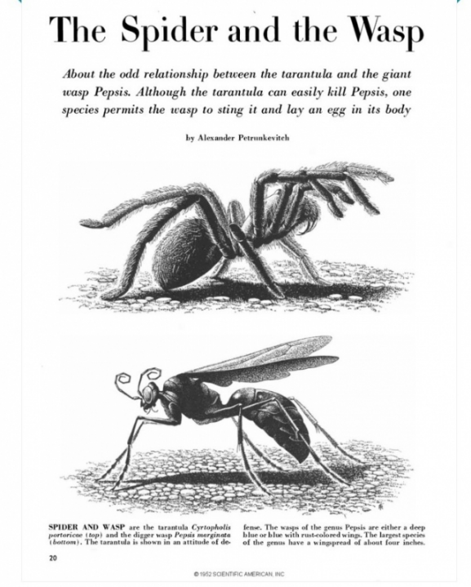
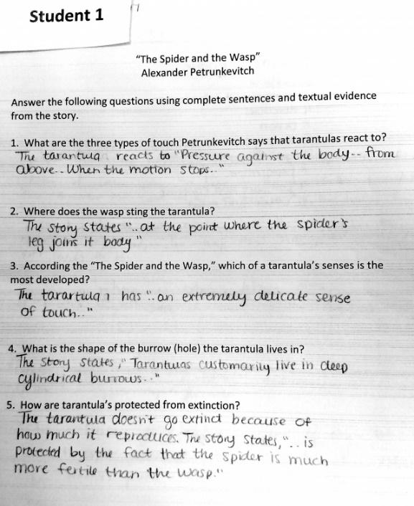

Overview
Ninth-tenth grade students read a renowned scientific article called “The Spider and the Wasp,” by Alexander Petrunkevitch and respond to questions about it. Although the text is strong, the questions only ask students to restate basic facts from the text and don’t ask them to draw on specific details and evidence.

About the Text

Title and Author | “The Spider and the Wasp” by Alexander Petrunkevitch
What is the Lexile Level of this text? | 1100-1200L
Based on Lexile, which grades is this text intended for? | 9-10
Is the text qualitatively complex enough for the grade? | Yes
Is this text fiction or non-fiction? | Non-fiction
Is this text authentic or was it written for educational purposes? | Authentic
Does the text provide sufficient detail to build knowledge of a worthwhile topic and/or is it worth reading closely and re-reading? | Yes

Related Standards
RI.9-10.1: Cite relevant and thorough textual evidence to support analysis of what the text says explicitly as well as inferences drawn from the text.
The assignment is weakly aligned to this standard. Assignment directions refer to using “textual evidence.” But questions are of a simplistic recall-and-restate nature (see Question 2, for example – “Where does the wasp sting the tarantula?”) and do not lend themselves to thoughtful responses grounded in evidence.

RI.9-10.2: Determine central ideas of a text, and analyze in detail their development over the course of the text, including how they emerge and are shaped and refined by specific details.
The assignment is weakly aligned to this standard. The final question (“How are tarantulas protected from extinction?”) gets at the main idea of the text. But there is no expectation that students analyze the development of this idea over the course of the text, nor that they cite specific details.

L.9-10.1: In both written and oral expression: a. Demonstrate appropriate use of parallel structure; b. Demonstrate appropriate use of various types of phrases (noun, verb, adjectival, adverbial, participial, prepositional, absolute) and clauses (independent, dependent; noun, relative, adverbial) to convey specific meanings and add variety and interest to writing or presentations.
The assignment is weakly aligned to this standard. The task directs students to write in “complete sentences” but given that the questions do not prompt substantive 9th grade-level writing, students’ opportunity to demonstrate command parallel sentence structures is very limited.

RI.9-10.10: By the end of the year, flexibly use a variety of comprehension strategies (i.e., questioning, monitoring, visualizing, inferencing, summarizing, synthesizing, using prior knowledge, determining importance) to read, comprehend and analyze grade-level appropriate, complex informational texts independently and proficiently.
The assignment is partially aligned to this standard. Students read a text that is appropriately complex and provides useful information, but the questions are weakly aligned because they give students no opportunity for analysis as the questions are basic recall, “right there” questions, that are explicitly stated in the text.

Why is this assignment weakly aligned?
The text is appropriate for ninth-tenth grade students. Students read an authentic, published journal article about insects’ struggle for survival. It builds their knowledge of a scientific topic and is appropriately challenging in structure, vocabulary, and purpose. The text would be particularly strong if it were part of a larger unit on a cohesive topic (e.g., a study of species survival, endangerment, and extinction).
The questions aren’t designed to build students’ deep understanding of the content and they don’t require students to analyze the text. The questions don’t align with ninth-tenth grade standards.
Students don’t need to support their answers with evidence from the text. The questions only ask students to restate explicit information from the text instead of making claims about the text and supporting those claims with details.

