9th & 10th Grade Reading and Writing Assignment
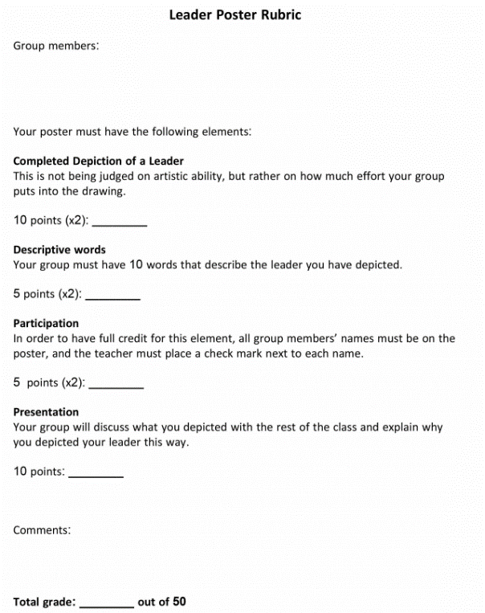
This assignment is weakly aligned to the standards.
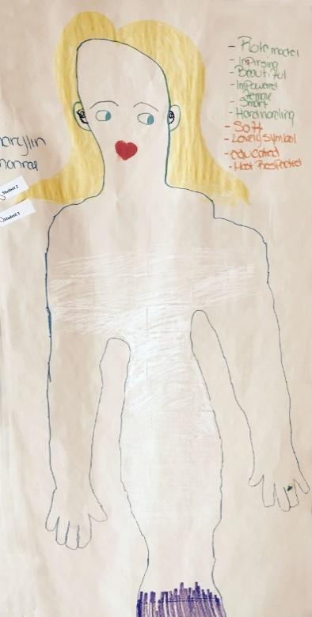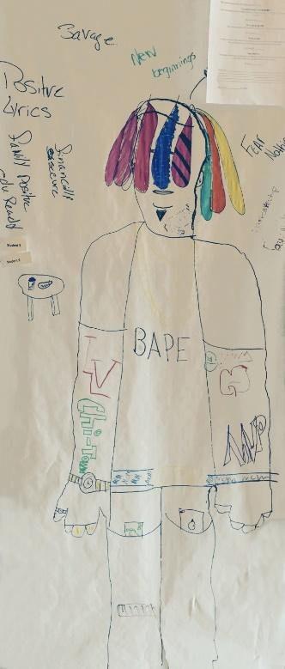
Overview
Ninth-grade students work in small groups to create a poster about what makes an effective leader. The poster includes a picture and some descriptive words for a leader, which groups of students present to the class. There is no associated text, so students create this poster based on their personal experiences and opinions rather than grounding their work in information learned from reading.
Related Standards
C.9-10.1: Compose arguments to support claims in an analysis of substantive topics or texts, using valid reasoning and relevant and sufficient evidence.
The assignment is weakly aligned to this standard. Students are asked to make a claim of sorts in depicting “what makes a leader.” But there is no expectation of writing an argument, drawing on texts, or including relevant supporting evidence for the claim.
RL.9-10.1: Cite relevant and thorough textual evidence to support analysis of what the text says explicitly as well as inferences drawn from the text.
The assignment is weakly aligned to this standard. Students are not using textual evidence and the task is not text-dependent, so all of the work is based upon opinion.
Why is this assignment weakly aligned?
Students don’t need to read anything. They use their personal ideas and experiences to create a poster on the broad topic of “what makes a leader.”
Students don’t need to write to complete the assignment. Students draw a picture of a leader and write down words that describe a leader, but they don’t engage in the more substantive, analytical writing required by ninth-grade standards.
It doesn’t build students’ knowledge and doesn’t let them practice ninth-grade reading or writing skills. There’s no connection between the assignment and the grade-level standards.

