Kindergarten Reading and Writing Assignment
This assignment is strongly aligned to the standards.

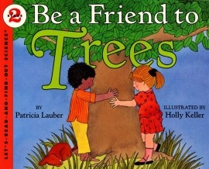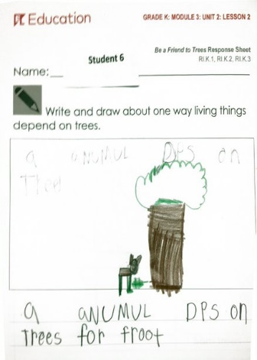
Overview
Kindergarten students listen to their teacher read a grade-appropriate book out loud, then answer a question by writing and drawing about a key idea from the text. This assignment is strong because students engage with a worthwhile text and share what they learned from it through writing.
About the Text
Title and Author | "Be a Friend to Trees" by Patricia Lauber
What is the Lexile Level of this text? | 570L
Based on Lexile, which grades is this text intended for? | 2-3
Is the text qualitatively complex enough for the grade? | Yes
Is this text fiction or non-fiction? | Non-Fiction
Is this text authentic or was it written for educational purposes? | Authentic
Does the text provide sufficient detail to build knowledge of a worthwhile topic and/or is it worth reading closely and re-reading? | Yes

Related Standards

RI.K.3: With prompting and support, identify the individuals, events, ideas, or pieces of information presented over the course of a text.
The assignment is strongly aligned to this standard because the different ways that living things depend on trees are key details in the text.
RI.K.10: With prompting and support, flexibly use a variety of comprehension strategies (i.e., questioning, monitoring, visualizing, inferencing, summarizing, using prior knowledge, determining importance) to make sense of grade-level appropriate, complex literary texts.
The assignment is strongly aligned to this standard because students engage with a grade-level appropriate, complex text to retell a key detail, a kindergarten appropriate way of summarizing.

L.K.1: When writing or speaking demonstrate appropriate use of a. common nouns and verbs; d. sentences using common prepositions; e. complete sentences.

The assignment is strongly aligned to this standard because students have an opportunity to demonstrate their command of various kindergarten conventions such as using nouns and verbs, using prepositions and producing complete sentences.

L.K.2: Demonstrate command of the conventions of standard English capitalization, punctuation and spelling when writing.
The assignment is strongly aligned to this standard because students have an opportunity to capitalize the first word of a sentence and spell simple words phonetically, which are both kindergarten conventions.

Why is this assignment strongly aligned?
This assignment is strongly aligned because students engage with a worthwhile text read to them by a fluent reader. The text contains useful information about trees (e.g., different types of trees, what can be made from trees, how animals depend on trees), complex vocabulary (e.g., words like “pulp” and “chemicals”), and vibrant illustrations.
The question requires students to recall a key idea from the text. Students must listen carefully to answer a question about one way living things depend on trees.
Students answer the question using grade-appropriate mediums. Students share what they learned by writing and drawing. The kindergarten writing standards (C.K.1 – C.K.3) focus on a combination of drawing, speaking and writing to share ideas and information.
The question is based on knowledge from the text but has more than one right answer. This lets students share what they learned from the text and express their unique perspective.
The question lets students practice their language skills through authentic writing. However, because of the lack of specific directions, this opportunity appears to be incidental since task directions do not include expectations for use of conventions.

