Kindergarten Reading and Writing Assignment
This assignment is weakly aligned to the standards.

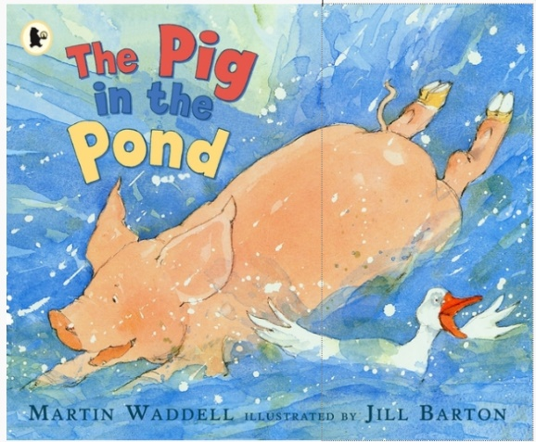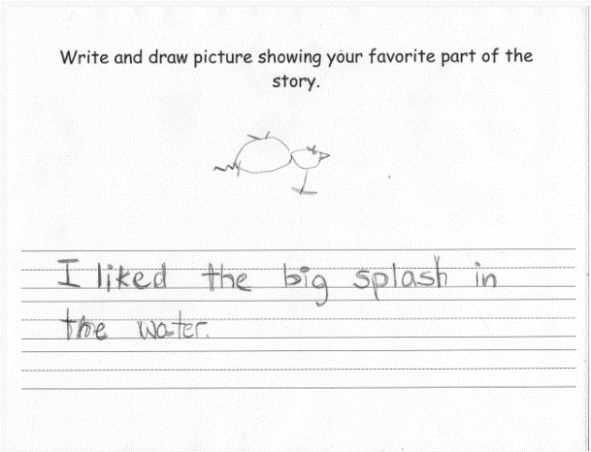

Overview
Kindergarten students listen to a text read aloud, then write and draw in response to a prompt about their favorite part of the story. This assignment is weak because the text is not adequately complex for a kindergarten read-aloud and the question posed doesn’t focus students on the main topic or key details, nor does it focus on the craft or structure of the text.
About the Text
Title and Author | "The Pig in The Pond" by Martin Waddell
What is the Lexile Level of this text? | AD270
Based on Lexile, which grades is this text intended for? | K-1
Is the text qualitatively complex enough for the grade? | No
Is this text fiction or non-fiction? | Fiction
Is this text authentic or was it written for educational purposes? | Authentic
Does the text provide sufficient detail to build knowledge of a worthwhile topic and/or is it worth reading closely and re-reading? | No

Related Standards

RL.K.1: With prompting and support, ask and answer explicit questions about key ideas and details, and make logical inferences to construct meaning from the text.
The assignment is weakly aligned to this standard because, while students answer a question about the text, the question does not focus students on key details.

RL.K.2: With prompting and support, orally recognize key details from a summary to demonstrate understanding of the lesson learned in the story.
The assignment is weakly aligned to this standard because students are not required to identify the main topic or key details in order to answer the question.

RL.K.10: With prompting and support, flexibly use a variety of comprehension strategies (i.e., questioning, monitoring, visualizing, inferencing, summarizing, using prior knowledge, determining importance) to make sense of grade-level appropriate, complex literary texts.*
The assignment is weakly aligned to this standard because students listen to a read-aloud, but there is no evidence that students are making meaning of the text through the assignment given and therefore no application of reading strategies as called out in this standard.

L.K.1: When writing or speaking demonstrate appropriate use of a. common nouns and verbs; b. regular plural nouns by adding /s/ or /es/; c. interrogative sentences using who, what, where, when, why and how; d. sentences using common prepositions; e. complete sentences.

The assignment is strongly aligned to this standard because students have an opportunity to demonstrate their command of various kindergarten conventions such using nouns and verbs, using prepositions and producing complete sentences.

L.K.2: When writing: a. Capitalize the first word in a sentence and the pronoun I; b. Recognize and name end punctuation; c. Write a letter or letters for most consonant and short vowel sounds; d. Spell simple words phonetically, drawing on knowledge of sound-letter relationships.
The assignment is strongly aligned to this standard because students have an opportunity to capitalize the first word of a sentence and spell simple words phonetically, which are both kindergarten conventions.
Why is this assignment weakly aligned?
This assignment is weak because the text is not adequately complex for a Kindergarten read-aloud and the task does not require students to listen with purpose and understanding:
The text is not adequately complex for a kindergarten read-aloud. The Lexile Level of read-aloud text should fall 2-3 grade levels above what students are expected to read independently. During read-aloud the teacher models fluent reading, allowing students to focus on making meaning. Additionally, this text does not provide opportunity to build knowledge and is not worth multiple reads or extended time and attention since the story has little nuance and is easy to follow.
The writing prompt is not appropriate because it does not require students to focus on the important information within the text; students do not have to comprehend what happened in the text with clarity or detail to answer the question. The writing prompt would be stronger if it were specific to the language and details of the text at hand. While it is important for students to answer text-dependent and text-specific questions, the question “What is your favorite part of the story?” does not help students to read with purpose and does not meet the intent of any of the reading standards.
While the task does not effectively attend to the reading standards, it does provide opportunity for students to practice applying their developing language (i.e. grammar and conventions) to their authentic writing, which is important for improving both reading and writing skills. However, this opportunity appears to be incidental rather than intentional as the task directions do not include clear expectations for use of conventions.

