HS Algebra Assignment
This assignment is strongly aligned to the standards.
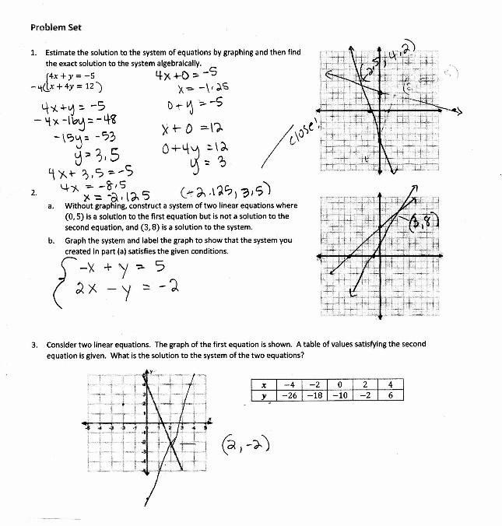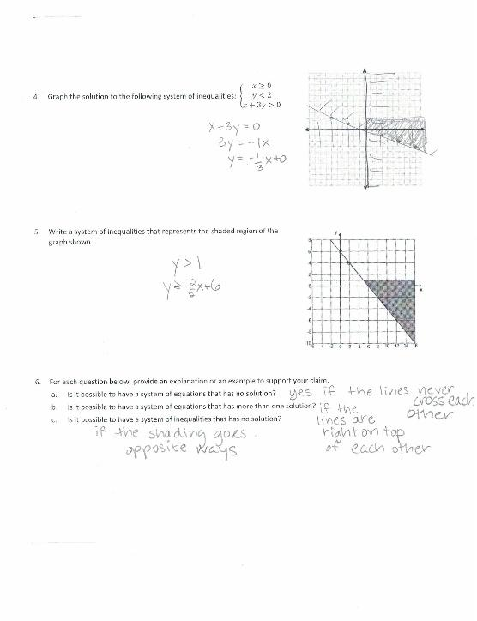

Overview
Students solve and reason about systems of two or more equations or inequalities. The assignment is strongly aligned to the standards because problems ask students to solve systems of linear equations exactly and approximately with graphs (KY.HS.A.20.b) and to “graph the solutions set to a system of linear inequalities in two variables as the intersection of the corresponding half-planes” (KY.HS.A.25.b).

Related Standards
We looked at how well the assignment aligned to the following standards:
KY.HS.A.20: Solve systems of linear equations in two variables.
KY.HS.A.20.b: Solve systems of linear equations with graphs, substitution and elimination, focusing on pairs of linear equations in two variables.
KY.HS.A.25: Graph linear inequalities in two variables.
KY.HS.A.25.b: Graph the solution set to a system of linear inequalities as the intersection of the corresponding half-planes.

Why is this assignment Strongly aligned?
In eighth grade, students learn about systems of two linear equations and how to solve them algebraically or by graphing (standard KY.8.EE.8). In high school, they extend their understanding of systems of equations to include linear equations, non-linear equations, and linear inequalities. This assignment is appropriate for high school because it asks students to (a) work from a verbal description of a system of linear equations, (b) engage with a system of equations where one equation is presented in graphical form and the other in table form, (c) reason about the possible solution types of systems in general, and (d) graph, solve, and reason about systems of linear inequalities.
Standards KY.HS.A.20.b and KY.HS.A.25.b are procedural, requiring students to solve systems by graphing and algebraically. The assignment requires these procedures explicitly and from a variety of function formats. The procedural nature of the problems aligns with the procedural requirements of the standards.

Practice Standards
The assignment provides students the opportunity to engage with Mathematical Practice Standard #1 (“Make sense of problems and persevere in solving them”) and Mathematical Practice Standard #7 (“Look for and make use of structure”). Students might “analyze givens, constraints, relationships, and goals” when writing a system of equations with given conditions, without first constructing a graph. They might also “see complicated things, such as some algebraic expressions, as single objects or as being composed of several objects” when solving a system of three linear inequalities by reasoning about their corresponding equations (Mathematical Practice Standard #1). They might also “see complicated things, such as some algebraic expressions, as single objects or as being composed of several objects” when solving a system of three linear inequalities by reasoning about their corresponding equations (Mathematical Practice Standard #7).

