HS Algebra Assignment
This assignment is weakly aligned to the standards.
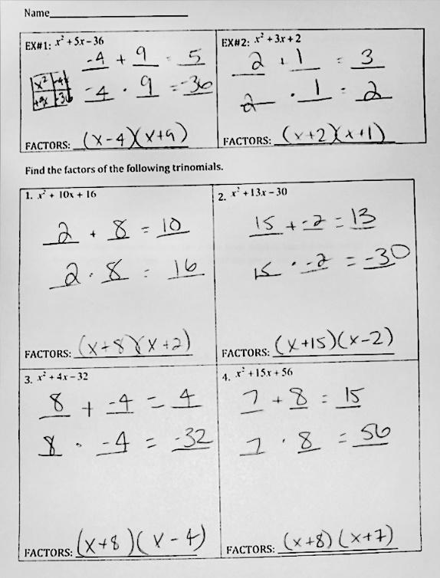

Overview
High school students factor algebraic expressions at an introductory level of complexity. The assignment is weakly aligned to the standard because it doesn’t ask students to use the factors beyond simply finding them, while the standard requires students to identify the zeros (the values of x for which the expression is equal to zero) and use this information to sketch a graph to represent the algebraic expression.

Related Standards
We looked at how well the assignment aligned to the following standards:
KY.HS.A.7: Identify roots of polynomials when suitable factorizations are available. Know these roots become the zeros (x-intercepts) for the corresponding polynomial function.

Why is this assignment weakly aligned?
Standard KY.HS.A.7 requires students to find the roots of a polynomial and demonstrate an understanding of how these roots relate to the graph of the corresponding polynomial function. Because the computations required by this assignment are so simple, they should be helping to build students’ understanding of the connections between the graph, the zeros, and the factors of quadratic functions, and to make sense of their structures. However, the assignment doesn’t allow students to make those connections.

The assignment requires students to find the factors of trinomials and to write the factors as a product of two binomials. Each of the six problems are factorable and the factors are simple numbers, so students are likely to be able to factor in their heads. Although factoring trinomials is a grade-level concept, high school students should be factoring to build their conceptual understanding of quadratic functions, not factoring for the sake of honing a stand-alone skill. If the assignment had asked students to use the factorization to draw a sketch of the graph, it would be more strongly aligned to KY.HS.A.7.
Practice Standards
The assignment does not give students the opportunity to engage in any mathematical practice standards. Were it more aligned to the standard, students would likely use Mathematical Practice Standard #7 (“Look for and make use of structure”) when they apply the understanding that the factors (x - a)(x - b) indicate that the quadratic function has zeros, or x-intercepts, at (a, 0) and (b, 0).

