HS Functions Assignment
This assignment is strongly aligned to the standards.
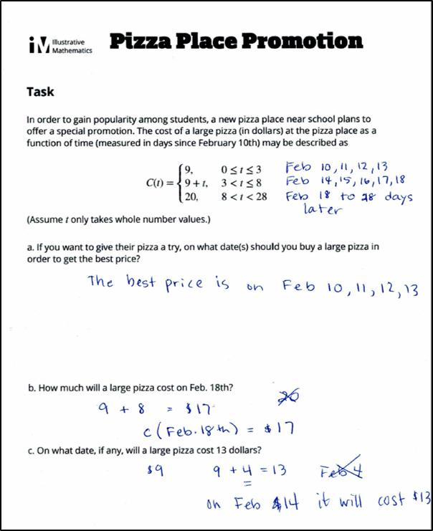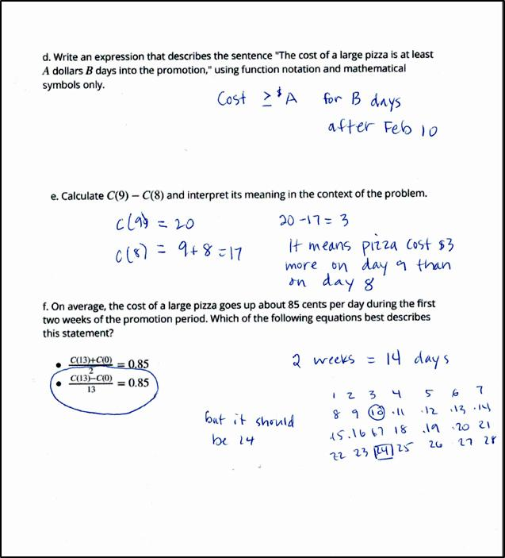

Overview
High school students are asked to use a piecewise-defined function representing a real-world scenario to answer questions and solve problems. The assignment is strongly aligned to the standards because it involves an authentic real-world situation and requires students to do grade-appropriate analysis.

Related Standards
We looked at how well the assignment aligned to the following standard:
KY.HS.F.1: Understand properties and key features of functions and the different ways functions can be represented.
KY.HS.F.1.a: Understand that a function from one set (called the domain) to another set (called the range) assigns to each element of the domain exactly one element of the range. If f is a function and x is an element of its domain, then f(x) denotes the output of f corresponding to the input x.
KY.HS.F.1.b: Using appropriate function notation, evaluate functions for inputs in their domains and interpret statements that use function notation in terms of a context.

Why is this assignment Strongly aligned?
The assignment uses an authentic scenario represented by a piecewise-defined function, a specialty function reserved for high school study. The problems allow students to engage with the function in several ways, including interpreting the quantities and expressions, connecting the mathematics to verbal descriptions, and analyzing and interpreting the function’s domain.
Note: If students were asked to graph a piecewise function this task would align to KY.HS.F.4f (+). Plus (+) standards are additional mathematics concepts students should learn in order to take advanced courses such as calculus, advanced statistics, or discrete mathematics. Plus (+) standards are not required learning for every Kentucky student.
Students use equations to model real-world contexts as early as middle school. By high school, both the mathematics and the reasoning should increase in complexity and sophistication, like they do in this assignment. The use of a piecewise-defined function and questions addressing the domain, the mathematical representations, and the average rate of change all ensure that the assignment is appropriate to high school.
Practice Standards
The connection to a familiar context allows students to engage with Mathematical Practice Standard #2 (“Reason abstractly and quantitatively”). Students mentally convert between the context (for example, “days since February 10”) and the mathematical representations of compound inequalities. They are specifically asked to translate a verbal description into a mathematical expression and are asked to calculate a mathematical expression and interpret its meaning in the context of the problem.

