HS Functions Assignment
This assignment is partially aligned to the standards.
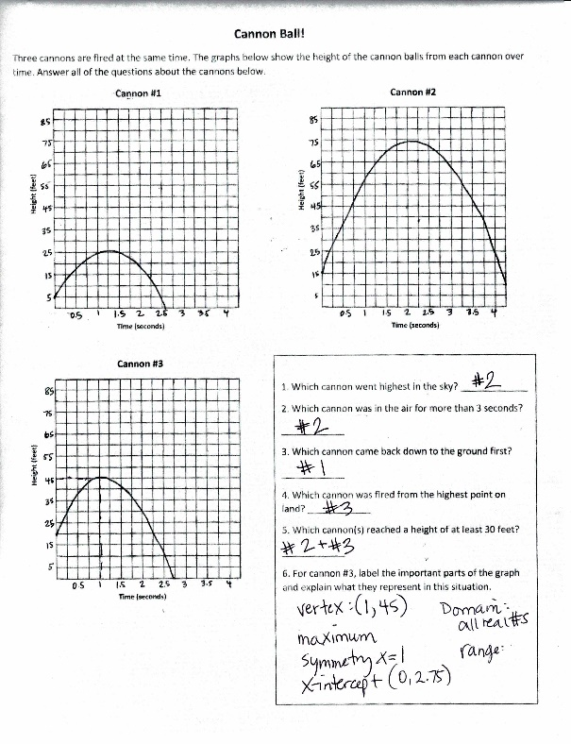

Overview
High school students interpret the values of three quadratic graphs in terms of the real-world context of the trajectory of fired cannon balls over time. The assignment is partially aligned to the standards because it involves high school-appropriate quadratic functions, but it isn’t appropriately complex for high school because students are only asked to match the graphs to simple features rather than interpreting or analyzing the information.

Related Standards
We looked at how well the assignment aligned to the following standard:
KY.HS.F.1: Understand properties and key features of functions and the different ways functions can be represented.
KY.HS.F.1.c: For a function that models a relationship between two quantities, interpret key features of graphs and tables in terms of the quantities and sketch graphs showing key features given a verbal description of the relationship.

Why is this assignment partially aligned?
The first five questions require students to match a quadratic graph to a description. Because the descriptions are simplistic, all three graphs are provided, and the axes are clearly labeled, students don’t need to understand quadratic functions to answer correctly—they just need to know how to read a graph. The complexity level is therefore more appropriate for middle school (such as in KY.8.F.5) than for high school.

Standard KY.HS.F.1.c asks students to interpret the key features of a function using its graph and/or table, which requires conceptual understanding. In this assignment, however, the graphs are already interpreted for students and matching the correct graph with the provided description targets procedural skill. To target conceptual understanding, the questions could have asked students to describe the differences between the three cannons and to support their responses using information from the provided graphs.
Practice Standards
These high school functions standards afford students the opportunity to engage with Mathematical Practice Standard #2 (“Reason abstractly and quantitatively”) by making connections between the graph and the real-world scenario, and with Mathematical Practice Standard #7 (“Look for and make use of structure”). With a tighter alignment to the standards, the assignment might support the use of graphing software or calculators to interpret key features of quadratic graphs (Mathematical Practice Standard #5: “Use appropriate tools strategically,”) and use of more precise numerical descriptions of the situation being modeled (Mathematical Practice Standard #6: “Attend to precision”).

