HS Functions Assignment
This assignment is weakly aligned to the standards.
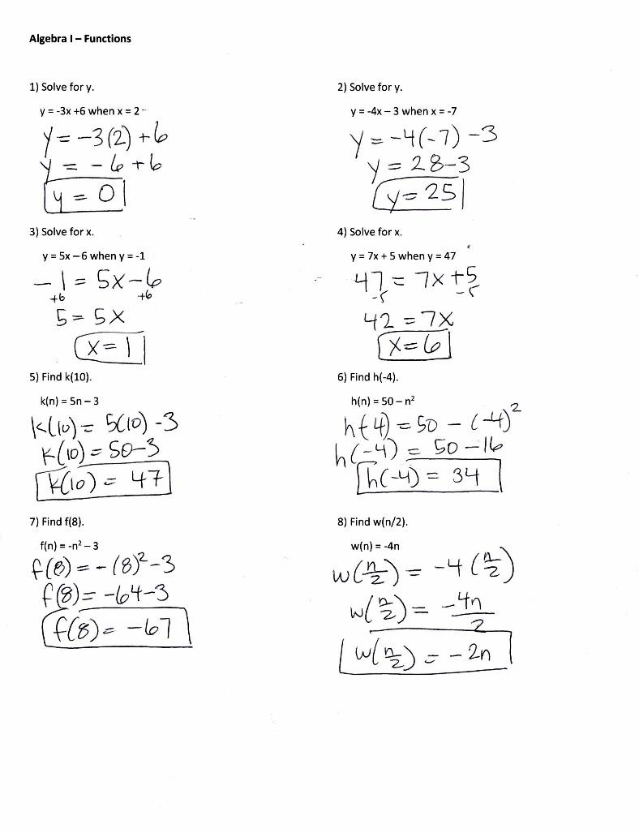
Overview
High school students evaluate functions for specific values of their variable. The assignment is weakly aligned to the standard because the notation, numerical values, and computations required are more closely aligned to middle school expectations. The problems do not provide any context or require students to interpret the statements that use function notation.

Related Standards
We looked at how well the assignment aligned to the following standards:
KY.HS.F.1: Understand properties and key features of functions and the different ways functions can be represented.
KY.HS.F.1.b: Using appropriate function notation, evaluate functions for inputs in their domains and interpret statements that use function notation in terms of a context.

Why is this assignment weakly aligned?
Problems #1-4 of this assignment align to eighth grade standard KY.8.EE.7 because they all involve solving linear equations in one variable (x or y). Although problems #5-8 use function notation, which is aligned with standard KY.HS.F.1.b, the numbers and computation are too simple for high school. Positive and negative integers and computation with simple arithmetic and exponents are more appropriate in sixth grade. The assignment would be more closely aligned to high school if the problems involved more complex numbers (such as rational numbers) and computations (such as higher order exponents or complex fractions).
Practice Standards
The assignment does not support students’ use of any mathematical practice standards. Were the assignment more aligned to KY.HS.F.1.b, students could have the opportunity to engage with Mathematical Practice Standard #2 (“Reason abstractly and quantitatively”). When students “interpret statements that use function notation in terms of a context,” they have to reason about the values and computations both within the given real-world context and also purely mathematically separate from the context.

