HS Geometry Assignment
This assignment is strongly aligned to the standards.
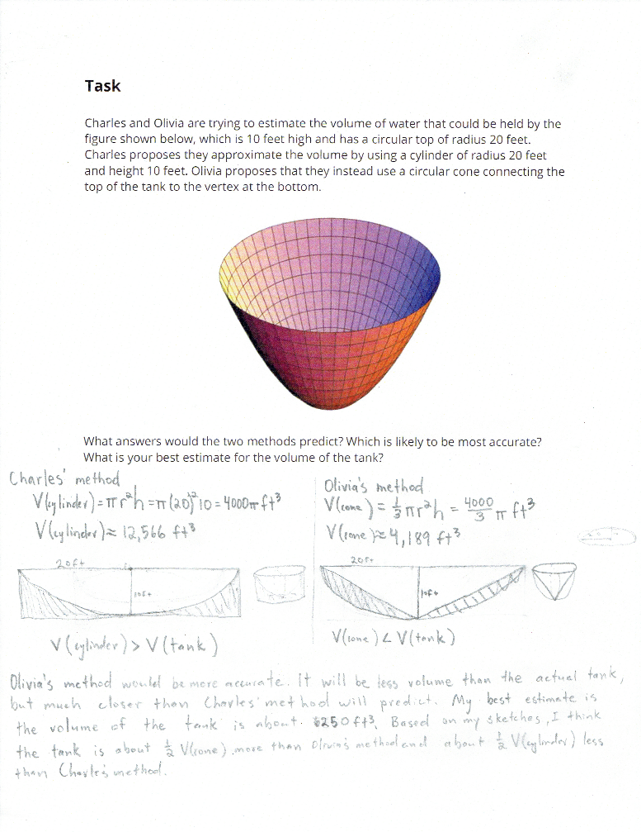

Overview
Students apply the volume formulas for a cylinder and a cone and reason about the model that provides the best estimate for a given geometric figure. This assignment is strong because it is well-aligned to a high school geometry standard. The task provides an opportunity to apply geometric volume formulas to solve a real-world problem and, as required by the standard, it involves students in the modeling process.

Related Standards
We looked at how well the assignment aligned to the following standard:
KY.HS.G.27*: Use volume formulas to solve problems for cylinders, pyramids, cones, spheres, prisms.
*The asterisk is included in the KAS for Mathematics and indicates that this is a modeling standard. Modeling is best interpreted not as a collection of isolated topics, but rather in relation to other standards. Making mathematical models is a Standard for Mathematical Practice.
Why is this assignment Strongly aligned?
In eighth grade, students learn the volume formulas for cylinders and cones (standard KY.8.G.9). In high school, they can explain how and why these formulas work, and apply the formulas to model geometric relationships in the real world.
This assignment allows students to demonstrate their conceptual understanding, procedural fluency, and ability to model and solve real-world problems, which is appropriate for the demands of standards KY.HS.G.27. Although the situation provides the geometric figures to use as models for the water tank, students must interpret cones and cylinders in context and apply what they know about them to calculate the estimated volume. Students must also use what they know about these figures and their relationship to the context to determine which is a more accurate model for the tank. Finally, students must draw their own conclusions and provide their own best estimate for the tank’s volume. These actions reflect the modeling process required by the standards.
Practice Standards
The task provides students the opportunity to reason about the volume of a figure that does not have a formula that they know. This gives students a chance to engage with Mathematical Practice Standard #1 ("Make sense of problems and persevere in solving them") as they determine which information to use—and how to use it—to answer the problem. Students continue to make sense of the problem as they determine how to justify which model may provide the most accurate prediction and to make their own conclusion about the estimated volume. The task also provides opportunities for students to engage with Mathematical Practice Standard #4 (“Model with mathematics”) and Mathematical Practice Standard #5 (“Use appropriate tools strategically”) as they may use volume formulas, drawings, and other tools to reason and justify their conclusions.

