HS Geometry Assignment
This assignment is partially aligned to the standards.
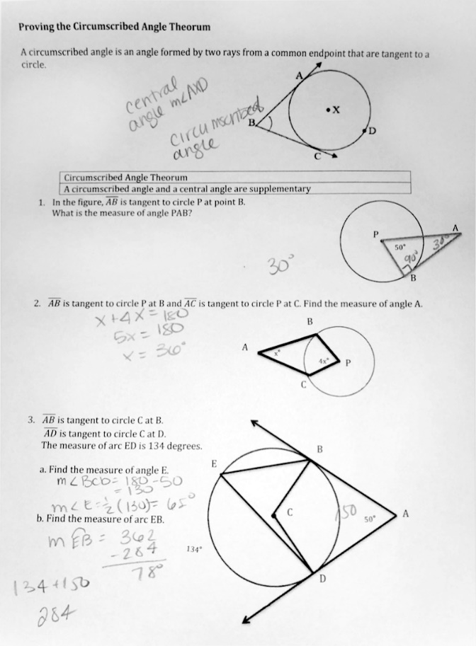

Overview
Students find the measures of unknown angles and arcs formed by circles, their chords and radii, and tangent segments or rays. Although the assignment aligns with the math content of the standards, it does not engage students in appropriate types of mathematical thinking.

Related Standards
We looked at how well the assignment aligned to the following standard:
KY.HS.G.16: Identify and describe relationships among angles and segments within the context of circles involving:
KY.HS.G.16.a: Recognize differences between and properties of inscribed, central and circumscribed angles.
KY.HS.G.16.b: Understand the relationships between inscribed angles and the diameter of a circle.
KY.HS.G.16.c: Understand the relationship between the radius of a circle and the line drawn through the point of tangency on that radius.

Why is this assignment partially aligned?
The assignment does address the mathematical concepts of standard KY.HS.G.16, as it deals with the relationships among inscribed (and circumscribed) angles, radii, and chords. Students identify the appropriate relationship(s) in order to set up equations and solve for unknown values.
Although the mathematical content of the assignment is aligned to standard KY.HS.G.16, the assignment does not require students to engage with the content in ways required by the standards. Specifically, students are not asked to demonstrate their conceptual understanding of these relationships: It asks students to solve for unknown values, but it doesn’t ask them to explain how they arrived at their answers or describe the relationships between the angles formed by chords, radii, and segments tangent to the circles.
Practice Standards
High school geometry standards often require students to go beyond simple computations. For example, standard KY.HS.G.16 requires students to identify and describe the relationships among angles and segments in circles, which allows them to engage in Mathematical Practice Standard #3 (“Construct viable arguments and critique the reasoning of others”). A written explanation of the relationships between the angles formed by chords, radii, and segments tangent to the circles would allow students to exhibit their understanding of the relationships, as well as their ability to use accurate terminology, symbols, and definitions, as required by Mathematical Practice Standard #6 (“Attend to precision”).

