High School Social Studies Assignment Example One
This assignment is strongly aligned to the Kentucky Academic Standards (KAS) for Social Studies.
Teacher Notes

Introduction
This Teacher Notes document provides instructional support for implementing the strongly aligned assignments to the KAS for Social Studies. To examine why this assignment is strongly aligned to the KAS for Social Studies, engage with the High School Example One Assignment Review Protocol for this assignment.

It is important to note that the assignment(s), indicated throughout the Teacher Notes with shaded boxes, and related resource(s) represent one example. It is not a requirement nor a suggestion for school curriculum. While the Kentucky Department of Education (KDE) is responsible for the development of high-quality academic standards, state law assigns each local district the authority to develop the school’s curriculum and determine appropriate instructional resources based on language found in Kentucky Revised Statute (KRS) 160.345. It is under the discretion of the superintendent to determine the local curriculum, including the evaluation and selection of instructional resources. The KDE does not adopt or select specific curricula for coursework. Per KRS 160.345(g), “the local superintendent shall determine which curriculum, textbooks, instructional materials, and student support services shall be provided in the school after consulting with the local board of education, the school principal, and the school council and after a reasonable review and response period for stakeholders in accordance with local board of education policy.”

KAS for Social Studies alignment:
- HS.UH.I.Q.1 Generate compelling questions to frame thinking, inquiry and/or understanding of key concepts in U.S. history.
- HS.UH.I.Q.2 Generate supporting questions to develop knowledge, understanding and/or thinking relative to key concepts in U.S. history framed by compelling questions.
- HS.C.CP.2 Analyze legislative, executive and judicial branch decisions in terms of constitutionality and impact on citizens and states.
- HS.UH.CE.6 Analyze how global interactions impacted American culture and society from 1890- present.
- HS.UH.I.UE.2 Gather information and evidence from credible sources representing a variety of perspectives relevant to compelling and/or supporting questions in U.S. history.
- HS.UH.I.UE.3 Use appropriate evidence to construct and revise claims and counterclaims relevant to compelling and/or supporting questions in U.S. history.
- HS.UH.I.CC.2 Engage in disciplinary thinking and construct arguments, explanations or public communications relevant to compelling and/or supporting questions in U.S. history.

Educators may have to engage with a standard multiple times throughout a year in order to meet the full intent of the standard. As a result, the following assignment example may not encompass the entire scope of the standards identified.

Overview:
Students will investigate September 11, 2001, to analyze the impact of this event on American culture and society. Additionally, they will analyze legislative, executive and judicial branch decisions made in response to September 11, 2001, in terms of constitutionality and students will determine the impact of these decisions on citizens and states. Finally, students will examine how September 11, 2001, impacts their lives today.

HS.UH.I.Q.1 Generate compelling questions to frame thinking, inquiry and/or understanding of key concepts in U.S. history.

Compelling Question:
“How do global interactions impact me?”

Setting the Stage: Compelling Question

Compelling questions are open-ended, enduring and center on significant unresolved issues. In high school, students are required to generate compelling questions. Strategies such as Connect, Extend, Challenge may support students in this work. For more information on generating compelling questions, visit Section 3B: “What are Compelling Questions and how do students ask them?” from the Inquiry Practices of the KAS for Social Studies module.

To activate prior knowledge about September 11, 2011, have students complete a K-W-L chart by answering the following questions:
- What I know…
- What I want to know…

Once students have completed the first two questions, have students watch CBS News coverage of the September 11, 2001, attack from the morning of September 11, 2001.

- CBS News. (2011, August, 30). 09.11.01: The towers are hit. https://www.youtube.com/watch?v=9eTzV7HvKHU.
  - Bryant Gumbel reports on the explosions at the World Trade Center towers and talks to eyewitnesses. (This report was from a DVD included with the tenth anniversary edition of the CBS News/Simon & Schuster book, "What We Saw: The Events of September 11, 2001, in Words, Pictures, and Video.")

As students are watching this clip, have them source it. The Stanford History Education Group (SHEG) states that “sourcing asks students to consider who wrote a document as well as the circumstances of its creation.” Having students source this clip is valuable because it captures the moment after the first plane struck the North Tower and when the South Tower was struck. This clip allows students to see that as the events of September 11, 2001, were unfolding, individuals did not know what was happening, or that the initial collision with the North Tower was part of a larger attack on the United States. This video clip is especially significant since the broadcast took place a few miles from the World Trade Center. SHEG sourcing questions have been modified here to be applied to a news broadcast.

As you watch the following clip, answer the following questions:

• What are the individual’s perspectives shared in this clip?
• Why was it broadcast?
• When was it broadcast?
• Where was it created?
• Is this source reliable? Why? Why not?

Once students have watched this clip and answered the questions above, have them engage in a Think, Pair, Share with a partner to contextualize the content presented in the clip. SHEG states that contextualization “asks students to locate a document in time and place and to understand how these factors shape its content.”
With a partner, engage in a Think, Pair, Share to answer the following question about the CBS News broadcast. These questions are asking you to contextualize what you saw in the clip:

• When and where was the (broadcast) created?
• What was different then?
• What was the same?
• How might the circumstances in which the document was created affect its content?

Once students have completed their Think, Pair, Share, facilitate a whole group discussion about what information this source provides for students, and what additional questions they have about September 11. It is important to note that contextualizing this clip allows students to understand that since this clip was created as the events of September 11, 2001, were happening, some of the information presented about the attack on the World Trade Center is inaccurate or incomplete. Students may add these additional questions to the second column of their K-W-L chart or share any questions that they previously recorded. For more information on how to conduct whole group discussions, visit Leading Discussions. Consider maintaining a Google document or use chart paper posted somewhere in the classroom to record and capture student responses and questions.

Inform students that they will now investigate the global interactions that impacted September 11. In this transition, highlight any student posed question as to the origins and motives behind the September 11 attack that this investigation might answer.
Supporting Question

HS.UH.I.Q.2 Generate supporting questions to develop knowledge, understanding and/or thinking relative to key concepts in U.S. history framed by compelling questions.

Supporting Question: “How have global interactions resulting from September 11, 2001, impacted American culture and society from 2001 to the present?”

Supporting questions are aligned to the compelling question and can be answered through using the concepts and practices of each social studies discipline. In high school, students are required to generate supporting questions. Strategies such as Think, Puzzle Explore may be used to support students in this work. For more information on developing supporting questions, visit “Section C: What are Supporting Questions, and how do students ask them?”
from the Inquiry Practices of the KAS for Social Studies module.

Investigation: Part 1
In order to investigate the supporting question for this assignment example, students will analyze global interactions and how they impacted American culture and society from 2001 to the present.

HS.UH.CE.6 Analyze how global interactions impacted American culture and society from 1890- present.

In order to investigate how global interactions impacted American culture and society from 2001 - present, students will research the global interactions that impacted September 11, 2001.
Inform students that they will research the history of Afghanistan and the Persian Gulf War to understand how these events impacted the events of September 11, 2001. It is important to note that the United States’ involvement in the Soviet invasion of Afghanistan and the Persian Gulf War were only two motives of the terrorist group, al-Qaeda, in conducting the attacks on September 11th. Exploration of additional motives is outside the scope of this strongly aligned assignment as two motives were the focus of this investigation to show students that global interactions impact citizens of the United States. Additionally, only a summary of the Soviet invasion into Afghanistan, the Persian Gulf War, and an overview of September 11, 2001, are provided to give context to the events that led up to September 11.
Divide the class into groups of three and assign each member within the pair one of the articles below.
- Britannica, The Editors of Encyclopedia. (2020, May 11). Soviet invasion of Afghanistan. Encyclopedia Britannica. https://www.britannica.com/event/Soviet-invasion-of-Afghanistan.
- Britannica, The Editors of Encyclopedia. (2023, January 9). Persian Gulf War. Encyclopedia Britannica. https://www.britannica.com/event/Persian-Gulf-War.
  - Note: Teachers may excerpt this article to meet the needs of their classroom. Additionally, this resource provides summaries of the event and "Top Questions" with answers to support students when engaging with this content.
- Khan Academy, The Editors of. (2021). September 11th. The Khan Academy. https://www.khanacademy.org/humanities/us-history/modern-us/us-after-2000/a/september-11th.
  - Note: For the purposes of this work, students will only read the section of the article entitled, “The road to 9/11.”

Students may be unfamiliar with encyclopedias, so consider providing an overview of encyclopedias, including how they are constructed and why they are considered valid sources. Prior to reading these sources individually, have students source the documents using the questions below.

Source the document:
Prior to reading these sources, source the document. The Stanford History Education Group (SHEG) states that “sourcing asks students to consider who wrote a document as well as the circumstances of its creation.”
- What is the author’s perspective?
- Why was it written?
- When was it written?
- Where was it written?
- Is this source reliable? Why? Why not?
Once students have sourced the articles, have them read the articles independently. To support students when reading independently, have students annotate the text to identify any information that explains the cause(s), summary of major incidents and impact of the event(s) discussed in their article. For more information on text annotation, visit Annotating Texts. As students are reading, have them identify and look up any challenging vocabulary in a dictionary or thesaurus. When students have completed their reading, have them complete a Quick Write that answers the following questions:
Summarize the Sourcing:
After you have sourced and read your article, answer the following question:
- What caused the event?
- Provide a brief summary of the incidents that impacted the event.
- What was the impact of the event?
Once students have sourced and summarized their assigned article, divide students into groups of three to complete a Three Step Interview to interview each other on the article they read. At the end of this activity, students should have a good understanding of each article. This will be essential for students to establish the connections between these articles prior to constructing a claim. If students need support in asking each other questions about what they read, they may engage with the Reporter’s Notebook or What Makes You Say That? thinking strategies to learn more about the topic their peers read about. Note takers may take notes in a Google doc so that all students can have access to the notes taken during the interviews.
In groups of three, conduct a Three Step Interview over the articles you read. To prepare for your interview, take two to three minutes to compose a summary of what you read.

In your groups of three, you will take turns assuming the role of the interviewer, the interviewee and note taker. Each interviewer will have three to four minutes to ask the interviewee questions about their article while the note taker takes notes about key events and details from the article.

You will have one to two minutes in between each interview to prepare for your new role until each member of your group has assumed all of the roles in this activity (interviewer, interviewee and note taker).

Once each interview has concluded, take two minutes to collect any information that was missed between note takers.
When students have completed their Three Step Interviews, conduct a whole group discussion where students share what they learned about the topics found in the three articles, The Soviet Invasion of Afghanistan, The Persian Gulf War and September 11th: The Plot, using the Connect, Extend, Challenge thinking strategy. Ultimately, this discussion should support students in understanding how the events discussed in their articles are connected. Pose the following questions to students as they engage in the discussion:
- How are the events you discussed with your partners connected to something you know about?
- What new ideas or impressions do you have that extended your thinking in new directions?
- What is challenging or confusing?
- What do you wonder about?
Consider maintaining a Google doc or chart paper in the classroom to collect and capture student responses. Visit Leading Discussions for more information on how to conduct whole group discussions.
Once students have completed the whole group discussion, have students individually engage with the Claim, Support, Question thinking strategy to answer the following question about the conflicts they discussed: How did global interactions impact September 11, 2001?
Answer the question, “How did global interactions impact September 11, 2001?” by completing the Claim, Support, Question thinking strategy.
First, make a claim about the topic. A claim is an explanation or interpretation of some aspect of the topic. In other words, answer the question.
Next, complete the following chart by identifying evidence that either supports or questions your claim. Evidence that supports your claim is information from the article that backs your claim. Evidence that questions your claim entails anything that isn’t explained or any new reasons or ideas your claim raises.
Support  Evidence that supports your claim. | Questions  Evidence that questions your claim.

Here is an example of this task from a Kentucky classroom:

Claim: Soviet Invasion helped lead the 9/11 Attack to happen

Support  “After the Soviets withdrew from Afghanistan, bin  Laden turned his sights on the United States. He  condemned US support for Israel and criticized  the presence of US troops in Saudi Arabia during  the first Gulf War. Bin Laden was one of the  founders of al-Qaeda... Al-Qaeda organized the  September 11th attacks... ” | Questions  “United States sponsored a new UN resolution  calling for the return of weapons inspectors, who  then reentered Iraq in November. Member states  of the UN Security Council, however, differed in  their opinion of the degree to which Iraq had  cooperated with inspections.”

Next, inform students about what happened on September 11, 2001. As shown in the students' responses to the first two questions of the K-W-L chart, students may have different levels of prior knowledge about the events of September 11. Therefore, consider providing a summary to ensure all students are aware of the events that occurred on that day. The following two sources may be utilized:
- Associated Press. (2019, September 11). Today in History for September 11 [video]. https://www.youtube.com/watch?v=-MIth8umRyo.
- National September 11 Memorial & Museum. (2021). 9/11 FAQs: What happened on 9/11?. National September 11 Memorial & Museum. https://www.911memorial.org/911-faqs.

What happened on 9/11?
  - “9/11” is shorthand for four coordinated terrorist attacks carried out by al-Qaeda, an Islamist extremist group, which occurred on the morning of September 11, 2001.
  - Nineteen terrorists from al-Qaeda hijacked four commercial airplanes, deliberately crashing two of the planes into the upper floors of the North and South Towers of the World Trade Center complex and a third plane into the Pentagon in Arlington, Virginia. The Twin Towers ultimately collapsed because of the damage sustained from the impacts and the resulting fires. After learning about the other attacks, passengers on the fourth hijacked plane, Flight 93, fought back, and the plane was crashed into an empty field in western Pennsylvania about 20 minutes by air from Washington, D.C.
  - The attacks killed 2,977 people from 93 nations: 2,753 people were killed in New York; 184 people were killed at the Pentagon; and 40 people were killed on Flight 93.
Source:
National September 11 Memorial & Museum. (2021). “9/11 FAQs: What happened on 9/11?.” National September 11 Memorial & Museum. https://www.911memorial.org/911-faqs.

To summarize what happened on September 11, 2001, have students revisit the K-W-L chart and complete the last column where they answer the question: “What I learned…”

Investigation: Part 2

HS.UH.CE.6 Analyze how global interactions impacted American culture and society from 1890- present.

HS.UH.I.CC.1 Engage in meaningful discussions/democratic discourse and respect diverse opinions relevant to compelling and/or supporting questions in U.S. history.

Next, explain to students that the events of 9/11 brought significant changes to America that still impact us today. To introduce students to some of these lasting changes, have them read How 9/11 Changed America: Four Lasting Impacts. As students are reading, have them identify and look up any challenging vocabulary in a dictionary or thesaurus.

Source:
Green, Matthew (2017, September 8). How 9/11 Changed America: Four Major Lasting Impacts (with Lesson Plan). KQED. https://www.kqed.org/lowdown/14066/13-years-later-four-major-lasting-impacts-of-911
Note: KQED is the PBS station for the San Francisco Bay area; therefore, it discusses the California connection in each section of the article. Educators may explain this to students and are encouraged to discuss Kentucky connections when discussing this article.

As students read this article, have them complete the following graphic organizer. Students should cite evidence from the article of how the impact listed has changed American society.

Lasting Impact | Evidence of how this impact has changed American culture and society
Ongoing Wars
Immigration and Deportation
The Friendly-ish Skies
Big Surveillance

To support students in using evidence to make a claim about how the impacts listed above changed American society and culture, facilitate a Philosophical Chairs discussion around the statement “Global interactions impacted American culture and society from 2001 to the present.” In this exercise, students engage in meaningful discussions while respecting diverse opinions (HS.UH.I.CC.1) about the statement provided. It is important to provide students with the opportunity to demonstrate mastery of HS.UH.I.CC.1 as engaging in this discussion will provide students with the opportunity to develop a deeper understanding of this content and their ability to support their positions with evidence.

Individually, consider the following statement: Global interactions impacted American culture and society from 2001 to the present. When considering this statement, complete the following:

- Spend three minutes writing your ideas about this statement.
- Decide on which position you will take on the statement (yes, no, undecided). When determining your position, cite evidence from what you have learned in this investigation to support your position.

Have students discuss their positions on this statement, citing evidence, for 10 to 15 minutes. Visit TeachingWorks Resource Library’s Implementing norms and routines for discourse for guidelines on how to establish norms in a discussion. Once this discussion has concluded, have students write a reflection that addresses one of the following questions:

- What comment challenged your thinking the most?
- Did you change your mind or not?
- How open-minded were you at the start of the conversation?

Once students have completed their reflection on the Philosophical Chairs discussion, have students independently complete a Quick Write to answer the question below:

Construct a claim to answer the following question: “How have global interactions resulting from September 11, 2001 impacted American culture and society from 2001 to the present?” In order to answer this question, gather information and evidence from the sources you explored during Investigation 1.
Once students have completed their Quick Write, inform them that they will continue to investigate the impact of global interactions and September 11, 2001 on legislative, executive and judicial branch decisions.
Investigation: Part 3
In order to investigate the supporting question for this assignment example, students must analyze legislative, executive and judicial branch decisions in terms of constitutionality and impact on citizens and states.

HS.C.CP.2 Analyze legislative, executive and judicial branch decisions in terms of constitutionality and impact on citizens and states.
To investigate legislative, executive and judicial branch decisions that resulted from September 11, 2001, in terms of constitutionality and their impact on citizens and states, students may engage with the following sources:
- Department of Justice. (n.d.). Highlights of the USA Patriot Act. https://www.justice.gov/archive/ll/highlights.htm.
- History.com. (2019, February 1). A Timeline of the U.S.-Led War on Terror. https://www.history.com/topics/21st-century/war-on-terror-timeline.
- History.com. (2019, October 7). The Office of Homeland Security is founded. https://www.history.com/this-day-in-history/office-of-homeland-security-founded.
- Transportation Security Administration. (n.d.). Transportation Security Timeline. https://www.tsa.gov/timeline.
- U.S. Senate Committee on Homeland Security & Governmental Affairs. (n.d.). 9-11 Commission, Homeland Security, and Intelligence Reform. https://www.hsgac.senate.gov/issues/9-11-commission.

Place students into small groups and assign each group to a different topic to explore. Note that each source referenced above is also linked in the instructions below.

In small groups, you and your peers will examine some of the decisions that resulted from September 11, 2001, in more depth. You and your group will investigate one of the following topics:

- 9-11 Commission
- The War on Terror
- USA PATRIOT Act
- Transportation Security Administration
- Department of Homeland Security

Create a slide deck with a summary of the action you investigated that resulted from the September 11 attacks. Be sure to include the following:
- Title of the action/decision
- Explanation of the action/decision
- Was this a legislative, executive or judicial decision?
- How has this decision impacted Americans?
- How has this decision impacted Kentucky?

While these directions direct students to make a slide deck, students may choose a different format to share this information. Students may use the provided sources when creating their slide deck, but also may wish to research more information from additional sources. Additional research may be necessary to investigate the impacts of these decisions on Kentucky. It is important to note that oral histories may also be considered a source to investigate. Educators may share their own personal experiences of how the topics mentioned above impacted Kentucky. As an example, educators may discuss how the screening process to board a flight at their local airport changed after the September 11 attacks.

When students have completed a rough draft of their slide deck, have students engage in small group discussions where they justify their statements or position and listen to the reasoning of others by using conversation markers. Conversation markers encourage students to “use statements that promote the cohesion of ideas” (Hattie, Stern, Fisher and Frey, 2020). Sample conversation markers for small group discussion may include, but are not limited to, the following:

- “Can you tell us more about that?”
- “Can you show me where you found that information?”
- “I agree with ____ because ___.” “That is a great point.”
- “I want to add on to what ____ just said.”

As students are completing their slide deck, engaging in conversation starters will promote deeper learning of their topic because students are required to engage in deep discussion that build on each other’s points. Additionally, this small group discussion will support students when presenting this information to the whole class.

Prior to continuing to the next step, teachers need to review the student slide deck to ensure that students summarized their assigned action accurately. If students are missing essential information in their slides, have students revise their slides to ensure accurate information is presented to their peers.

Below is an example of a slide deck created for this task from a Kentucky classroom:

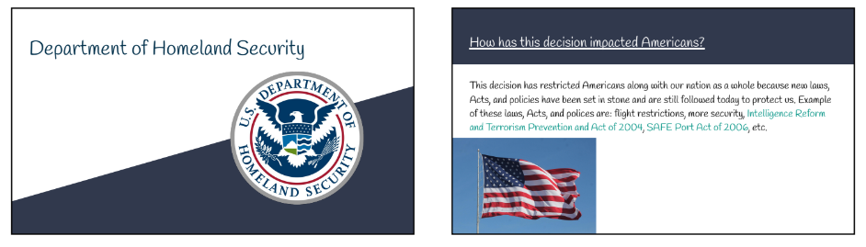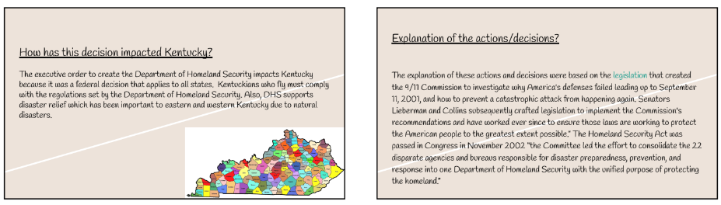
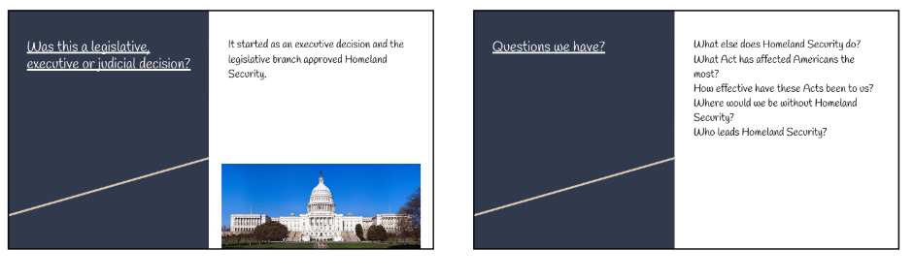

Have students present their slide deck to the entire class to support their classmate’s understanding of each of the five actions/decisions that were investigated by each group. As students are presenting their assigned topics, allow students to ask questions and initiate whole group discussion. Students may utilize the conversation starters used previously to support all students in acquiring a deeper understanding of the topics presented.

Present your slide decks to the class and explore the slide decks of your peers. As you review the slide decks of your peers, complete the following graphic organizers:

Title of the action/decision | Explanation of the action/decision | Was this a legislative, executive or judicial decision? | How has this decision impacted Americans? | How has this decision impacted Kentucky? | Questions
9-11 Commission

The War on Terror

USA PATRIOT Act

Transportation Security Administration

Department of Homeland Security

Here is a student example from a Kentucky classroom of a completed chart:

Title of the action and/or decision | Explanation of the action/decision | Was this a legislative, executive or judicial decision? | How has this decision impacted Americans? | How has this decision impacted Kentucky? | Questions
9-11 Commission | A commission created to investigate why America’s defenses failed, and how to prevent an attack from happening again. | Legislative decision | The committee approved strengthening the government’s power to respond using weapons of mass destruction. | It helped create things we still have today such as homeland security and TSA. | What is the commission doing now?
The War on Terror | President Bush declared the global War on Terror and called other leaders to join in on the campaign. | Executive decision | It sent tons of troops to go fight against terrorists. | Troops are just recently being sent back home. | How were the people who fought feeling about being sent home?
USA PATRIOT Act | It is a U.S. law that grants law enforcement more power to help prevent terrorist attacks. | Executive decision | The Patriot Act has limited the privacy of American citizens by allowing law enforcement the ability to look into things such as finances and e-mails. | It has affected Kentucky by allowing law enforcement to go through our private things. | How were Americans fighting about the privacy violation?
Transportation Security Administration | It required 100% of baggage to be screened, the expansion of the Air Marshal Service and reinforced cockpit doors. | Legislative decision | It still affects how we travel through air today, making it much more difficult to get on a plane. | Kentuckians have to go through all the requirements to get on planes. | Will it be this way forever?
Department of Homeland Security | It is one of the largest parts of the government, it is responsible for preventing attacks, security, immigration and disaster relief. | Executive decision | It has helped prevent other terrorist attacks against America. | It helps to keep Kentuckians safe by helping prevent an attack from happening here. | How has it grown over the years?

Investigation: Part 4
In order to investigate the supporting question for this assignment example, students must analyze legislative, executive and judicial branch decisions in terms of constitutionality and impact on citizens and states.

HS.C.CP.2 Analyze legislative, executive and judicial branch decisions in terms of constitutionality and impact on citizens and states.
HS.C.I.CC.1 Engage in civil discussion, reach consensus when appropriate and respect diverse opinions relevant to compelling and/or supporting questions in civics.

Next, explain to students that they are going to analyze the Constitutionality of these decisions. Consider a brief review of the Bill of Rights to refresh students’ memories on the freedoms it contains. The full text of the Constitution may be accessed from the Constitution Center. Have students briefly read and annotate the first ten amendments to the Constitution by completing the following:

In your small groups, review the Bill of Rights from the Constitution. Annotate the Bill of Rights by:

●Underline key ideas and major points.
●Write a ? next to anything that is confusing.
●Circle key words or phrases.
●Put an ! next to information that helps you make a connection to the decision/act you learned about.

Next, have students ask the following questions to make connections between the information they reviewed from the Bill of Rights and the decision/act they investigated.

- What right(s) expressed in the Bill of Rights is being challenged in this decision/act?
- Was this right(s) violated by this decision/act? Why? Why not?

Then, ask students to consider the five decisions that were presented and decide whether they think these decisions are Constitutional in a Structured Academic Controversy. This exercise will address HS.C.I.CC.1 by allowing students to engage in civil discussion. It is important that students are given the opportunity to discuss their opinions on the constitutionality of these decisions with their peers to hear different perspectives and help them develop and refine their thinking. Explain to students that they must examine the rights expressed in the Bill of Rights and determine whether or not they think these rights may have been violated by any of these decisions/acts. Allow students to use their graphic organizers, any of the sources they have previously used during these investigations and also allow them to do more research if needed to help determine the Constitutionality of each decision. The central question students may consider during their Structured Academic Controversy include, but are not limited to, the following:

Is this act/decision Constitutional? Why? Why not?

Prior to engaging with the protocol below, assign students a perspective for this work within their small group. Some students will be assigned the perspective that the decision/act is Constitutional while the other members of the small group will be assigned the perspective is not Constitutional.

- In pairs or groups of three, gather information and evidence from credible sources representing the perspective assigned to you on your act/decision.
- Prepared a concise, detailed written summary of your position. Cite evidence from your gathered sources to support your position.
- During the Structured Academic Controversy, your group will present your perspective that addresses the question “Is this act/decision Constitutional? Why? Why not?”
  - While you are listening to the presentations of others, remain open-minded about the perspectives presented by your peers.

Visit Structured Academic Controversy for more information. For more information on gathering and analyzing evidence, visit Gathering and Analyzing Evidence.

Conclude this investigation by asking students to complete a Quick Write to the following prompt:

Many legislative, executive and judicial decisions resulting from September 11, 2001, have been considered controversial. Select two decisions you have learned about in this investigation and answer the following:

- What positive impacts have these acts/decisions had on Americans?
- What negative impacts have these acts/decisions had on Americans?
- Do you think this act/decision was Constitutional? Why or why not?

Cite evidence from the sources you have investigated to support your responses.

Investigation: Part 5

- HS.UH.I.UE.2 Gather information and evidence from credible sources representing a variety of perspectives relevant to compelling and/or supporting questions in U.S. history.
- HS.UH.I.UE.3 Use appropriate evidence to construct and revise claims and counterclaims relevant to compelling and/or supporting questions in U.S. history.

To support students in synthesizing their thinking to answer the Task Aligned to the Supporting question, have students engage in a Gallery Walk to examine some research data related to September 11, 2001. Examining this data will allow students to determine how September 11, 2001, continues to impact American culture and society today. This investigation will include excerpts from the source below:

Hartig, Hannah and Doherty, Carroll. (2021, September 2). Two Decades Later: The Enduring Legacy of 9/11. https://www.pewresearch.org/politics/2021/09/02/two-decades-later-the-enduring-legacy-of-9-11/#CHAPTER-9-11-transformed-u-s-public-opinion-but-many-of-its-impacts-were-short-lived.

Prior to presenting the data to students, have them watch the following clip to review how to read a graph:

Florida PASS Program. (2021) Reading Graphs. https://www.youtube.com/watch?v=12MFPC1D4zE

As you watch Reading Graphs, consider the following questions:
- What are the types of graphs discussed in the video?
- What information can you find in a line graph?
- How do you read a graph?

When the video concludes, facilitate a whole group discussion to check for understanding to ensure that students know how to read and interpret graphs.

Next, inform students that they will engage in a Gallery Walk to gather information and evidence from graphs to understand how September 11, 2001, continues to impact American culture and society today. Prior to providing the directions for the Gallery Walk, post the following graphs around the classroom.

Graphs One and Two
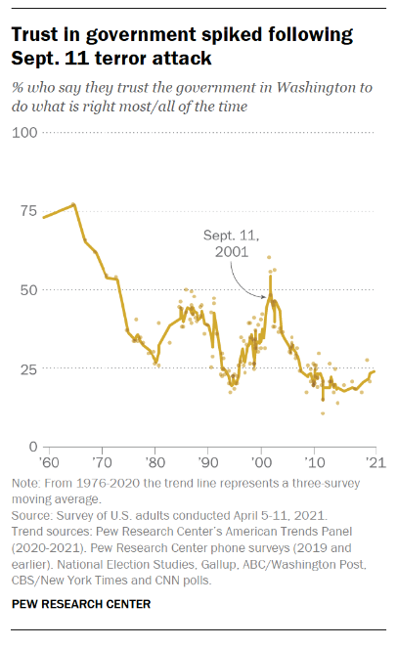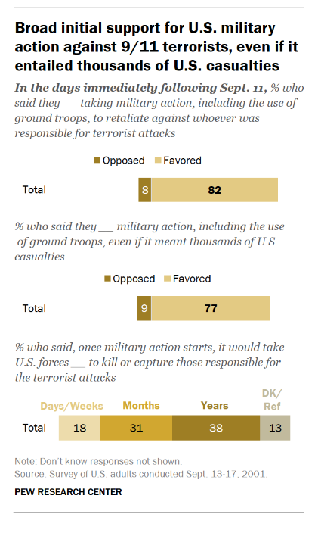

Graph Three
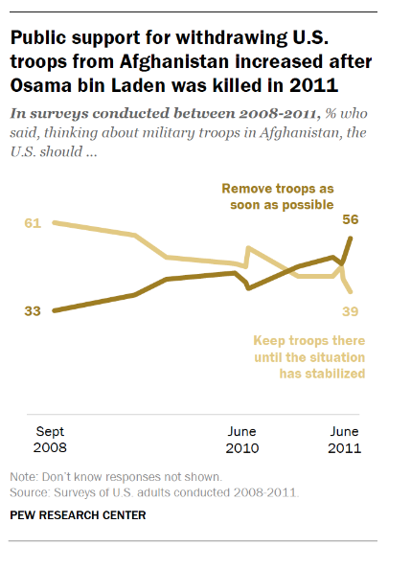

Graphs Four and Five
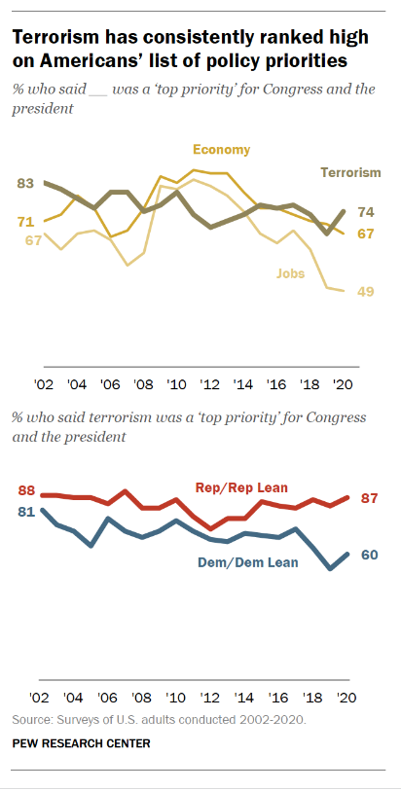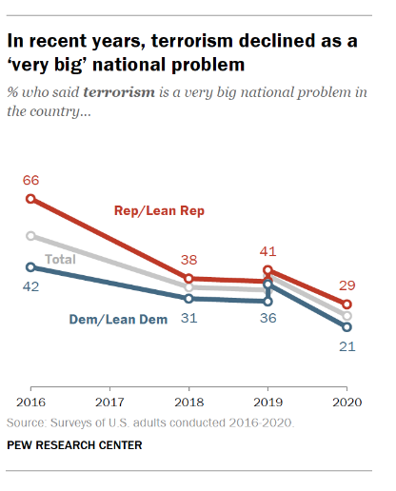

As students are engaging in the Gallery Walk, have them complete the graphic organizer below to gather information and evidence from the presented graphs to understand how September 11, 2001, continues to impact American culture and society today.

Source Information. What is the title of the graph and what type of graph is presented? | Read the information on each axis. What is being compared? | Describe the information provided in the graph. What do the lines or percentages show? | Interpret the information provided in the graph. According to this graph, how does September 11, 2001, continue to impact American culture and society today?

Once students have completed their graphic organizer, facilitate a class discussion to answer the following question:

How has September 11, 2001, continued to impact American culture and society today? When stating your claim, use evidence gathered from the graphs to support your response.

Explain to students that they will now complete the Task Aligned to the Supporting Question, where they will synthesize everything they have learned throughout these investigations to demonstrate their mastery of both the disciplinary strand standards and inquiry standards aligned to this assignment.

Task Aligned to the Supporting Question:

Kentucky Academic Standards (KAS) for Social Studies alignment:
- HS.UH.I.Q.2 Generate supporting questions to develop knowledge, understanding and/or thinking relative to key concepts in U.S. history framed by compelling questions.
- HS.C.CP.2 Analyze legislative, executive and judicial branch decisions in terms of constitutionality and impact on citizens and states.
- HS.UH.CE.6 Analyze how global interactions impacted American culture and society from 1890- present.
- HS.UH.I.UE.2 Gather information and evidence from credible sources representing a variety of perspectives relevant to compelling and/or supporting questions in U.S. history.
- HS.UH.I.UE.3 Use appropriate evidence to construct and revise claims and counterclaims relevant to compelling and/or supporting questions in U.S. history.
- HS.UH.I.CC.2 Engage in disciplinary thinking and construct arguments, explanations or public communications relevant to compelling and/or supporting questions in U.S. history.
In these assignments, students are required to synthesize information learned through engaging with the disciplinary strand standards to answer a supporting question.

Task Aligned to the Supporting Question:
How have global interactions resulting from September 11, 2001, impacted American culture and society from 2001 to the present?

In order to answer the supporting question, use your understanding of:

- Global interactions and how they impacted American culture and society from 2001 to the present; and
- Legislative, executive and judicial branch decisions in terms of constitutionality and impact on citizens and states.

In your response, analyze legislative, executive and judicial branch decisions due to September 11, 2001, in terms of constitutionality and impact on citizens and states. Be sure to use appropriate evidence to construct and revise claims in your response.
To support students in answering the Task Aligned to the Supporting Question, students may use the following resources from the previous investigations:
- Investigation 1: Students may use their Claim, Support, Question chart; the Lasting Impact chart, the Quick Write
- Investigation 2: Students may use their Slide Deck, the graphic organizer with notes on their peers’ slide deck, the Quick Write
Additionally, students may complete a Prewriting Strategy, such as Listing. The University of Kansas’ Writing Center states that “(l)isting is a process of producing a lot of information within a short time by generating some broad ideas and then building on those associations for more detail with a bullet point list.” To begin, organize students into small groups. For guidance on how to organize students into small groups, teachers may reference Using Roles in Group Work or Setting up and managing small group work. Have the small groups engaging in Listing as a pre-writing strategy by completing the following:
- First, list all the global interactions that impacted September 11, 2001, that you learned about throughout the investigations. All group members should generate ideas while one group member records the responses.
- Second, explain how these global interactions impacted American culture and society. All group members should generate ideas while one group member records the responses.
- Third, identify the legislative, executive and judicial branch decisions that resulted from September 11, 2001.
- Fourth, group these legislative, executive and judicial branch decisions according to constitutionality and unconstitutionality and give each group a label.
- Fifth, write a sentence about each group label, explaining why the legislative, executive and judicial branch decisions listed are constitutional or unconstitutional. All group members should generate explanations while one group member records the responses.
For more information on Argument/Opinion Writing, access the KDE’s Composition in the Classroom.
Student Work Samples:
Below are student work samples from Kentucky classrooms of the Task Aligned to the Supporting Question. For more information as to why the examples listed below are strongly, weakly or partially aligned to the KAS for Social Studies, visit the Assignment Review Protocol Module’s Section 5D to Understanding the Student Work Review Protocol.

Strongly Aligned Work Sample

American culture has been impacted by what occurred on 9/11 by making the government more aware
of things that could potentially be an attack, upping security in America, and being able to pass laws
some see as unconstitutional. The US Patriot Act is an example of the government looking more closely
at things than before. This act allows law enforcement to look at things they didn't before and made the,
be more aware of the contents. As it says in The USA PATRIOT Act: Preserving Life and Liberty, “Allows
law enforcement to use surveillance against more crimes of terror. Before the Patriot Act, courts could
permit law enforcement to conduct electronic surveillance to investigate many ordinary, non-terrorism
crimes, such as drug crimes, mail fraud, and passport fraud. Agents also could obtain wiretaps to
investigate some, but not all, of the crimes that terrorists often commit. The Act enabled investigators to
gather information when looking into the full range of terrorism-related crimes, including:
chemical-weapons offenses, the use of weapons of mass destruction, killing Americans abroad, and
terrorism financing.” The TSA Act is an example of the government being more cautious after what
happened. The act requires bags to be scanned and checked in order weapons can not make it on the
aircraft. In the Transportation Security Timeline it says, “President Bush signed the Aviation and
Transportation Security Act into law requiring screening conducted by federal officials, 100 percent
checked baggage screening, expansion of the Federal Air Marshal Service and reinforced cockpit doors.”
Finally, it caused laws that people consider unconstitutional to pass. An example of this again is the US
Patriot Act. People claim that allowing the government to go through citizens' private emails breaks their
4th amendment right. The 4th amendment states the people have a right “to be secure in their persons,
houses, papers and effects, against unreasonable searches and seizures.” People argue that because the
government has no evidence against them, they can't search their private possessions.

Partially Aligned Work Sample

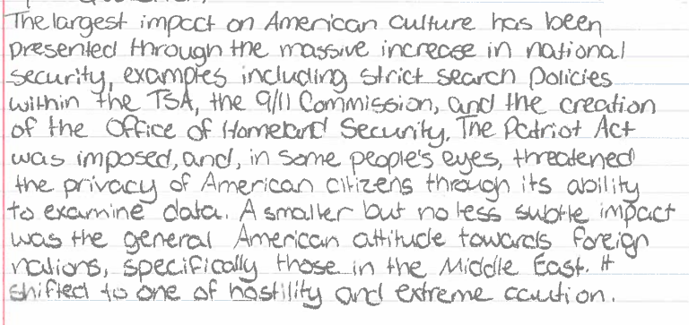

Weakly Aligned Work Sample

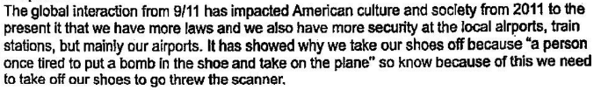

Task Aligned to the Compelling Question:

Kentucky Academic Standards (KAS) for Social Studies alignment:
- HS.UH.I.Q.1 Generate compelling questions to frame thinking, inquiry and/or understanding of key concepts in U.S. history.
- HS.UH.I.UE.2 Gather information and evidence from credible sources representing a variety of perspectives relevant to compelling and/or supporting questions in U.S. history.
- HS.UH.I.UE.3 Use appropriate evidence to construct and revise claims and counterclaims relevant to compelling and/or supporting questions in U.S. history.
- HS.UH.I.CC.2 Engage in disciplinary thinking and construct arguments, explanations or public communications relevant to compelling and/or supporting questions in U.S. history.
This assignment culminates with students using their historical thinking skills to understand America’s past and what decisions of the past account for present circumstances and make sense of the interconnected world around them.

Task Aligned to the Compelling Question

Based on your explanation to the supporting question, engage in disciplinary thinking and construct an argument to answer the following question: “How do global interactions impact me?” In order to support your argument, gather information and evidence from credible sources representing a variety of perspectives in U.S. history.

All valid claims must be based on logical evidence. In order for students to construct coherent arguments and explanations using their understanding of the social studies disciplines, they must understand how to substantiate those claims using evidence. This skill requires students to collect, evaluate and synthesize evidence from primary and secondary sources to develop and support a claim.

Hattie, J., Stern, J., Fisher, D., & Fry, N. (2020). Visible Learning for Social Studies. Corwin.
Michaels, S., O’Conner, M. C., Hall, M. W., & Resnick, L. B. (2010). Accountable Talk sourcebook: For classroom conversation that works (v. 3. 1). Pittsburgh, PA: University of Pittsburgh Institute for Learning. http://ifl.lrdc.pitt.edu

