HS Statistics and Probability Assignment
This assignment is strongly aligned to the standards.
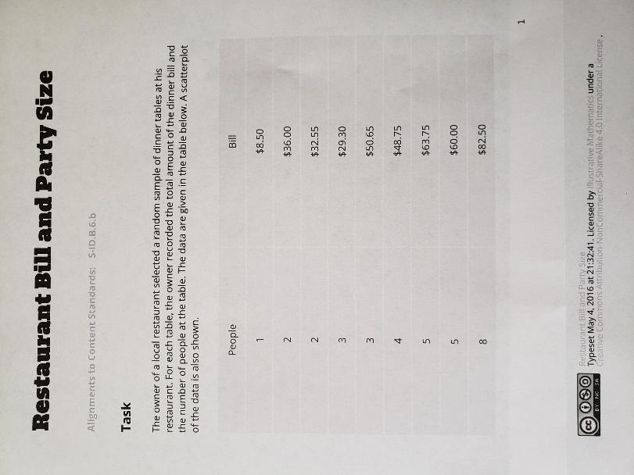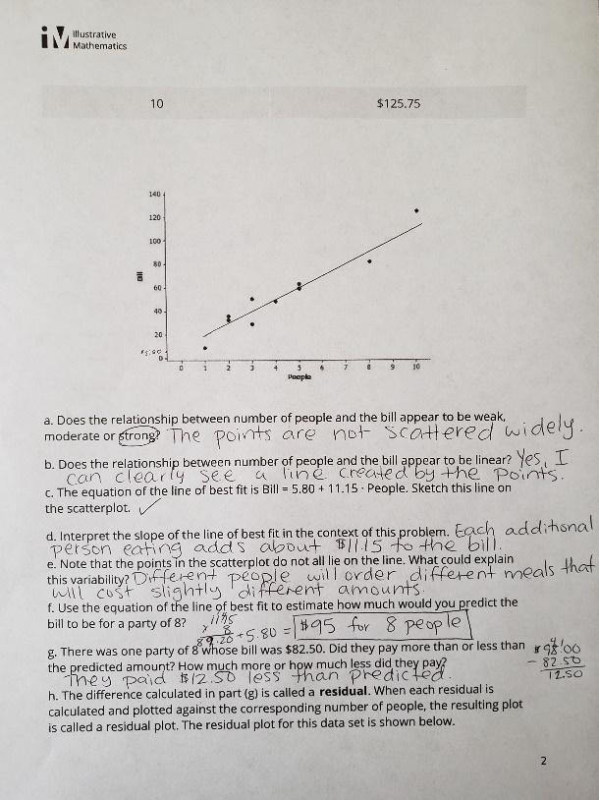
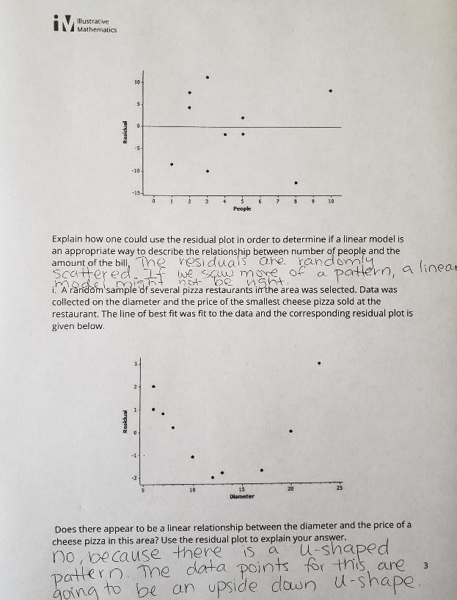

Overview
High school students explain why a linear model is most appropriate for a given data set and then answer questions about the situation and the math involved. They are then exposed to a second context through a residual plot where a linear model is not appropriate, and they need to explain how they know given the residuals. The assignment is strongly aligned to the standard because it requires students to fit a model to data, assess the fit of the model by analyzing residuals, and solve problems in the context of the data.
Related Standards
We looked at how well the assignment aligned to the following standard:

KY.HS.SP.6 Represent data on two quantitative variables on a scatter plot and describe how the explanatory and response variables are related.
- Calculate an appropriate mathematical model, or use a given mathematical model, for data to solve problems in context.
- Informally assess the fit of a model (through calculating correlation for linear data, plotting, calculating and/or analyzing residuals)

Why is this assignment Strongly aligned?
In eighth grade, students first work with bivariate data (measurement data on two related variables). They create scatter plots, find linear equations that best fit the data, and use their equations to answer real-world questions. These concepts are extended in high school when students work with bivariate data that might have a non-linear relationship. This assignment allows students to work with bivariate data in a manner appropriate for high school.
The assignment appropriately allows students to build their conceptual understanding by asking them to use functions fitted to data to solve problems in the context of the data and informally assess the fit of a function by analyzing residuals (all aligned with standard KY.HS.SP.6).
Practice Standards
The assignment gives students a strong opportunity to engage with Mathematical Practice Standard #4 (“Model with mathematics”), which suggests that students “apply the mathematics they know to solve problems arising in everyday life, society, and the workplace.” In this task, students are asked to use a function to describe how one quantity of interest depends on another in an authentic, if simulated, context. The assignment also allows students to engage with Mathematical Practice Standard #2 (“Reason abstractly and quantitatively”) by asking questions that require them to fluently move from the decontextualized symbolic representation of the situation to the contextualized situation where they pay attention to the meaning of the quantities.

