HS Statistics and Probability Assignment
This assignment is partially aligned to the standards.
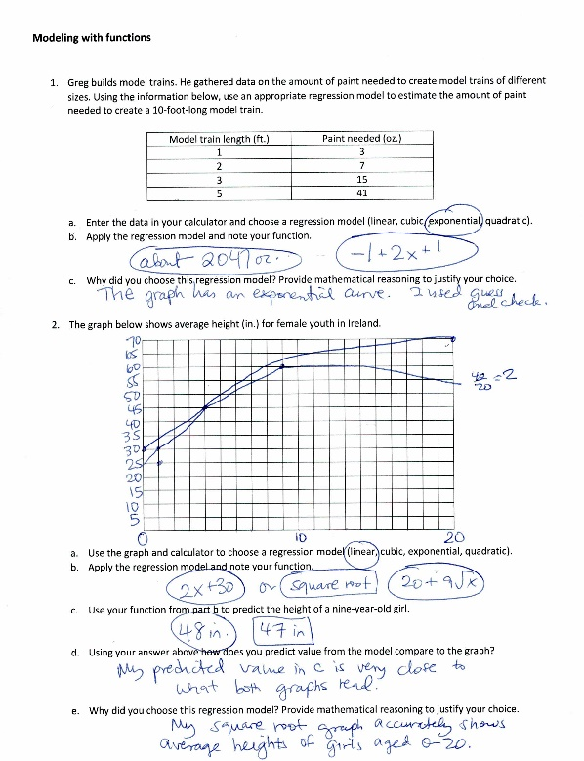

Overview
High school students find the regression models that best represent the data provided and answer questions about the real-world situations they model. The assignment is partially aligned to the standards because it requires students to use technology to test and analyze different models, but it doesn’t provide the opportunity for students to represent the data on a scatterplot, describe how the variables are related, or to plot and analyze residuals.
Related Standards
We looked at how well the assignment aligned to the following standard:
KY.HS.SP.6: Represent data on two quantitative variables on a scatter plot and describe how the explanatory and response variables are related.
KY.HS.SP.6.a: Calculate an appropriate mathematical model, or use a given mathematical model, for data to solve problems in context.
KY.HS.SP.6.b: Informally assess the fit of a model (through calculating correlation for linear data, plotting, calculating and/or analyzing residuals).

Why is this assignment partially aligned?
The assignment involves mathematical models appropriate to high school (linear, quadratic, exponential), and in question 2b, allows students to use the model to answer questions about the situation it represents. However, the assignment is only partially aligned with the standard because it does not give students enough opportunity to describe how the explanatory and response variables are related (KY.HS.SP.6), to use models fitted to data to solve problems in the context of the data, or to calculate an appropriate model for the context (KY.HS.SP.6.a). Students could assess the fit of their regression models by plotting, calculating and/or analyzing residuals (KY.HS.SP.6.b), but the structure of the assignment does not encourage them to do so.
The assignment does allow students to use appropriate procedural skill, such as representing quantitative data on a scatter plot and fitting functions to data. However, students should also be building their conceptual understanding by describing how variables are related, choosing a model suggested by context, and analyzing residuals—and the assignment does not require students to do any of those things.
Practice Standards
The assignment gives students the chance to engage with Mathematical Practice Standard #5 (“Use appropriate tools strategically”) by suggesting the use of calculators to test and select regression models for the provided data. To be fully aligned to the standard, however, the assignment should also have given students the chance to engage with Mathematical Practice Standard #7 (“Look for and make use of structure”) by asking students to describe how variables are related and assess the fit of a function by plotting and analyzing residuals.

