HS Statistics and Probability Assignment
This assignment is weakly aligned to the standards.
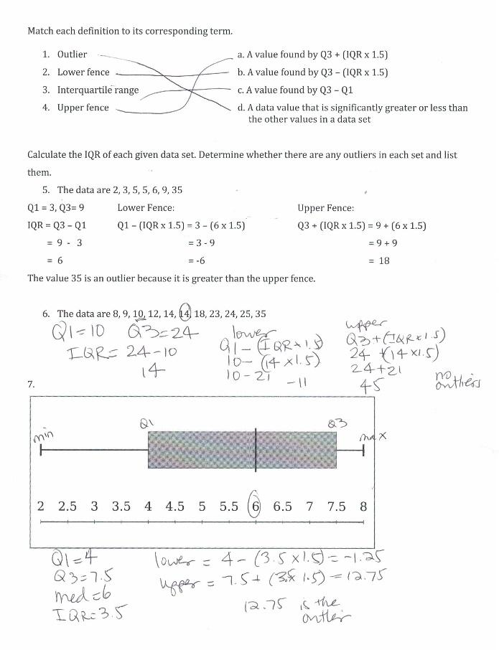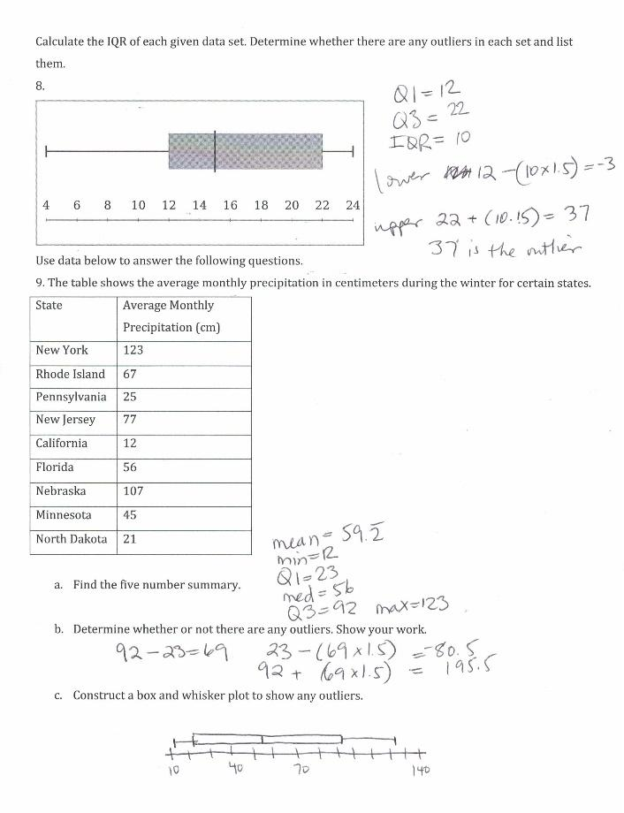
Overview
High school students calculate statistics of given data sets, presented as sets of numbers, box plots, or in a table. The assignment is weakly aligned to the standards because it tells students which statistics to calculate instead of allowing them to determine themselves which statistics are most appropriate. Although students are asked to determine if outliers are present, they do not use this information in the ways required by the standard. Additionally, the assignment doesn’t require students to make connections between two or more data sets.

Related Standards
We looked at how well the assignment aligned to the following standards:
KY.HS.SP.1: Represent the distribution of data with plots on the real number line (stem plots, dot plots, histograms and box plots).
KY.HS.SP.2: Use statistics appropriate to the shape of the numerical data distribution to compare center (median, mean) and spread (interquartile range when comparing medians and standard deviation when comparing means) of different data distributions.
KY.HS.SP.3 Interpret differences in shape, center and spread in the context of the distributions of the numerical data, accounting for the presence and possible effects of extreme data points (outliers).
Why is this assignment weakly aligned?
This assignment aligns more closely to sixth-grade standards (KY.6.SP.4 and KY.6.SP.5) because of its focus on computing statistics (interquartile range, outliers, five-number summary) for given data sets. There are no options for students to select “the statistics appropriate to the shape of the distribution,” or to consider the standard deviation as a measure of variability as required by the high school standards.
High school students should be using data representations and statistics to compare and interpret differences in two or more data sets, but this assignment only asks students to work with one data set at a time (again, more closely aligned to sixth-grade expectations). Additionally, technology should be leveraged in high school to create displays and to calculate statistics to help students focus on interpretation and comparison, but this assignment does not involve technology.
Practice Standards
The assignment does not provide the opportunity to engage with any mathematical practice standards. Were it more closely aligned to the high school standards, students would have the opportunity to engage with Mathematical Practice Standard #5 (“Use appropriate tools strategically”) by using graphing calculators or computer software to create data displays and calculate statistics. Students could also have been given the chance to engage with Mathematical Practice Standard #7 (“Look for and make use of structure”) by selecting the “statistics appropriate to the shape of the data distribution.”

