Kindergarten Assignment
This assignment is strongly aligned to the Kentucky Academic Standards (KAS) for Social Studies.
Teacher Notes

Introduction
This Teacher Notes document provides instructional support for implementing the strongly aligned assignments to the KAS for Social Studies. To examine why this assignment is strongly aligned to the KAS for Social Studies, engage with the Kindergarten Assignment Review Protocol for this assignment.

It is important to note that the assignment(s), indicated throughout the Teacher Notes, and related resource(s) represent one example. It is not a requirement nor a suggestion for school curriculum. While the Kentucky Department of Education (KDE) is responsible for the development of high-quality academic standards, state law assigns each local district the authority to develop the school’s curriculum and determine appropriate instructional resources based on language found in Kentucky Revised Statute (KRS) 160.345. It is under the discretion of the superintendent to determine the local curriculum, including the evaluation and selection of instructional resources. The KDE does not adopt, select or recommend specific curricula for coursework. Per KRS 160.345(g), “the local superintendent shall determine which curriculum, textbooks, instructional materials, and student support services shall be provided in the school after consulting with the local board of education, the school principal, and the school council and after a reasonable review and response period for stakeholders in accordance with local board of education policy.”

Kentucky Academic Standards (KAS) for Social Studies alignment:
- K.I.Q.1 Ask compelling questions about their community.
- K.C.PR.1 Identify examples of rules that apply in the school and community, and explain why they exist.
- K.H.CO.1 Describe interactions that occur between individuals/groups in families, classrooms and communities.
- K.I.UE.1 Identify information from two or more sources to investigate characteristics of a community.
- K.I.UE.2 Construct responses to compelling questions about oneself and one’s community.
- K.I.CC.2 Construct an argument to address a problem in the classroom or school.

Educators may have to engage with a standard multiple times throughout a year in order to meet the full intent of the standard. As a result, the following example may not encompass the entire scope of the standards identified.

Overview:
Students identify examples of rules that apply in the school and community, and explain why they exist. Students will use their knowledge of existing school rules to identify a safety concern that does not have a school rule. Next, students will propose a Safety Tip that would make school safer for them and their friends. Students will use their knowledge of why following school rules is important to answer the compelling question, “How can I improve my classroom community?”

Setting the Stage: Compelling Question

K.I.Q.1 Ask compelling questions about their community.

Compelling Question:
“How can I improve my classroom community?”

Compelling questions are open-ended, enduring and center on significant unresolved issues. This assignment provides a compelling question to demonstrate alignment because Kindergarten students are not required to ask compelling questions without teacher support. Therefore, teachers may provide the compelling questions that students engage with as it is not the expectation of the standard that students ask the compelling questions on their own. For more information on compelling questions, visit Section B: “What are Compelling Questions and how do students ask them?” from the Inquiry Practices of the KAS for Social Studies module.

Considerations for Prior Learning
In this assignment, students engage with the KAS for Social Studies to build knowledge that will enable them to construct an argument to answer the compelling question. As a reminder, the compelling question is provided below.

Compelling Question:
“How can I improve my classroom community?”

Throughout these investigations, students engage with the KAS for Social Studies to build knowledge that will enable them to construct an argument to answer the compelling question: “How can I improve my classroom community?”

To build context to support students when investigating the compelling question, the following resource may be utilized:
Rathmann, Peggy. (1995). Officer Buckle and Gloria. New York: G.P. Putnam's Sons.

It is important to note that Officer Buckle and Gloria is not considered an informational text nor a source of information, but rather an artistic work that helps create a compelling context for inspiring students to be engaged in being responsible and identifying safety problems within the school.

In order to support students in understanding the need to follow rules, conduct a Read Aloud with Officer Buckle and Gloria. As the students engage with this literary text, consider leading a brief discussion of the safety tips found in the story. The discussion may include students making connections to the tips, whether they have heard of them before and why they are important to follow. This will provide students with the context necessary to understand why they must follow rules and laws.

Investigation: Part 1
K.H.CO.1 Describe interactions that occur between individuals/groups in families, classrooms and communities.

Explain to students that you are going to investigate interactions between people in our community. As a reminder, “community” in Kindergarten refers to the students’ classroom, school and local town, city or district. First, ensure that students understand the word “interaction” when referring to individuals in a community. Provide them with a student-friendly definition, such as “people talking to each other” and provide examples. Ask students to Turn and Talk to a partner to share examples of interactions between people that they have seen today. Students should take turns talking and listening to each other; provide Partner A with 2 minutes to speak while Partner B listens, and 2 minutes for Partner B to speak while Partner A listens.

Then, come back together as a whole group and allow several students to share what their partner shared during their Turn and Talk. This will show the importance of listening to and valuing the ideas of others. Student responses may be both positive and negative and may include, but are not limited to teachers greeting students in the hallways, friends talking in the lunchroom, a teacher asking a student to stop running in the hallway, a student asking a teacher for help, students sharing markers and students treating classroom materials with respect.

Explain to students that some interactions can be positive and benefit both people, while other interactions may be negative and harm one or both people. Ask students to recall the examples they shared. Ask students to provide several examples of both positive and negative interactions that can take place among people in their classroom and school community and ask them to explain their answer. Some students responses may include, but are not limited to:

- A student breaks a box that holds art supplies (negative).
- A student says congratulations to another student when they do well on a test (positive).
- Students having an argument on the playground (negative).
- A crossing guard helping students safely cross the road (positive).

Explain that students will now role play different interactions. This exercise will further help students understand the meaning of interactions by seeing examples in action and will also help practice determining whether interactions are positive or negative, while providing an explanation. Place students into groups of two or three and provide each student with a scenario to act out. For example, a group of three may have one student pretend to be a bus driver and the other two students are children on the bus who are getting out of their seat when the bus is moving. A pair could have one person who is the parent and the other is their child who came home with an A on their test. Set expectations for students that, while some scenarios will be portraying a negative interaction, they should show respect to their peers and honor their personal space during this exercise. Ensure that students understand their scenario and provide them time to practice their role playing, offering support as needed.

Once students are ready to perform, have students return to their seats and ask one group at a time to conduct their role playing in front of the class. After each performance, ask the class the following questions:

- What role is each student playing?
- What interaction is happening between them?
- Is this a positive or negative interaction? What is your reasoning?

After this exercise, students should understand interactions and how they can be positive or negative. To assess students’ individual understanding, provide students with cards that represent different interactions, such as the ones below:
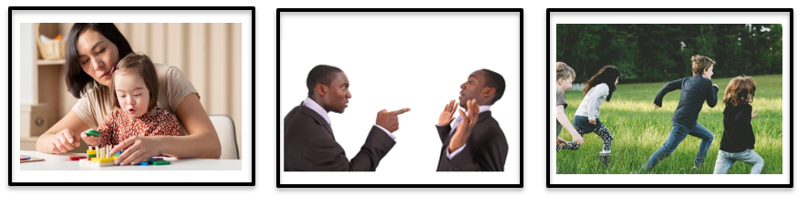
Ask students to sort these images for positive and negative interactions. As students work, ask them to explain their choices. Once students have identified the images as positive or negative, conduct a whole group discussion where they share their responses.

Next, ask students to focus on the negative interactions they have identified throughout the previous discussions and exercises. Have them recall several specific examples and pose the following questions for each one:

- Why is this a negative interaction?
- Who is harmed during this interaction, and why?
- What could prevent this negative interaction from happening?

For example, for the interaction of two people arguing, students may respond that they should have calmly discussed their disagreement and not pointed at one another. For the interaction of a student being in trouble for running down the hall, the student should have walked in the hallway. For the students standing while the bus is in motion, they should have been seated. After several examples have been discussed, ask the following question:

What prevents us from running down the hall or sitting while the bus is in motion?

Students should respond by saying “rules.” Redirect student responses if they do not reply with the term “rules.”

Next, ask students the following question:

How can rules help prevent negative interactions in our homes, schools and communities?

Ask students to Turn and Talk to a partner with the same procedure mentioned previously. Then, discuss this question as a class. Explain to students that they will further explore the purpose of rules in their community, school and classroom.

Investigation: Part 2
Explain to students that they will investigate rules in the community and their purpose. During whole group discussion with prompting and support, students will examine street signs to describe the relationship between visuals and the text and to explain why the community rule expressed in the street sign exists. Provide a graphic organizer to support students in analyzing each sign. The sample images below may be used, or you may use signs in your community with which students are familiar.

Street Sign | Look at each sign. What do you see? | What does the sign mean? | Why do we have this rule in our community?
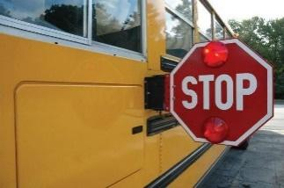
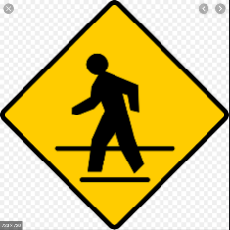
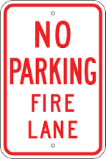

The first two questions “What do you see?” and “What does the sign mean?” are used here as prompting and support for describing the relationship between the visuals and the text and for leading students to determine why they have the rule in the community. Visuals with no text (no letters or words) are still considered text because the visual, or sign in this case, communicates a message to the reader - even without the use of text. When prompting and supporting students to answer each question, the first question, “What do you see?” is about describing each of the features, individually, that work together to give the sign meaning (color, letters, words, shapes, and more). To answer the second question, “What does the sign mean?” students must bring together their answers to the first question to determine how the features work together to create an overall meaning. Use probing questions like the ones below to yield thorough explanations of each question, thus leading to strong descriptions of the relationship between the visuals and the text and to clearly explain why the community needs the sign/rule.

Below are some questions to prompt student responses while completing the graphic organizer together:

What do you see?
- What colors do you see?
- Are there any letters or words on the sign? If so, what letters/words do you see?
- Are they uppercase or lowercase letters?
- Where are the letters/shapes? Is there anything special about the letters/shapes? For example, uppercase, position of the words, etc.
- What shapes do you see?

What does the sign mean?
- Think about the colors you see on the sign. What do you know about the color red? For example, red means hot/stop/warning and grabs attention in some way.
- Do the colors go well together?
- Are the letters/words/shapes/pictures on the sign easy to see or difficult to see?
- Where do you see this sign in our community?
- If there are letters or words, what do the letters/words say and mean?
Why do we have this rule in our community?
- Why is this sign needed?
- What are the consequences of not having the sign/rule?

Ask students to Turn and Talk to a partner with the same procedure mentioned previously. Then, discuss this question as a class. Explain to students that they will further explore the purpose of rules in their community, school and classroom.

Investigation: Part 3
K.C.PR.1 Identify examples of rules that apply in the school and community, and explain why they exist.

Explain to students that they will now investigate school rules and their purpose. With prompting and support, review the school rules (or use the list of sample school rules below) and discuss why they have each rule.

Example of School Rule | Why do we have this rule in our school?
Keep hands and feet to self.
Student shoes need to be secured to the foot; shoes, such as flip flops, are not allowed.
Visitors to the school must enter through the front doors and check in with the office.
Students must walk quietly in the hallway when transitioning activities.

Discussion should include asking students what they think the consequences would be if they didn’t have the rules or if the teachers and principal did not make sure the rules were followed. This assignment lends itself well to introducing students to the vocabulary word, consequence. A kindergarten appropriate definition of consequence is what happens because of something else. Example: When you forget your lunch at home, the consequence is you have to eat school lunch instead. OR The consequence of going out in the rain without an umbrella is you will get wet.

Once students can explain the purpose of school rules, inform them that they will now investigate the purpose of rules in the community.

Investigation: Part 4
K.C.PR.1 Identify examples of rules that apply in the school and community, and explain why they exist.

Explain to students that they will now investigate classroom rules and their purpose. With prompting and support, review the classroom rules (or use the list of sample classroom rules below) and discuss why they have each rule.

Example of Classroom Rule | Why do we have this rule in our classroom?
Listen to the speaker.
Respect your classmates and their property.
Do not leave the classroom without permission.
Always give your best effort.

Now that students can explain the purpose of rules in their community, have them complete the Task Aligned to the Compelling Question below.

Task Aligned to the Compelling Question
Part One:
KAS for Social Studies alignment:
- K.I.Q.1 Ask compelling questions about their community.
- K.H.CO.1 Describe interactions that occur between individuals/groups in families, classrooms and communities.
- K.I.CC.4 Use listening skills to decide on and take action in their classrooms.

Inform students that they will now prepare to answer the compelling question, “How can I improve my classroom community?” Improving a classroom community may require making a new classroom rule to make sure that students within the class are able to positively interact with one another.

Compelling Question: Part One

Participate in a discussion to identify ways to improve your classroom community.

To support students in answering the compelling question, “How can I improve my classroom community?”, conduct a whole group discussion to support students in answering this question. Students may share that they could improve their classroom community by following classroom procedures and rules such as raising their hand to speak or making a new rule to solve a problem within the classroom.

Once students have identified ways to improve their classroom, have them engage in the What Makes You Say That? Thinking Strategy for students to propose ideas about any parts of their classroom that can be improved by creating a new rule. As each pair shares their responses, ask the students:

- What is the problem?
  - Why is a new rule or procedure needed to address this problem?
  - What is a new rule that would address this problem?
- What makes you say that?
  - How will this new rule address this problem?
  - How will this new rule improve our classroom community?

Record student responses in the chart below:

New Rule | What problem will the new rule solve? | How will this new rule improve our classroom community?

Once every student has shared at least one idea for creating a rule to improve the classroom community, have students play the Red light, Green Light listening game to using listening skills to decide on a new rule to create and use to improve the classroom community. Provide each student with two signs or sheets of paper, one red and one green. Tell students that they will now review each new rule identified by their classmates to determine which rules they would like to use in their classroom. As you read each rule, have students hold up either the red paper indicating that they would not like to use that rule, or the green paper to indicate they would like to use that rule. Record the number of students who are in favor of this new rule by adding a column on the chart used previously, like in the example below.

New Rule | What problem will the new rule solve? | How will this new rule improve our classroom community? | Number of classmates who would like to use this rule to improve their classroom.

Discuss with students which new rules had the most votes and the least and determine which rules have enough support from students in the classroom to consider adding to the already existing classroom rules. Have students identify which rule they would like to explore in more detail and summarize their work in Part One of the Task Aligned to the Compelling Question by answering the following prompt individually:

- What rule do you want to know more about?
- Why did you pick this rule to investigate?
- Explain how you used listening skills to decide on and act on ways to improve your classroom community.

Now that students have identified the new rules they would like to use in their classroom, divide the students into small groups. Each small group will be responsible for making a poster in Part Two that explores the new rule in more detail. For guidance on how to organize students into small groups, teachers may reference Using Roles in Group Work or Setting up and managing small group work.

Part Two:
KAS for Social Studies alignment:
- K.I.Q.1 Ask compelling questions about their community.
- K.C.PR.1 Identify examples of rules that apply in the school and community and explain why they exist.
- K.I.UE.1 Identify information from two or more sources to investigate characteristics of a community.
- K.I.CC.2 Construct an argument to address a problem in the classroom or school.

Compelling Question: Part Two

In small groups, use the discussion from Part One to create a poster that shows your new classroom rule.

Create a poster to hang in our classroom. The poster must show a new rule that you and your classmates think will improve our classroom community.

Your poster must show the following:
- 1. The new rule to use in your classroom,
- 2. Why the rule is needed. What problem does it solve? Use information from two or more sources in the classroom to explain how creating a new rule will improve your classroom community.
- 3. How following the new rule will improve the classroom community.

Use what you have learned about school and community rules and why they exist to design the new classroom rule.
Use drawing and writing that will make your friends want to follow the classroom rule.

This task is asking students to produce a poster that is considered Writing for Publication, since it is used for an authentic purpose and audience and will be posted for others to see. As a result, it should be clear and readable to others.
Example:
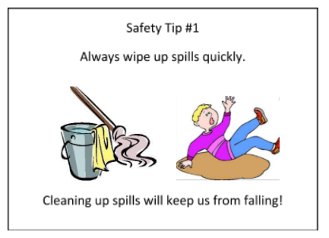
This poster argues we should always wipe up spills quickly because leaving water on the floor is not safe. The student argues why this is a problem by including a picture of someone slipping and falling in the water. The student offers a solution to the problem by showing the spill should be quickly wiped up with a mop and/or towel and mop bucket. The sentence at the bottom states the argument that cleaning up spills will prevent falls.

Provide support to students as needed. As a reminder, the purpose of this task is to assess students’ mastery of the social studies standards identified, so do not worry about students’ spelling, grammar or handwriting when determining if the student has demonstrated mastery of the social studies standards cited for this assignment. After completing this task, allow groups to share their poster with the class and display the posters in the classroom to serve as reminders about the new rule they created to help keep their classroom safe.

The focus of kindergarten social studies is to provide students with rich explorations of topics that affect them and their personal environment. The culminating assignment is students’ synthesis, or integration of knowledge and ideas, of the identified KAS for Social Studies.

Student Work Samples:
Below are student work samples from Kentucky classrooms of Part Two of the Task Aligned to the Compelling Question:

Strongly Aligned
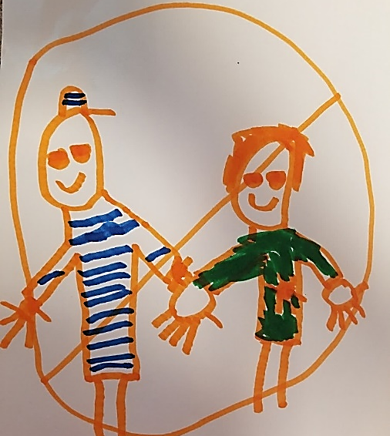

Partially Aligned
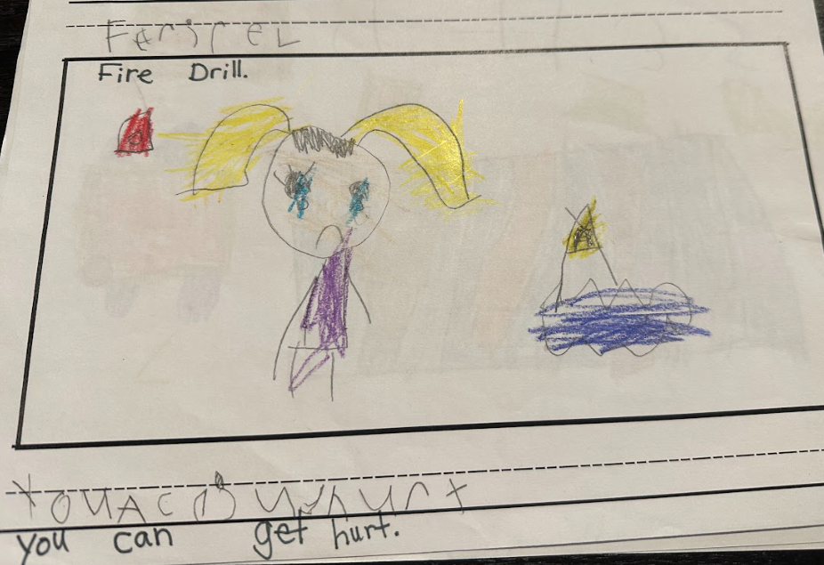

Weakly Aligned
