Kindergarten Math Assignment
This assignment is strongly aligned to the standards.
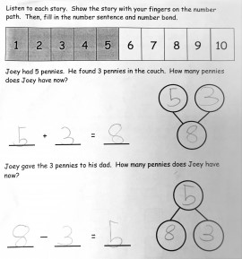

Overview
Kindergarten students write equations and number bonds to represent two addition and subtraction problems. This assignment is strong because it builds students’ conceptual understanding of addition and subtraction and how both operations can be represented in multiple ways.
Related Standards
KY.K.OA.1: Represent addition and subtraction with objects, fingers, mental images, drawings, sounds, acting out situations, verbal explanations, expressions, or equations.

Why is this assignment STRONGly aligned?
This assignment is well-aligned with KY.K.OA.1 which requires students to represent addition and subtraction in a variety of ways, including symbolic representations such as expressions and equations. In this assignment, students have to represent one addition and one subtraction problem symbolically in two ways: equations and number bonds. The numbers used in both problems (5+3=8 and 8-3=5) are appropriate, because kindergarten standards require students to add and subtract within 10. The methods for adding (counting all) and subtracting (taking away) are also appropriate for kindergarten; more complex methods, such as finding an unknown addend, are more appropriate for first grade.

This assignment builds students’ conceptual understanding of addition and subtraction. Kindergarten students begin learning what addition and subtraction represent by acting them out in concrete ways, such as using fingers or other objects to add and subtract, and they also learn that addition and subtraction can be represented symbolically using mathematical language such as equations. Number bonds are another symbolic representation that help students grasp the concepts of addition and subtraction by visualizing the relationship of parts to a whole.

